**December 2, 2012**

**Volume 1, Issue 12**

Sunday School Times

Published almost weekly, but more like…..whenever, so get used to it, OK?

# Justice 600 Years In The Making

**By Mr. Lyle (mrlyle1@gmail.com**

***Stuff For Today***

• Sunday School Commandments

• Technology pick of the week—just in time for Christmas

• Probably the bloodiest story in the Bible. It is the only Kroger Bible story that must be edited for violence!



Often we fail to realize how important it is to obey God fully. Our shortcomings can result in consequences that may far outlive us. We have only the short span of our lives to observe the results of our actions.

The lesson today traces a seemingly small infraction, a failure to fully obey. We have an advantage in that we can travel through time as we turn the pages of our Bible.

The story will span nearly 6 centuries. We will meet men and women who were faithful to their God, and a few who failed miserably.

Along the way, you will be introduced to quite a cast of characters: a man of the tribe of Benjamin called Kish, Saul the king of Israel, a pagan king named Agag, Samuel the prophet of God, an un-named Amalekite, a Jew called Mordecai, a young lady named Hadassa, an arrogant government official known as Haman, and Xerxes the king of Babylon.

We will look at the following passages in the Bible:

***I Samuel 9:1***

***I Samuel 15:1-3, 9, 32-33***

***II Samuel 1:6-10***

***Esther (the whole book)***

**New for this Christmas: the B.O.O.K**

(Advertisement)

Announcing the new **Built-in Orderly Organized Knowledge** device.

Just lift the cover of your new **B.O.O.K.** and you will find it delightfully compact and portable. It can be used anywhere, yet it is powerful enough to hold as much information as a CD rom disk.

Here’s how it works. Each **B.O.O.K**. is constructed of sequentially numbered sheets of paper, each capable of holding thousands of bits of information! And by using both sides of each sheet, our manufacturing costs are cut in half. And we pass that savings on to you!

When using the **Built-in Orderly Organized Knowledge** device, each sheet is scanned optically and the information is registered directly into your brain. A simple flick of the finger takes you to the next sheet. The “browse” feature allows you to move very quickly to any sheet, even forward or backward as you wish. Many come with an “index” feature, which pinpoints elected information for instant retrieval

An optional **B.O.O.K. mark** accessory allows you to open the **B.O.O.K.** to the exact place you left in a previous session- even if the **B.O.O.K**. has been closed. **B.O.O.K.marks** fit universal design standards: thus a single **B.O.O.K.mark** can be used by various manufacturers.

Portable, durable and affordable, the **B.O.O.K**. is the entertainment wave of the future, and many new titles are expected soon! And be watching for our new programming tool, the

**Portable Erasable-Nib Cryptic Intercommunication Language Stylus P.E.N.C.I.L.S.**

Thank you again for your interest in our **B.O.O.K.** And remember, now is the time to invest, at the ground floor of this exciting wave of the future!

Make your checks payable to C.A.S.H. (**C**ompletely **A**mbiguous **S**hipping and **H**andling)

## **The 7 Sunday School Commandments**

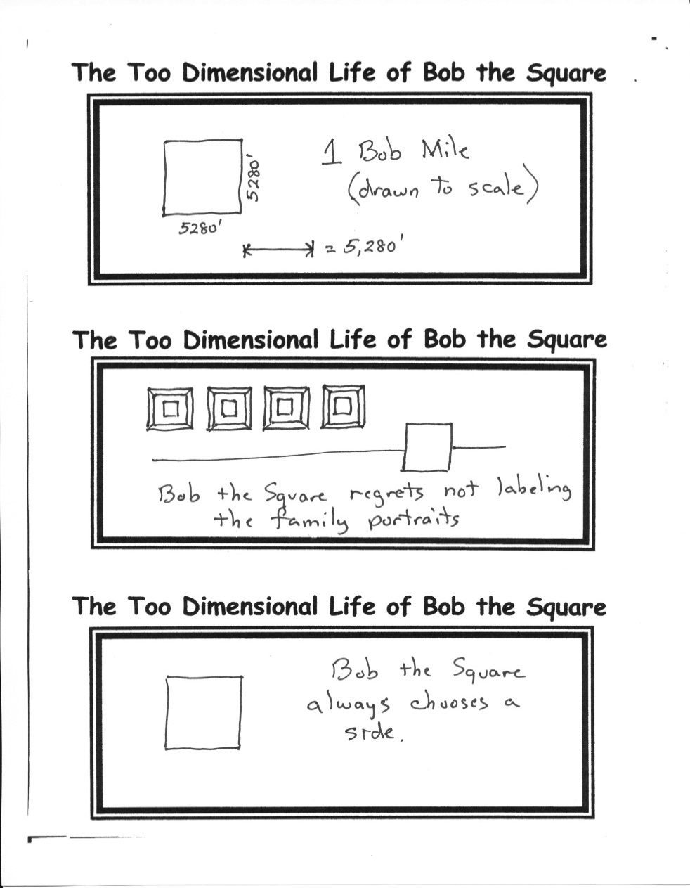

By Mr. Lyle (mrlyle1@gmail.com)

1. Thou shalt bring 2 million dollars in unmarked bills to the corner of 43rd and Jackson Streets….oops, wrong list!
2. Thou shalt bring a smile. If thou cans’t not find thine and thou hast left thine in a dumpster, then thou shalt return to that dumpster, and retrieve thy smile.
3. Thou shalt be breathing. And having brushed thy teeth this morning, verily it shall be minty fresh.
4. Thou shalt not poke thy neighbor in the eye lest he smite you on the nose.
5. Thou shalt not smite thy neighbor on the nose lest he kicketh hard against thy shin.
6. Thou shalt not kick hard against thy neighbor’s shin lest he poke thee in the eye.
7. Thou shalt have a good time, for verily verily I say unto thee; he that refuseth to have a good time shall be cast into the Lake of Fire… oops, wrong list again!