**December 30, 2012**

**Volume 1, Issue 15**

Sunday School Times

Published almost weekly, but more like…..whenever, so get used to it, OK?

# The “Forgotten” Character Trait

**By Mr. Lyle (mrlyle1@gmail.com**

***Stuff For Today***

• Enthusiasm defined

• Free advice you can take out into the world as you grow older.

• If you could use only four words to describe God, which four would you choose?

**New Year Resolutions for 2013**

1. I will not eat meat loaf this year.

2. I will not try to ski through a revolving door again.

3. I will not bake any cake recipe that tells me to beat eggs. Why! What did they do?

4. I will try to be good. Does being good at being stupid count?

5. I will optimize Murphy’s Law by using my computer.

6. I will be alert this year. The world needs more lerts.

7. I will drive more defensively this year. My M-1 Abrams tank arrives next week.

8. I will fill out my taxes this year in Roman Numerals.

9. I will fall behind earlier this year so I have more time to catch up.

10. I will be more patient this year. I sure hope it won’t take long!

***Isaiah 59:17***

*He put on righteousness as His breastplate,*

*and the helmet of salvation on His head;*

*He put on the garments of vengeance*

*and wrapped Himself in zeal as in a cloak.*

God is an incredible being. We struggle to understand Him. Bringing Him down to our level is to rob Him of His Majesty. God is infinite, and our human minds cannot comprehend that definition.

But God wants us to know Him in a very personal way. His love for us is amazing when you consider just what we are, compared to Him. His intense desire for us, His longing that we have the opportunity to have a relationship with Him, prompted this whole idea we call salvation.

Through the pages of His Word, the Bible, He gives us everything we need to know about Him and His character. In minute bits and pieces, each just small enough for us to grasp, He reveals His never-ending personality, His love.

Given the task of defining and explaining God, Isaiah, in chapter 59:17 is succinct, and perfectly so, for it was God the Holy Spirit who gave these words to be written for all to read.

In four words we find a description of God unmatched anywhere else in Scripture for its brevity, clarity, and balance. As we end 2012, we will look at this verse and be reminded of the awesomeness of the God who loves us!

**Enthusiasm: (noun)**

**Great Excitement For, or Interest in, Some Thing or a Cause**

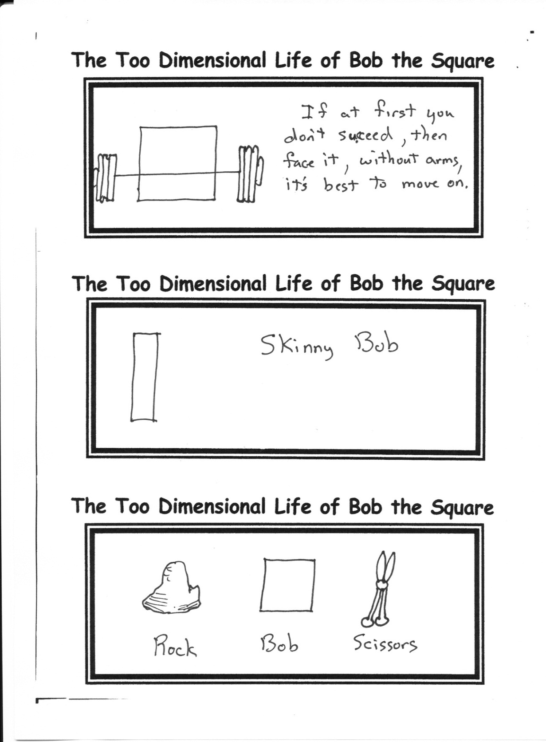

**My New Year Wish For You**

May you have the symptoms of goniochromism the entire year of 2013 and beyond!

1. Some of us get dipped in flat, some in satin, some in gloss....But every once in a while, you find someone who's iridescent, and when you do, nothing will ever compare.

2. I saw a little girl touch a big bug and shout, "I conquered my fear! YES!" and calmly walk away. I was inspired.

3. Success is the ability to go from one failure to another with no loss of enthusiasm.

4. One of the worst things that can be said about an individual is that they are “uncurious”.

By Mr. Lyle (mrlyle1@gmail.com)