**January 13, 2013**

**Volume 1, Issue 17**

Sunday School Times

Published almost weekly, but more like…..whenever, so get used to it, OK?

# The Most Incredible Word—EVER!

**By Mr. Lyle (mrlyle1@gmail.com**

***Stuff For Today***

• Recall Notice

• In The Bleachers

• The single most amazing word in the English language!

***John 3:16***

*For God so loved the world that He gave His only begotten Son, that whosoever believeth in Him, should not perish, but have everlasting life.*

Heaven is an amazing place. It already exists—God abides there with myriads of myriads of Heavenly beings. We as Christians look forward to a day when we will experience it firsthand.

However, it is out of our reach. We cannot get there by anything that we can accomplish. Were it not for the grace and love of God, we would all burn in Hell forever.

The promise of God is clear; only those who are saved shall be allowed to enter that magnificent place. And only God can save us from our immense problem with sin. Try as we might, it is useless to think that we could solve the issue of sin by ourselves.

On our very, very, very best day, doing our very, very, very, best thing, compared to God, my goodness, your goodness, is nothing.

The good news is that all sin can be forgiven. There is nothing so heinous that God is not able to erase the penalty.

Because of what Jesus accomplished, salvation is available to all who believe. Creation was finger work—delicate and intricate. Salvation is described as the strong arm of the Lord at work—powerful and amazing.

Eternal life in Heaven is an incomprehensible idea. God has set eternity in the hearts of men, but we struggle to understand it.

The Christian has been bought and paid for. The penalty for our sin has been met. We have been redeemed. That word infers freedom.

So what is the incredible word? Class time today will include a detailed introduction of the word Hoosumaber!

## **Important Recall Notice**

By Mr. Lyle (mrlyle1@gmail.com)

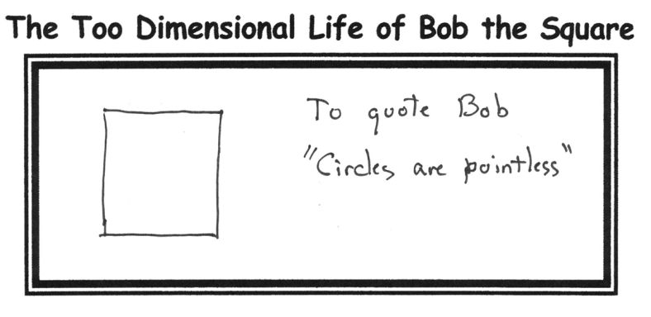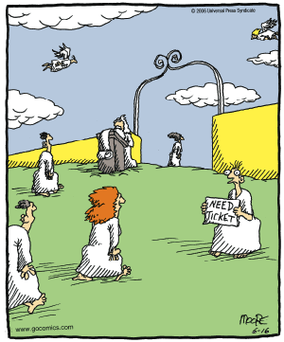

**Heaven**

The Maker of all human beings is recalling all units manufactured, regardless of make or year, due to a serious defect in the primary and central component of the heart. This is due to a malfunction in the original prototype units code named A.D.A.M. and E.V.E., resulting in the reproduction of the same defect in all subsequent units. This defect has been technically termed, “Sub-sequential Internal Non-morality”, or more commonly known as SIN as it is primarily expressed.

Some symptoms of this problem include: (a). Loss of direction, (b). Confusion of the mental component, (c). Amnesia of origin, (d). Foul vocal emissions, and ( e). Erratic, and self-destructive behaviors.

Please listen to the remainder of this notice as it is read in class.