**September 23, 2012**

**Volume 1, Issue 2**

Sunday School Times

Published almost weekly, but more like…..whenever, so get used to it, OK?

# Day Four Of Creation Is Incredible

**By Mr. Lyle (mrlyle1@gmail.com**

***Stuff For Today***

• A big change for Hammie the cat.

• Everything you always wanted to know about genetics, but were afraid to ask.

• How to build a scale model of the universe!

How big is the God you worship? A careful study of the creation story reveals a God of incredible power and majesty. Day 4 is my personal favorite.

***2 Peter 3:3-7***

***3****First of all, you must understand that in the last days scoffers will come, scoffing and following their own evil desires.****4****They will say, “Where is this ‘coming’ he promised? Ever since our fathers died, everything goes on as it has since the beginning of creation.”****5****But they deliberately forget that long ago by God’s word the heavens existed and the earth was formed out of water and by water.****6****By these waters also the world of that time was deluged and destroyed.****7****By the same word the present heavens and earth are reserved for fire, being kept for the day of judgment and destruction of ungodly men.*

***Genesis 1:1-19***

***1****In the beginning God created the heavens and the earth.****2****Now the earth was****[***[***a***](http://www.biblegateway.com/passage/?search=Genesis%201:1-19&version=NIV1984#fen-NIV1984-2a)***]****formless and empty, darkness was over the surface of the deep, and the Spirit of God was hovering over the waters.*

***3****And God said, “Let there be light,” and there was light.****4****God saw that the light was good, and he separated the light from the darkness.****5****God called the light “day,” and the darkness he called “night.” And there was evening, and there was morning—the first day.*

***6****And God said, “Let there be an expanse between the waters to separate water from water.”****7****So God made the expanse and separated the water under the expanse from the water above it. And it was so.****8****God called the expanse “sky.” And there was evening, and there was morning—the second day.*

***9****And God said, “Let the water under the sky be gathered to one place, and let dry ground appear.” And it was so.****10****God called the dry ground “land,” and the gathered waters he called “seas.” And God saw that it was good.*

***11****Then God said, “Let the land produce vegetation: seed-bearing plants and trees on the land that bear fruit with seed in it, according to their various kinds.” And it was so.****12****The land produced vegetation: plants bearing seed according to their kinds and trees bearing fruit with seed in it according to their kinds. And God saw that it was good.****13****And there was evening, and there was morning—the third day.*

***14****And God said, “Let there be lights in the expanse of the sky to separate the day from the night, and let them serve as signs to mark seasons and days and years,****15****and let them be lights in the expanse of the sky to give light on the earth.” And it was so.****16****God made two great lights—the greater light to govern the day and the lesser light to govern the night. He also made the stars.****17****God set them in the expanse of the sky to give light on the earth,****18****to govern the day and the night, and to separate light from darkness. And God saw that it was good.****19****And there was evening, and there was morning—the fourth day.*

## **HAMMIE DEVASTATED**

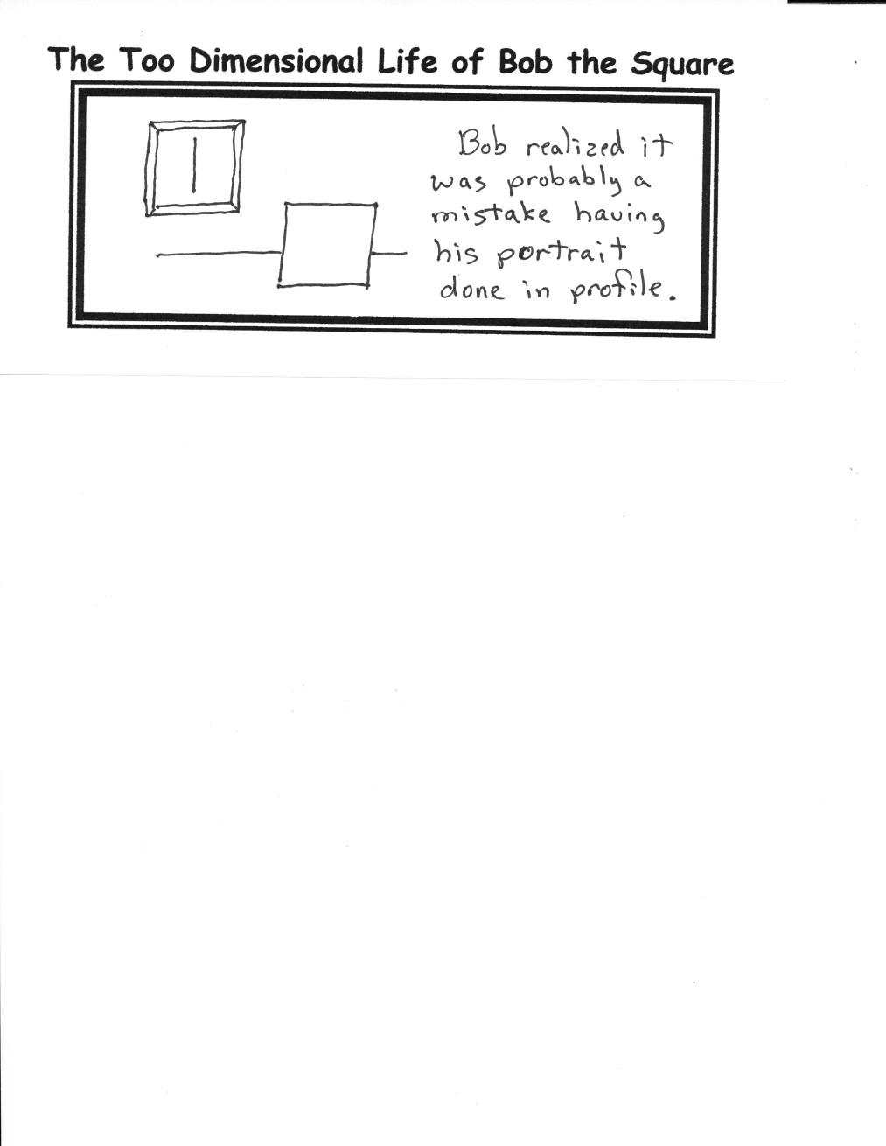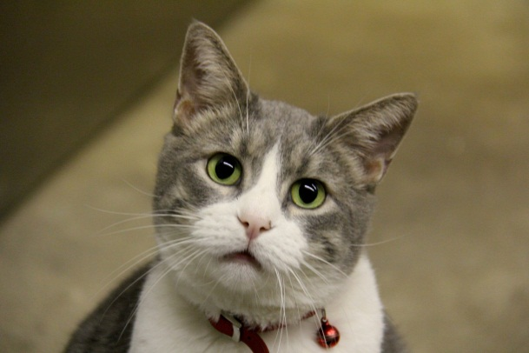

A search for a family tree takes a fascinating turn as a father submits a sample of his DNA to a scientific study. Genetic markers point in a direction absolutely no one expected! The story is worth listening to.

By Mr. Lyle (mrlyle1@gmail.com)

**DNA Test Results Back**

By Mr. Lyle (mrlyle1@gmail.com)

Hammie’s two best friends moved away Friday to live with their Person. The identical twin black kittens were affectionately known as the “Itty Bitty Kitty Committee” at the Ratzlaff household. Hammie was like a loveable, overweight uncle who looked after them. A very personable cat, his loneliness is quite apparent. Ms Jeanette has agreed to step in and show him some additional attention during this time of transition.