**March 3, 2013**

**Volume 1, Issue 24**

Sunday School Times

***Stuff For Today***

• H.o.r.s.e. and a UFO

• A little black and white bear breaks a primary law of physics.

• How to prove the un-provable.

Published almost weekly, but more like…..whenever, so get used to it, OK?

# Seeing Is Believing—Or Is It?

**By Mr. Lyle (mrlyle1@gmail.com**

***II Corinthians 5:7***

***We live by faith and not by sight.***

Taken in context, this verse refers to Heaven. Paul is talking to the Corinthian church about their ultimate future—where will Christians spend eternity? The truth of this verse, though, extends into all areas of the Christian walk.

So much of our Christianity is “unprovable” by the standards of the world. The culture we live in demands a reality check based upon the five physical senses: taste, touch, hearing, sight, and smell. The spiritual world, which is very real indeed, is not accessed by any of these senses. So the unsaved look at our belief system as foolishness.

For the Christian, the Bible must be seen as absolutely dependable. It does not just contain the Words of God—it is the Word of God! And if God is perfect, (He is, by the way), then His Word is also perfect.

Mankind, since the fall, has been separated from God by sin. I believe that Adam understood firsthand how incredibly awesome God actually is. The Bible says that Adam walked with God in the garden in the cool of the day. Have you ever wondered what God looks like—or sounds like—or feels like—or smells like? Adam knew.

Everything that we need to know about God is described in the Bible. We trust, we have faith that what God has said in His Word is true and unchanging. And what is even more amazing, He gives us the faith that we need to believe!

Will there at times be days of doubt? Yes, even some of the heroes of the Bible exhibited skepticism at times. Usually that uncertainty was a result of their physical senses. What they saw, and felt, and heard, and smelled overwhelmed the truth that they knew, deep down, was unchanging.

Learn to trust God implicitly. Don’t waste your life in pursuit of some physical evidence of God. Your five senses are not infallible. They are, in reality, quite easily deceived. Trust the Bible to be true, no matter what!

**A Portal To Another Dimension**

By Mr. Lyle (mrlyle1@gmail.com)

Some things even science fiction struggles to rationalize. Allow me explain as best I can.

The story is told of an ancient forest in a dark, uncharted region of Africa with trees unknown to science or the modern world. Legends tell us of peculiar things—strange things--that happen in the presence of the few remaining samples of this wood that have survived the millennia, carefully handed down from one generation to another.

It is said that a manuscript of extreme antiquity reveals that even the simplest box, built of this wood, defies all known laws of physics, and is proof itself of the existence of other dimensions.

After much careful study and research, and a bit of luck, I must have obtained some of this very lumber!

A simple box with a very odd characteristic—the stuff legends are made of!

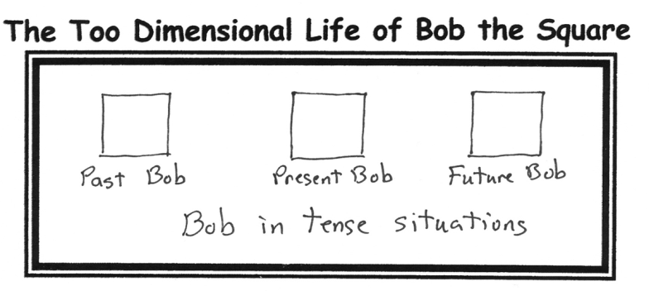

All kidding aside, the meal and dinner theatre this Friday night will be something that you will ALWAYS remember for the rest of your life. I experienced it for myself for the first time over 40 years ago when I was just a boy. It was one of those moments in time that I will cherish forever!

***The Most Masterfully Measured and Made Major Mouth Moving Main Meal Moment in March***

The single most incredibly fun evening is this Friday night.  **Do not miss this!** If you had to pick one thing to attend this year, this would be it! Why? 1. Guaranteed fun. 2. Guaranteed fun. 3. Guaranteed fun. 4. Guaranteed fun. 5. Just Because, that’s why!