**September 30, 2012**

**Volume 1, Issue 3**

Sunday School Times

Published almost weekly, but more like…..whenever, so get used to it, OK?

# Investigation Continues in Eden

***Stuff For Today***

• Monarch butterflies—the handiwork of God!

• Everything you always wanted to know about Tootsie Roll Pops.

• What kind of fruit tree could change the course of human history?

**By Mr. Lyle (mrlyle1@gmail.com)**

Accounts have surfaced of a snake in Eden that talks. Adam and Eve reportedly disobeyed a major command of God, and the consequences of that act are still with us today. Their claim was that the talking snake was somehow involved. In Genesis 3 we find an eye witness account of the events of that day..

***3****Now the serpent was more crafty than any of the wild animals the Lord God had made. He said to the woman, “Did God really say, ‘You must not eat from any tree in the garden’?”****2****The woman said to the serpent, “We may eat fruit from the trees in the garden,****3****but God did say, ‘You must not eat fruit from the tree that is in the middle of the garden, and you must not touch it, or you will die.’”* ***4****“You will not surely die,” the serpent said to the woman.****5****“For God knows that when you eat of it your eyes will be opened, and you will be like God, knowing good and evil.”* ***6****When the woman saw that the fruit of the tree was good for food and pleasing to the eye, and also desirable for gaining wisdom, she took some and ate it. She also gave some to her husband, who was with her, and he ate it.****7****Then the eyes of both of them were opened, and they realized they were naked; so they sewed fig leaves together and made coverings for themselves.* ***8****Then the man and his wife heard the sound of the Lord God as he was walking in the garden in the cool of the day, and they hid from the Lord God among the trees of the garden.****9****But the Lord God called to the man, “Where are you?”* ***10****He answered, “I heard you in the garden, and I was afraid because I was naked; so I hid.”* ***11****And he said, “Who told you that you were naked? Have you eaten from the tree that I commanded you not to eat from?”* ***12****The man said, “The woman you put here with me—she gave me some fruit from the tree, and I ate it.”* ***13****Then the Lord God said to the woman, “What is this you have done?” The woman said, “The serpent deceived me, and I ate.”* ***14****So the Lord God said to the serpent, “Because you have done this, “Cursed are you above all the livestock and all the wild animals! You will crawl on your belly and you will eat dust all the days of your life.* ***15****And I will put enmity between you and the woman, and between your offspring****[***[***a***](http://www.biblegateway.com/passage/?search=genesis%203&version=NIV1984#fen-NIV1984-71a)***]****and hers; he will crush****[***[***b***](http://www.biblegateway.com/passage/?search=genesis%203&version=NIV1984#fen-NIV1984-71b)***]****your head, and you will strike his heel.”* ***16****To the woman he said, “I will greatly increase your pains in childbearing; with pain you will give birth to children. Your desire will be for your husband, and he will rule over you.”* ***17****To Adam he said, “Because you listened to your wife and ate from the tree about which I commanded you, ‘You must not eat of it,’ “Cursed is the ground because of you; through painful toil you will eat of it all the days of your life.* ***18****It will produce thorns and thistles for you, and you will eat the plants of the field.* ***19****By the sweat of your brow you will eat your food until you return to the ground,  since from it you were taken; for dust you are and to dust you will return.”* ***20****Adam****[***[***c***](http://www.biblegateway.com/passage/?search=genesis%203&version=NIV1984#fen-NIV1984-76c)***]****named his wife Eve,****[[d](http://www.biblegateway.com/passage/?search=genesis%203&version=NIV1984" \l "fen-NIV1984-76d" \o "See footnote d)]****because she would become the mother of all the living.* ***21****The Lord God made garments of skin for Adam and his wife and clothed them.****22****And the Lord God said, “The man has now become like one of us, knowing good and evil. He must not be allowed to reach out his hand and take also from the tree of life and eat, and live forever.”****23****So the Lord God banished him from the Garden of Eden to work the ground from which he had been taken.****24****After he drove the man out, he placed on the east side****[***[***e***](http://www.biblegateway.com/passage/?search=genesis%203&version=NIV1984#fen-NIV1984-80e)***]****of the Garden of Eden cherubim and a flaming sword flashing back and forth to guard the way to the tree of life.*

In a related story, the Parable of the Good Samaritan, as it is commonly called, actually sheds light on the truth of what actually happened in Eden. Luke 10 says this

*.* ***25****On one occasion an expert in the law stood up to test Jesus. “Teacher,” he asked, “what must I do to inherit eternal life?”* ***6****“What is written in the Law?” he replied. “How do you read it?”* ***27****He answered: “‘Love the Lord your God with all your heart and with all your soul and with all your strength and with all your mind’****[***[***c***](http://www.biblegateway.com/passage/?search=luke%2010&version=NIV1984#fen-NIV1984-25383c)***]****; and, ‘Love your neighbor as yourself.’****[***[***d***](http://www.biblegateway.com/passage/?search=luke%2010&version=NIV1984#fen-NIV1984-25383d)***]****”* ***28****“You have answered correctly,” Jesus replied. “Do this and you will live.”* ***29****But he wanted to justify himself, so he asked Jesus, “And who is my neighbor?”* ***30****In reply Jesus said: “A man was going down from Jerusalem to Jericho, when he fell into the hands of robbers. They stripped him of his clothes, beat him and went away, leaving him half dead.****31****A priest happened to be going down the same road, and when he saw the man, he passed by on the other side.****32****So too, a Levite, when he came to the place and saw him, passed by on the other side.****33****But a Samaritan, as he traveled, came where the man was; and when he saw him, he took pity on him.****34****He went to him and bandaged his wounds, pouring on oil and wine. Then he put the man on his own donkey, took him to an inn and took care of him.****35****The next day he took out two silver coins****[***[***e***](http://www.biblegateway.com/passage/?search=luke%2010&version=NIV1984#fen-NIV1984-25391e)***]****and gave them to the innkeeper. ‘Look after him,’ he said, ‘and when I return, I will reimburse you for any extra expense you may have.’* ***36****“Which of these three do you think was a neighbor to the man who fell into the hands of robbers?”* ***37****The expert in the law replied, “The one who had mercy on him.” Jesus told him, “Go and do likewise.”*

## **Monarch Migration Expected to Peak This Week**

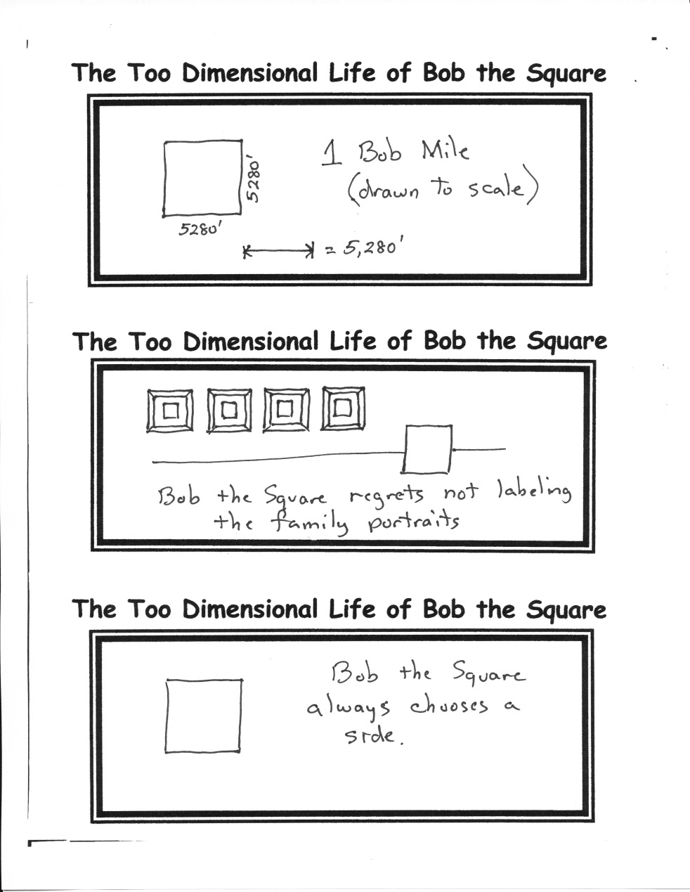

Do not miss **d-now 2012**! Coming this weekend to Russellville, this will be an excellent time to learn more about what it means to truly be a disciple of Jesus. Contact Brandon if you need more details.

By Mr. Lyle (mrlyle1@gmail.com)

**D-NOW 2012**

The annual migration of the Monarch butterfly has begun once again. A pasture in Pottsville has been a way stop for a large group each year. The bright yellow wild flowers growing there are a bit too difficult to resist, as they descend by the thousands to rest and feed. The migration should peak this week, although numbers are expected to be down.

By Mr. Lyle (mrlyle1@gmail.com)