**May 12, 2013**

**Volume 1, Issue 33**

Sunday School Times

***Stuff For Today***

• Happy Mommy’s Day!

• A special Mother’s Day Edition of SST

• Clint Eastwood--1966

Published almost weekly, but more like…..whenever, so get used to it, OK?

# The Good, The Bad, And The Ugly

**By Mr. Lyle (mrlyle1@gmail.com**

***Romans 16:13***

***Greet Rufus, chosen of the Lord, and his mother, who has been a mother to me, too.***

Though her name is never mentioned, and on the surface there seems to be nothing outstanding about her, this mother deserves a closer look. Mark 15:21 tells us that the man who carried the cross for Jesus, as He struggled towards Calvary, was the father of Rufus! His name was Simon, and he appears again in Acts 13:1 where we find that he was most probably a black skinned gentleman. Scripture hints that the entire family were pillars in the early church. Paul spent much time in Antioch where they lived, and most likely must have spent many hours with them and developed a close bond with this very special un-named lady. Paul called her “Mom”.

***II Kings 11:1 and 2***

***When Athaliah the mother of Ahaziah saw that her son was dead she proceeded to destroy the whole royal family. But Jehosheba, the daughter of King Jehoram, the sister of Ahaziah, took Joash son of Ahaziah and stole him away from among the royal princes who were about to be murdered. She put him and his nurse in a bedroom to hide him from Athaliah, so he was not killed.***

It is said that an acorn does not fall far from the tree. So was the case of Athaliah. The daughter of Ahab and Jezebel, she undoubtedly watched their godless, wicked lives and patterned her behavior in imitation. Politics has always created strange bedfellows, and in an effort to align the northern kingdom of Israel with the southern kingdom, Judah, she married into the family line governing Judah. Her true character came to the forefront when her son, the king of Judah, was assassinated. Instead of seeking justice or mourning appropriately, her first instinct was to ensure her place as queen as she proceeded to murder every young boy in the family line of David. We shudder as we attempt to imagine what kind of animal would do such a thing, even putting to death her own grandchildren. It would be wise to remind ourselves at this point that there was a spiritual battle being fought here as well. Satan knew of the promise God had made to David about a man on his throne forever, and this was just another attempt to foil and spoil the plan of God. It failed in its intent. One boy slipped by under the radar and survived, having been kept hidden for six years from the bloody Athaliah.

***Genesis 29:16 and 17***

***Now Laban had two daughters; the name of the older was Leah, and the name of the younger was Rachel. Leah had weak eyes, but Rachel was lovely in form, and beautiful.***

I have looked at this passage in the original language and have come to understand that the phrase “weak eyes” probably was a nice way of saying that this young lady was not very attractive. Her daddy had to trick someone into marrying her! As a mother, she lacked something. The Bible records HUGE problems with all four of her boys. After they were grown, two of them murdered every man in an entire city, and stole all of their wealth, one was guilty of sleeping with his step mother, and one was guilty of sleeping with his daughter-in-law! Someone failed in raising those boys. The father was not exempt from blame, to be sure, but, clearly, Mom failed too.

**A Very Touching Mother’s Day Story**

By Mr. Lyle (mrlyle1@gmail.com)

Three sons left home, went out on their own and prospered.  
Getting back together, they discussed the gifts they were  
able to give their elderly mother.  
  
 The first said, "I built a big house for our mother.”

The second said," I sent her a Mercedes with a driver."

The third smiled and said, "I've got you, both beat. You  
know how Mom enjoys the Bible, and you know she can't see  
very well. I sent her a parrot that can recite the entire  
Bible. It took 20 monks in a monastery 12 years to teach  
him. I had to pledge to contribute $100,000.00 a year for 10  
years, but it was worth it. Mom just has to name the chapter  
and verse, and the parrot will recite it."

Soon thereafter, Mom sent out her letters of thanks:  
"Marlon," she wrote the first son, "the house you built is  
so huge. I live in only one room, but I have to clean the  
whole house."

"Marvin," she wrote to another, "I am too old to travel. I  
stay home all the time, so I never use the Mercedes. And the  
driver is so rude!"

"Dearest Melvin," she wrote to her third son, "You were the  
only son to have the good sense to know what your mother  
likes. That chicken was delicious."

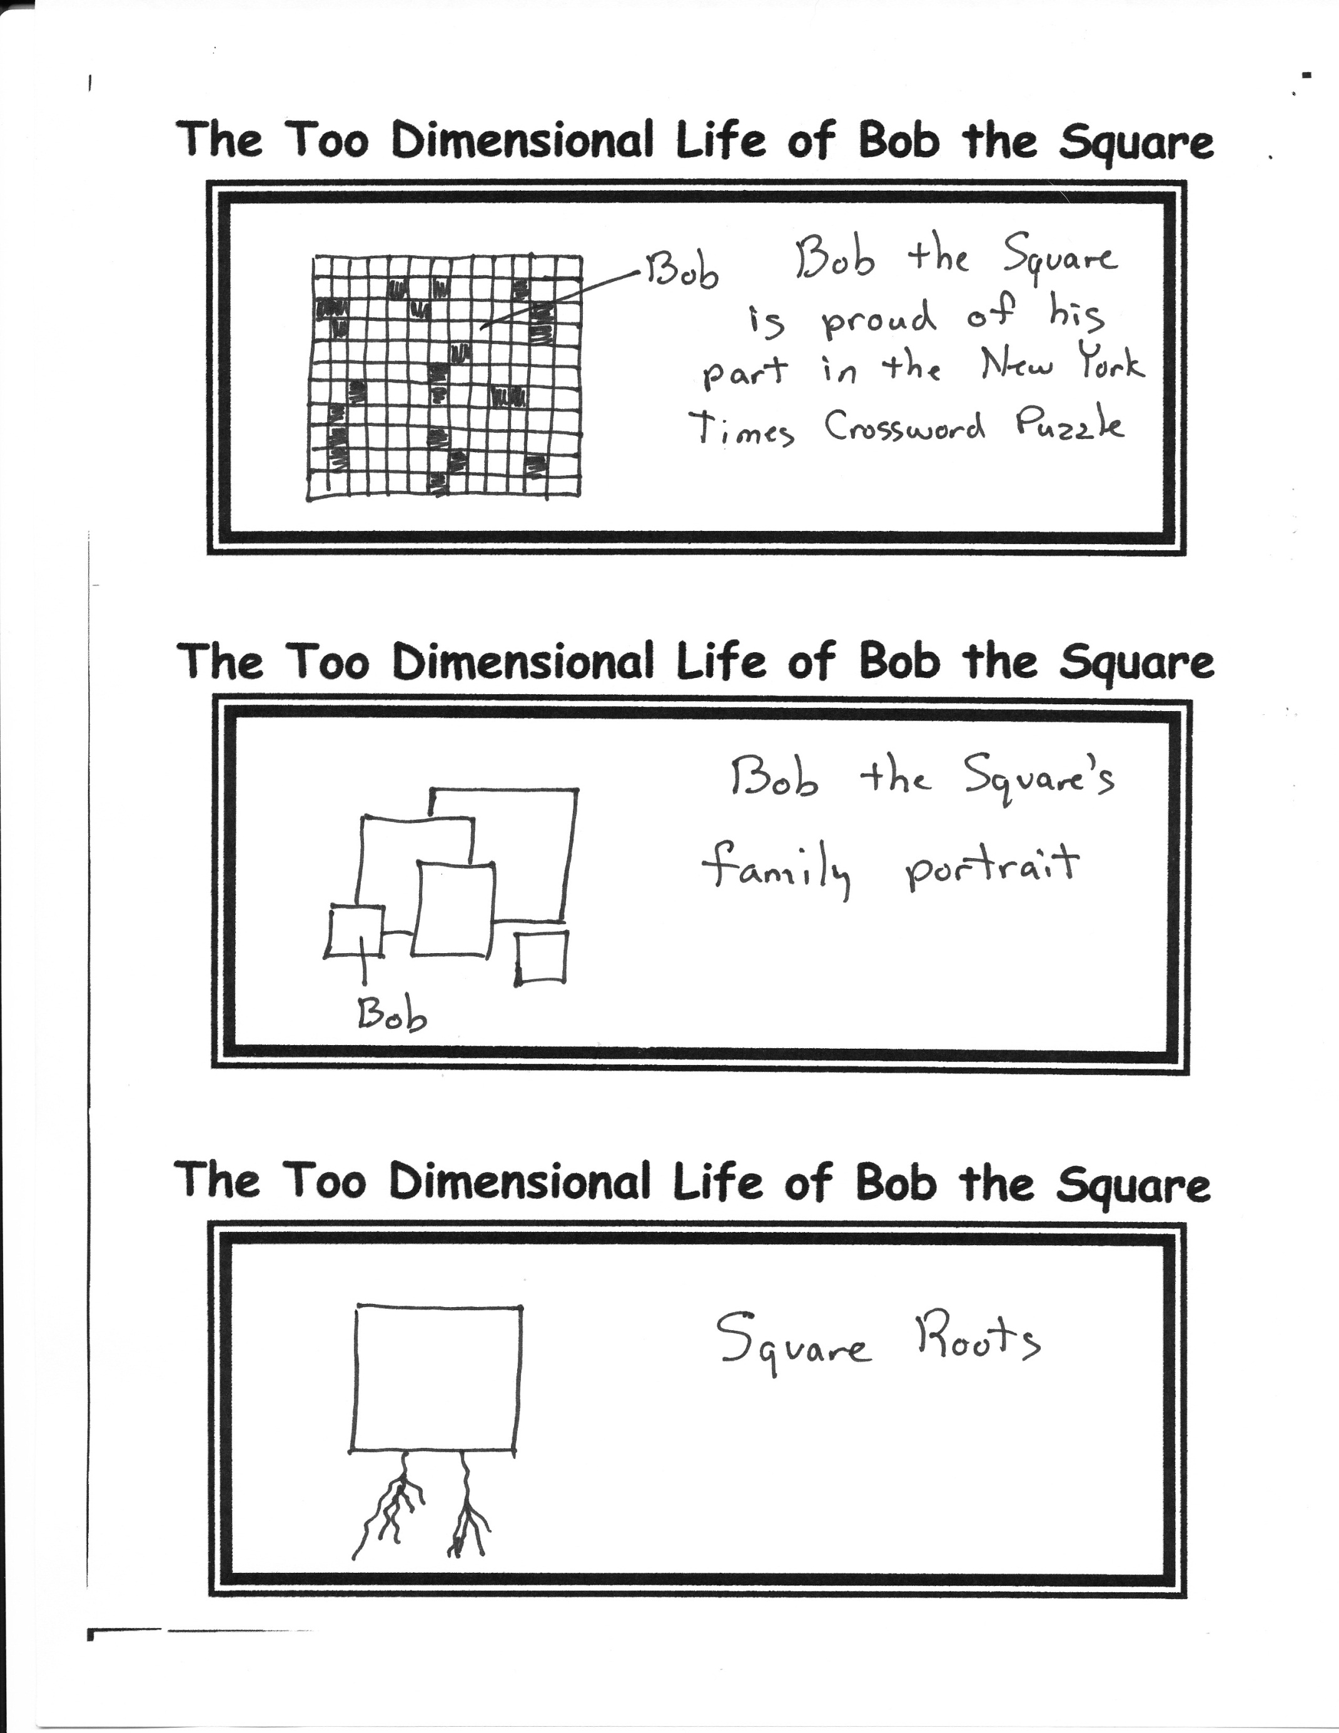

***Observation:*** Mary was the mother of Jesus

***Consideration:*** Jesus is the Lamb of God

***Deduction:*** Mary REALLY DID have a little lamb!

**A Quote From Mr. Wilbur F. Human (When He met someone that he didn’t particularly like)**

“I’ll bet your mama didn’t even like you!”

(Bob’s Mom)

**A Precious Mom’s Day Poem**

Mom, I know you do the dishes

And I know you cook the food.

I know you scrub the floors

Even when you’re in a bad mood.

And every night you walk the dog

While I’m watching all my shows.

On Thursdays you take out the trash

And you clean and wash the windows.

You always do my laundry,

And always make my bed.

You let me sleep late every day

And play video games instead.

Mom, I know you’re sad I’ll go someday

And leave you all alone.

But right now I’m only 38

And I really like it here at home