**June 30, 2013**

**Volume 1, Issue 38**

Sunday School Times

***Stuff For Today***

• The truth about Captain Crunch

• ourundergroundhome.com

* The founding of the USA

Published almost weekly, but more like…..whenever, so get used to it, OK?

# The 56 Who Signed

**By Mr. Lyle (mrlyle1@gmail.com**

***Isaiah 33:22***

***For the Lord is our judge, the Lord is our lawgiver, the Lord is our king; it is he who will save us.***

On July 4th, 1776, the Declaration Of Independence was adopted. The vote was taken from north to south by colonies, as was the custom. There was no fanfare, no trumpets, no one stood up on his chair and cheered. For several hours, they worked on, dealing with other pressing problems before adjourning for the day.

What kind of men were the 56 signers who adopted the Declaration of Independence and who, by signing, committed an act of treason against the crown? To many, the names Franklin, Adams, Hancock, and Jefferson are almost as familiar as household words. Most of us, however, know nothing of the other signers. Who were they? What happened to them?

You may be somewhat surprised at the names you will not find there: George Washington, Alexander Hamilton, and Patrick Henry. They were all elsewhere that day.

Ben Franklin was the only really old man. 18 were under 40; 3 were in their 20’s. Of the 56, almost half—24—were lawyers and judges. 11 were merchants, 9 were landowners and farmers, and the remaining 12 were doctors, ministers, and politicians.

With only a few exceptions, these were men of substantial property. All but 2 had families—one had 18 children. The vast majority were men of education and standing in their communities. They had economic security as few men had in the 18th century.

Each had more to lose from revolution than he had to gain by it. John Hancock, one of the richest men in America, already had a price of 500 pounds on his head. He signed in enormous letters so that his Majesty could read his name without glasses and could now double the reward.

These men knew what they risked. The penalty for treason was death by hanging. And remember, a great British fleet was already anchored in New York harbor.

It was principle, not property, that brought these men to Philadelphia. Though the resolution was formally adopted on July 4th, it was not until August 2nd that they actually penned their name on the document.

Even before the list was published, the British marked down every member of Congress suspected of having put his name to treason. All of them became the objects of vicious manhunts. Some were taken. Some, like Jefferson, had narrow escapes. All who had property or families near British strongholds suffered.

Do not miss the last line of this amazing document: “And for the support of this Declaration with a firm reliance on the protection of divine Providence, we mutually pledge to each other our lives, our fortunes, and our sacred honor.”

**The Truth Is Finally Exposed!**

By Mr. Lyle (mrlyle1@gmail.com)

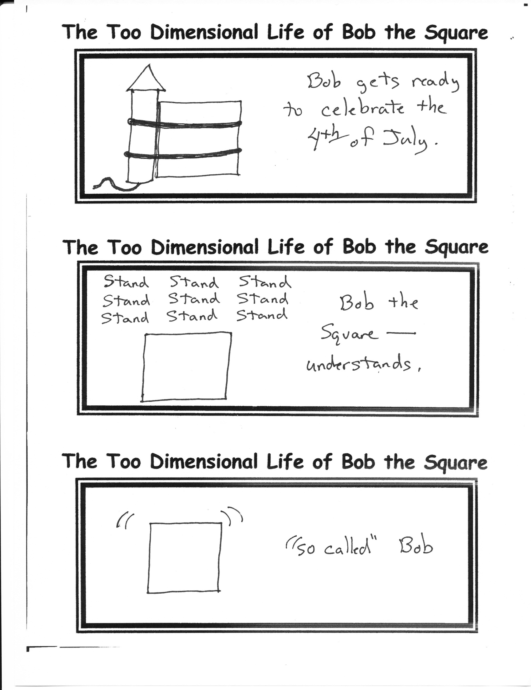

**There is nothing to print here, so move on along please.**

**ourundergroundhome.com**

**Website Launched**

Captain Crunch cereal was introduced in 1963. Horatio Magellan Crunch has “captained” his ship now for 50 years.

A careful observation of the familiar picture on the box reveals a sinister problem. Note the number of stripes on his sleeve—3. A real captain’s uniform has 4 stripes. The “Captain” is actually only a commander.

How much longer will the “Captain” continue his charade? No one knows, but I for one am disappointed, and feel betrayed.