**August 11, 2013**

**Volume 1, Issue 43**

Sunday School Times

***Stuff For Today***

• Graduation Ceremony

• Parting Gifts

* Hasta La Vista Baby

Published almost weekly, but more like…..whenever, so get used to it, OK?

# Another Year Gone

**By Mr. Lyle (mrlyle1@gmail.com**

***Psalm 119:105***

***Thy Word is a lamp unto my feet and a light to my path always.***

To the departing seventh graders we bid farewell. Another year has passed and life continues. I trust that as you continue to grow and mature that you will always remember bits and pieces of what you have been taught here in this Sunday School class. I consider it a great honor to have had the opportunity to stand in front of all of you each Sunday.

I thought it might be fun to remember our year together. See how many of the lessons you can recall. In order:

1. An Olympic diving documentary and an up side down testimony picture.

2. A scale model of the universe and a needle through the arm.

3. Do not eat the Tootsie Roll Pops!

4. The Pineapple Story.

5. The technical definitions of the word “free”.

6. Frying bacon.

7. Are you a moose?

8. The 600 year story.

9. A Kroger Christmas.

10. Isaiah 59:17

11. A card trick looking for a perfect heart.

12. Hoosumaber.

13. The Real Estate Deal.

14. Leprosy, forgiveness and a paper cutter.

15. Mr. Lyle Bowl XIII.

16. The Golden Lampstand.

17. Adam to Noah timeline.

18. Hacking Agag to pieces.

19. The Tater collection.

20. Chocolate covered marshmallows.

21. A wooden box portal into another dimension.

22. Picking the lamb on Palm Sunday

23. Balancing a brick on the end of some long pipes.

24. The checkerboard illusion.

25. The picture of garbage.

26. The Happy Hippy Hippo Hunters.

27. The kidnapper trial.

28. The story of Ed.

29. Sincerely yours.

30. Beach in a bottle.

31. The chisel skit.

32. And many, many other things.

**How to Say Goodbye Without Actually Saying Goodbye**

**Graduation Program**

Welcome and Prayer

Pomp and Circumstances beyond our control

Address by Class Valasalutadictatorian

Magnanimous

Canunimous

Laudinum

The Reading of the Sunday School Times

Presentation of Diplomas and Various Other Unsundry Items

Closing Prayer

You’re Outa Here!

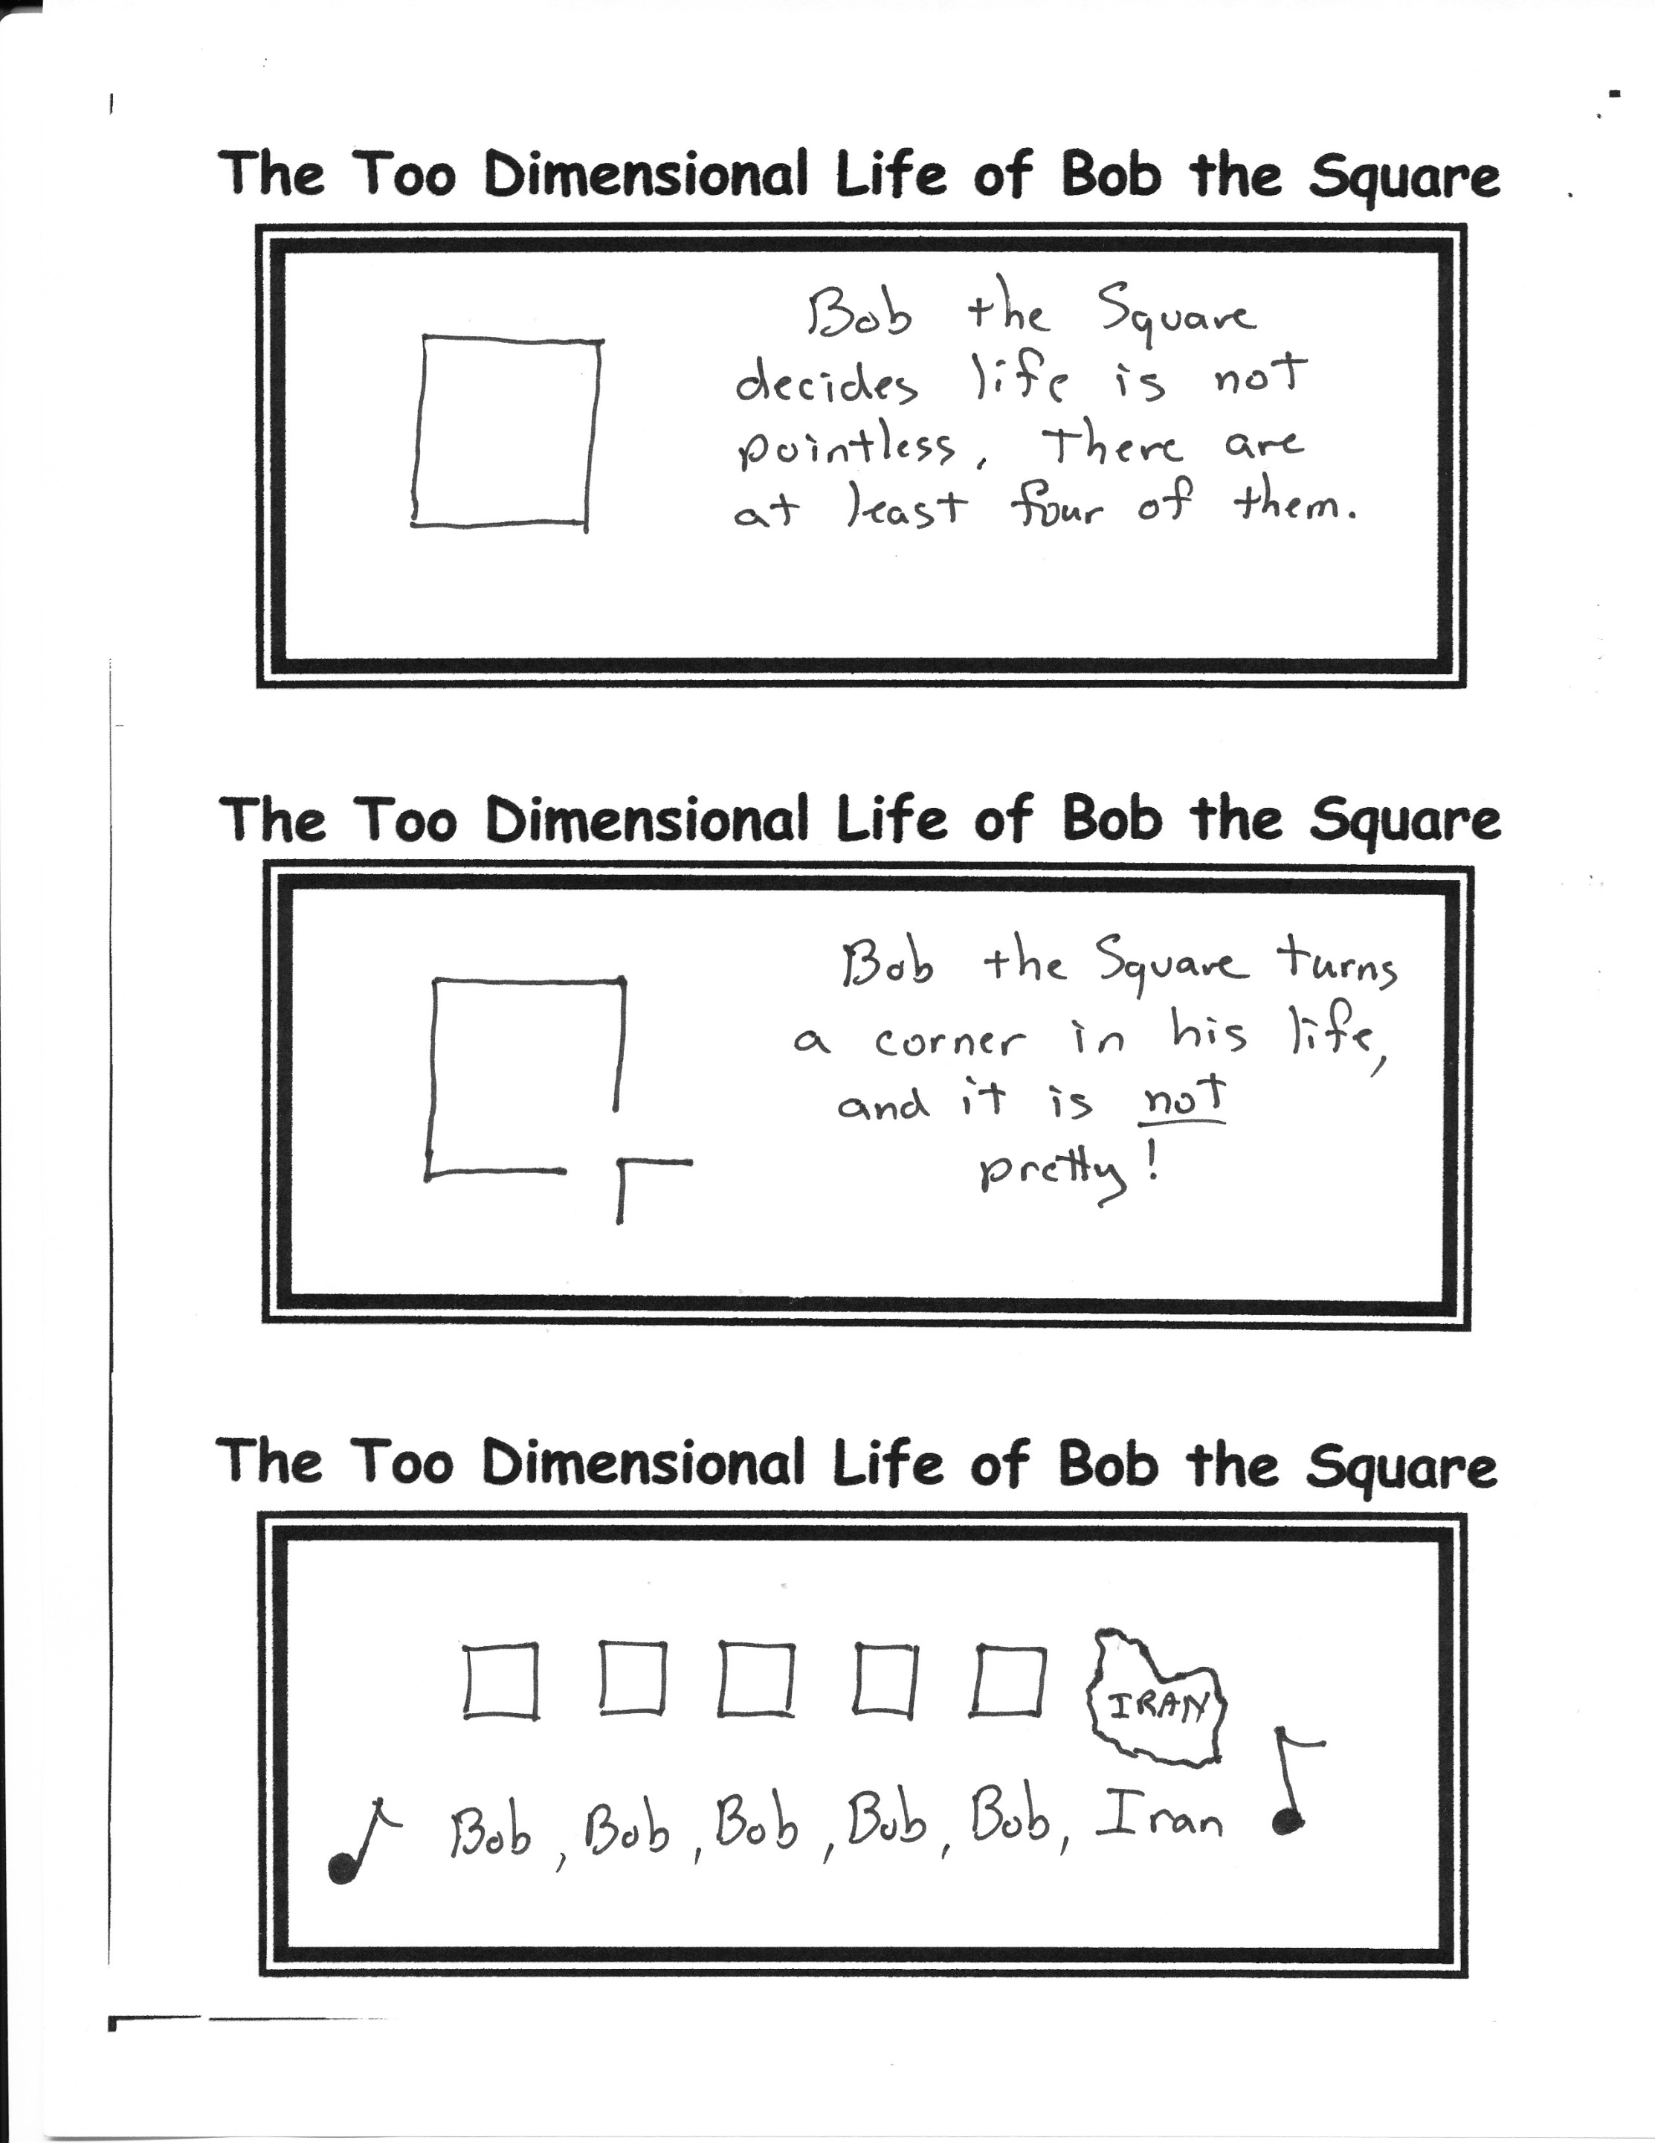

By Mr. Lyle (mrlyle1@gmail.com)

1. Cheerio

2. Toodle-oo

3. See ya later alligator

4. Take care

5. Take it easy

6. I need to scoot

7. Later, dude

8. See ya

9. See ya (wouldn’t wanna be ya)

10. Hold the fort down

11. Adios amigos

12. Gotta split

13. Catcha lataaa

14. Yo

15. Let us hope that before our next meeting humanity escapes extinction.