**The Eleventh Month, the Fourth Day, Anno Domini 2012**

**Volume 1, Issue 9**

Sunday School Times

(Technical Edition)

***Exactness in relation to this 24 hour period of time:***

• Maternal Anser

• The Paternally Oriented Invocation

• Interrogative Query and Rejoining Sedulity

Published almost weekly, but more like…..exactly now, so get used to it, OK?

# Technically the Seigeur Rogation

**Transmorgrafied By Mr. Lyle (mrlyle1@gmail.com**

Paternal relative associated with us, established in a celestial position. The designation assigned to your person is inviolable. Hasten the appearance of the sovereign theocracy retained by you. Your expressed intensions and purpose be realized similarly upon this sublunary macrocosm as the extra-terrestrial commorancy. Bequeath upon us diurnally circadian triticum comestibles. Exculpate incumbrances as we exculpate conditional liabilities obligated toward us. Cease inveiglement resulting in inducement, but emancipate us from perdition. For you possess sovereign monarchial disposition, dynamic efficacy, and eminent illustriousness in perpetuity. So be it.

**Technically Maternal *Anser***

A trio of rodents of the species *Mus Muscula* suffering from acute ablepsia.

A trio of rodents of the species *Mus Muscula* suffering from acute ablepsia.

Observe the peculiar manner in which they ambulate!

Observe the peculiar manner in which they ambulate!

The entire group, with one accord, pursued the agricultural engineer’s spouse.

She, in turn, retaliated both quickly and effectively by amputating their posterior appendages with a large blade typically used in cleaving the muscle tissue of animals which have been prepared for ingestion by cooking.

In all your existence, have you observed such erratic behavior as that just described, as

A trio of rodents of the species *Mus Muscula suffering from acute ablepsia.*

## **Scriven Solicitations Persist, Induce Subsequent Elucidation**

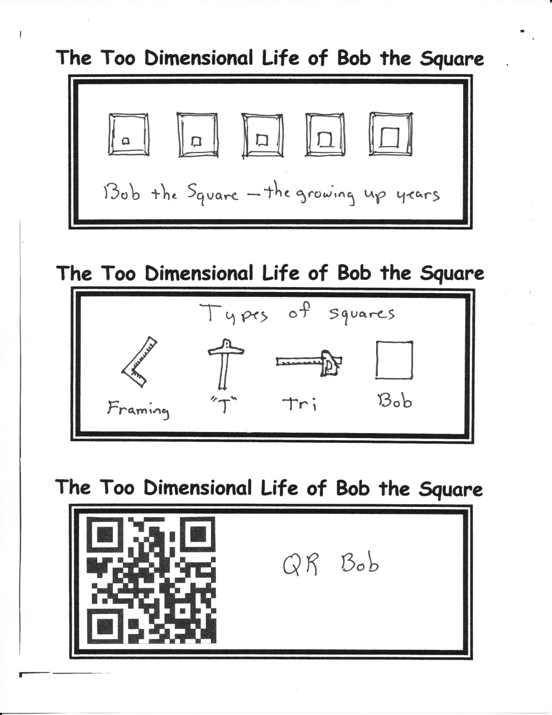

**Definition of the word *Technical****:*

1. Of or relating to a particular subject, art, or craft, or its techniques:

We will persevere concurrently with our designed interrogative procedure. Those who excogitate previous class times will educe recollections of last week.

Critics acclaimed it:

*The vingean stited oveltel was pathinsonal. As well the dilopedelving continued to be serand and moperfoint. We can only hope for a more or less borrinously taciticsal and expanoratory galance.*

By Mr. Lyle (mrlyle1@gmail.com)