**February 2, 2014**

**Volume 2, Issue 20**

Sunday School Times

Published almost weekly, but more like…..whenever, so get used to it, OK?

# Game Day 2014

***Stuff For Today***

• Wait, Wait, Let Me Guess!

• Spiritual Salad

* Recipe
* The Game

**By Mr. Lyle (mrlyle1@gmail.com**

***John 3:16***

***For God so loved the world that He gave His only begotten Son, that whosoever believeth in Him, should not perish, but have everlasting life.***

***Official Rules***

The game begins with the participant standing at the beginning line with their toes touching the line but not completely covering it. Hands shall be held down at the side, but not tight against the body. A bend in the elbow is allowed to a maximum of 15 degrees. Once movement has begun, swing of the arms is allowed but shall not be so noticeable as to distract from the other processes of the game. Should the referee feel the arm movement to be a showy display of unsportsmanlike conduct, the turn shall be forfeited. Each time a potential participant shall attempt a traverse of the course, they shall begin with placing the right foot forward first. They shall then pull that same foot back for exactly 2 seconds, not allowing it to touch the floor. It shall be held up off the floor for that 2 second interval at a regulation height of 6 inches. The same foot may then be placed firmly down in front of said participant. If an alternate foot, namely the right foot is chosen as an option, the entire process must be completed in the afore mentioned details, but with the opposite foot being used. This process may be used a third time, but the 6 second time limit will come into bearing by then and is probably not a good strategy anyway, so it is not recommended that it even be tried. The eyes of the participant must be open, looking straight forward. Glancing around is expressly prohibited, as is any direct or indirect communication from the participant to his or her team mates. They may direct their words of encouragement and suggestions to the participant, but in no way are they allowed to physically touch the participant. No smile shall be allowed at this point in the procedure. Humming of a song is allowed, but it must be a song that everyone else knows. Should a song be hummed that is not know by everyone, a penalty shall be assessed by the judge. If this entire procedure is not accomplished in a minimum of 6 seconds, a delay of game penalty may be assessed by the referee at his discretion. Penalties may not be questioned by any participants, ever! If any quarrels do arise due to the participant not being aware of this rule, another penalty may be assessed by the referee. Once the initial step, namely the afore mentioned placement of the first foot onto the carpet, has been achieved, the participant must stand still, cross both arms, and loudly proclaim the those that are watching the proceedings these exact words: “Ma Ma Ooga Ooga Ma Ma”. This procedure constitutes the first step and it’s appropriate regulations as prescribed by the official who is the inventor of this magnificent event.

The second step is now going to be addressed. The second step may be taken backwards if so desired. But if taken, it must be done in exactly the same method as the first step, but in opposite order. Starting with the “Ma Ma Ooga Ooga Ma Ma” statement, all the way to standing with the toes aligned on the starting line. While this process is allowed, it serves only as a process whereby to confuse the other teams in the competition, and is therefore considered a method of strategy. A forward step strategy must follow the following prescribed order of events. The left foot is now to be considered. The participant must at this point stop for a moment and carefully perform each of the required elements. After clearing of the throat, arms must be raised, with hands placed under the armpits. A ritual flapping should immediately begin, with arms rising to at least a horizontal position in the upward movement. This shall be known as the “Chicken Tribute”. A “Chicken Tribute” must be done with flamboyant gestures, clucking and bobbing of the head in a chicken pecking fashion. If the referee is not satisfied that the “Chicken Tribute”, it must be done again until done correctly, or the game participant will forfeit their turn, and return to the starting line and begin again from the beginning, because that is the appropriate place to begin again. Once the “Chicken Tribute” has been successfully performed, the right foot may now be placed into movement. In a very quick jerk, the left foot must be moved from the starting line, but at no time may it be raised any higher than 3 inches from the floor. The foot may be placed next to the already placed right foot. If this is the chosen placement, the participant must stand at attention with arms to their side and sing one verse of Yankee Doodle Dandy. The rest of the team still standing and watching the events that are transpiring must clap and cheer for the magnificent rendition of this American classic. These cheers shall be no less than 5 seconds in length and no more than 10 seconds in length. The second option available to the participant is that they may choose to indeed put the left foot down ahead of the already placed right foot. This results in obvious increased travel on the course of competition, and also has requirements to be allowed to remain valid. Once the left foot has been placed in the down position, balance shall be checked, and once checked, the following course of events must transpire. First, there shall be a smile on the face of said participant. The participant must then crow like a rooster. This must be done with gusto and exuberance. The referee is the sole consideration of this part of the process. Should the referee feel that the requirements have not been met to assigned levels of expertise, the move shall be forfeited. Once the rooster crow has been successfully completed, the “Chicken Tribute” must be completely performed to the afore mentioned details. If properly performed, the participant shall be allowed to hold their position and prepare for their next step.

And that, ladies and gentlemen, is just rules 1 and 2 (of 150). An incredibly complex game, winning is nearly impossible. The level of expertise and perfection required to traverse the field and succeed is non-negotiable. No regular player has ever even come close to winning. Many try and fail. The referee is demanding, and rightly so—he invented the game with it’s magnificent rules. Yes, I said “magnificent” rules.

For anyone brave enough to read through the entire rule book, there is an amazing solution available. A careful study of rule number 150 reveals that, if requested and accepted by the player, a substitute furnished by the referee can and will traverse the field perfectly, and thus win the game for all players. You can win this impossible game, but not by yourself!

God has a game for us to play—life. And it is incredibly difficult to win because He demands perfection. Luckily for us, He knew we would have a problem succeeding on our own and furnished a substitute, Jesus Christ, who came to this earth and lived a perfect life, so that, if we accept Him as our savior, we can have eternal life in Heaven. Are you still trying to play the game on your own?

**A Spiritual Salad**

By Mr. Lyle (mrlyle1@gmail.com)

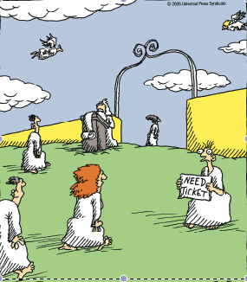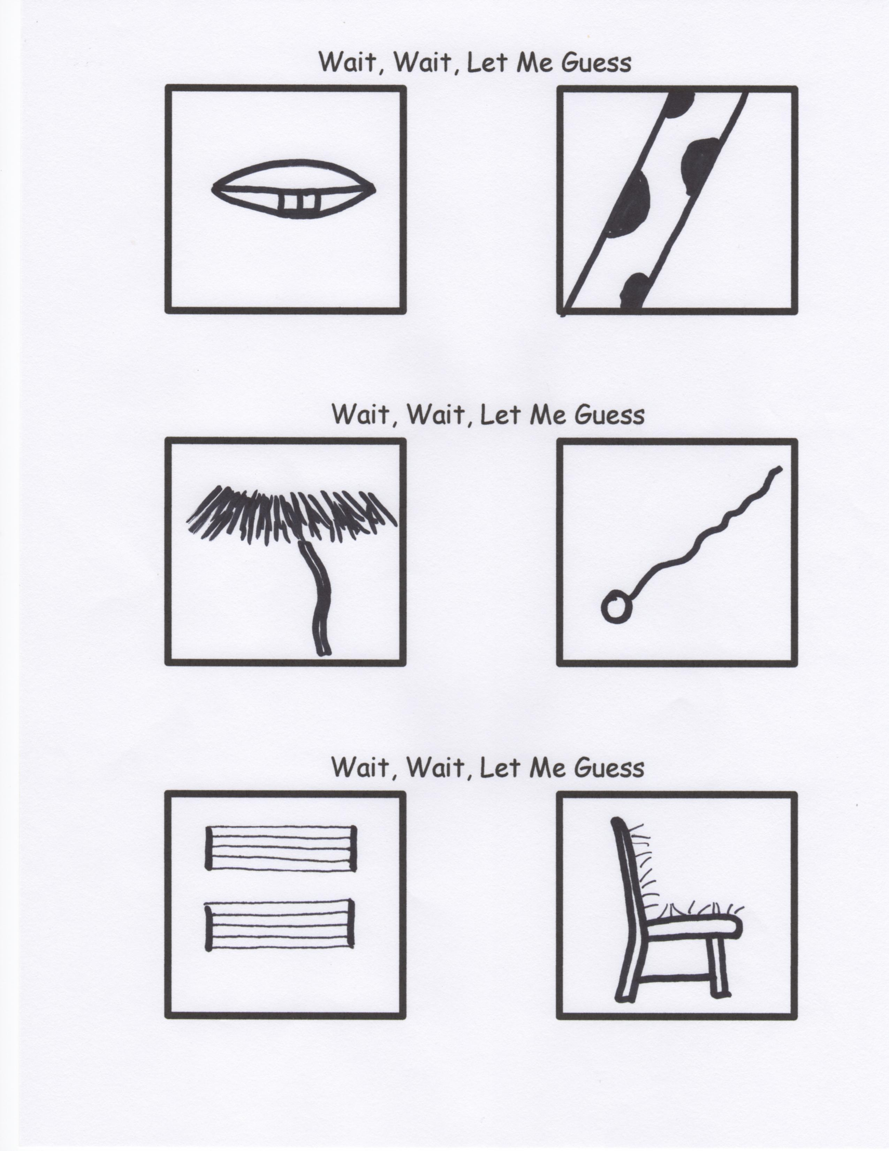

**A Favorite Family Recipe**

***Iced Water***

**Ingredients:**

2 cups tap water

1 cup bottled water

Place one cup of tap water in a mixing bowl. Gently add one cup of bottled water. Whisk briskly until thoroughly mixed. Pour into pre-heated sauce pan. Place over high heat until ingredients begin to bubble. Fold in remaining one cup of tap water. Heat and stir frequently until mixture reaches a full boil. Remove from heat and allow to cool for 30 minutes.

After mixture is cooled to room temperature, pour entire contents into a metal mixing bowl and chill in a refrigerator overnight. The next day, portions may then be poured into individual drinking glasses.

Serving Suggestions: Place five cubes of ice in the bottom of each glass. Gently drizzle cooled liquid over the ice and fill cup to brim.

Makes three servings.

**Romans 13:12**—LET US cast off the works of darkness

**Romans 13:13**—LET US walk honestly

**Romans 14:13**—LET US not therefore judge one another any more

**Romans 14:19**—LET US therefore follow after the things which make for peace

**2 Corinthians 7:1**—LET US cleanse ourselves from all filthiness

**Galatians 5:25**—LET US walk in the Spirit

**Galatians 5:26**—LET US not be desirous of vainglory

**Galatians 6:9**—LET US not be weary in well doing

**Galatians 6:10**—LET US do good unto all men

**I John 4:7**—LET US love one another

**There Will Be No Extra Tickets Available At The Gate Of Heaven!**

**Just a thought:**

Have A Day!