**February 9, 2014**

**Volume 2, Issue 21**

Sunday School Times

Published almost weekly, but more like…..whenever, so get used to it, OK?

# Reveal Another Terrific Zero

***Stuff For Today***

• Wait, Wait, Let Me Guess!

• A Valentine

* A Valentine ruined
* RATZ

**By Mr. Lyle (mrlyle1@gmail.com**

***I Corinthians 13***

**Though** I speak with the tongues of men and of angels, and have not charity, I am become as sounding brass, or a tinkling cymbal. **2**And **though** I have the gift of prophecy, and understand all mysteries, and all knowledge; and **though** I have all faith, so that I could remove mountains, and have not charity, I am nothing. **3**And **though** I bestow all my goods to feed the poor, and **though** I give my body to be burned, and have not charity, it profiteth me nothing. **4**Charity suffereth long, and is kind; charity envieth not; charity vaunteth not itself, is not puffed up, **5**Doth not behave itself unseemly, seeketh not her own, is not easily provoked, thinketh no evil; **6**Rejoiceth not in iniquity, but rejoiceth in the truth; **7**Beareth all things, believeth all things, hopeth all things, endureth all things. **8**Charity never faileth: but whether there be prophecies, they shall fail; whether there be tongues, they shall cease; whether there be knowledge, it shall vanish away. **9**For we know in part, and we prophesy in part. **10**But when that which is perfect is come, then that which is in part shall be done away. **11**When I was a child, I spake as a child, I understood as a child, I thought as a child: but when I became a man, I put away childish things. **12**For now we see through a glass, darkly; but then face to face: now I know in part; but then shall I know even as also I am known. **13**And now abideth faith, hope, charity, these three; but the greatest of these is charity.

During the 1960’s and 70’s one of the more popular daytime TV shows was a game show called “Let’s Make a Deal”. The host, Monty Hall, would make “deals” with contestants. Generally he would give a participant a small token prize to begin with, like some cash money. He would then offer them a trade. They could keep

what they already had, or they could trade it for some unknown item behind a door or curtain. Many times the trade might result in an appliance or even a car. Other times, a donkey, or a pile of straw bales, or a junked 1959 Desoto might be lurking there. Always though, it was great entertainment watching people make their choices, never knowing what to expect.

Our game this morning is patterned after that TV show. It is fast paced, and great fun. Choices will be made. And one important thought will come out of it all.

The single most important thing in the world is LOVE. All that we do or say must be predicated on the idea that love is the reason behind our actions. The culture that we live in is convinced that love is an emotion—a feeling. It is far more than a soft, fuzzy feeling for someone. Love is an action.

John 3:16 may well be the most memorized verse in the Bible. For some, the most important word may be *whosoever*—salvation is available to anyone. Others may focus upon *He gave—*and the idea that salvation is a free gift. Still others may say that our eternal destiny is the most critical factor.

Consider this one thought. Why did God do this? Why did He send His Son? Could He not have found a suitable solution in another way? After all, He is God, isn’t He?

Romans 5:8 puts it quite clearly. It is all about love. The most grand, amazing, astonishing display of the genuine love of God is that He allowed Himself to be crucified on a cross for worms like us! It was a demonstration for the whole universe to see.

**Excuse Me, But May I Ruin Your Valentine’s Day?**

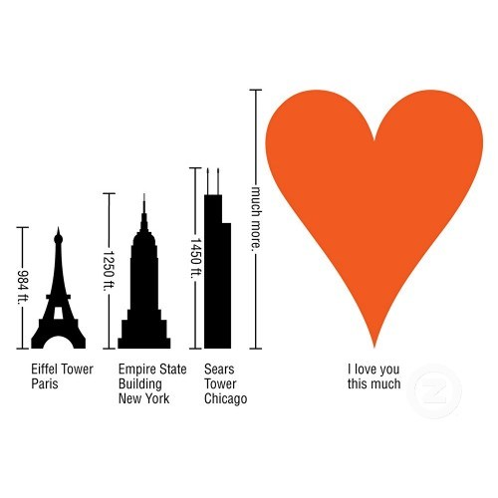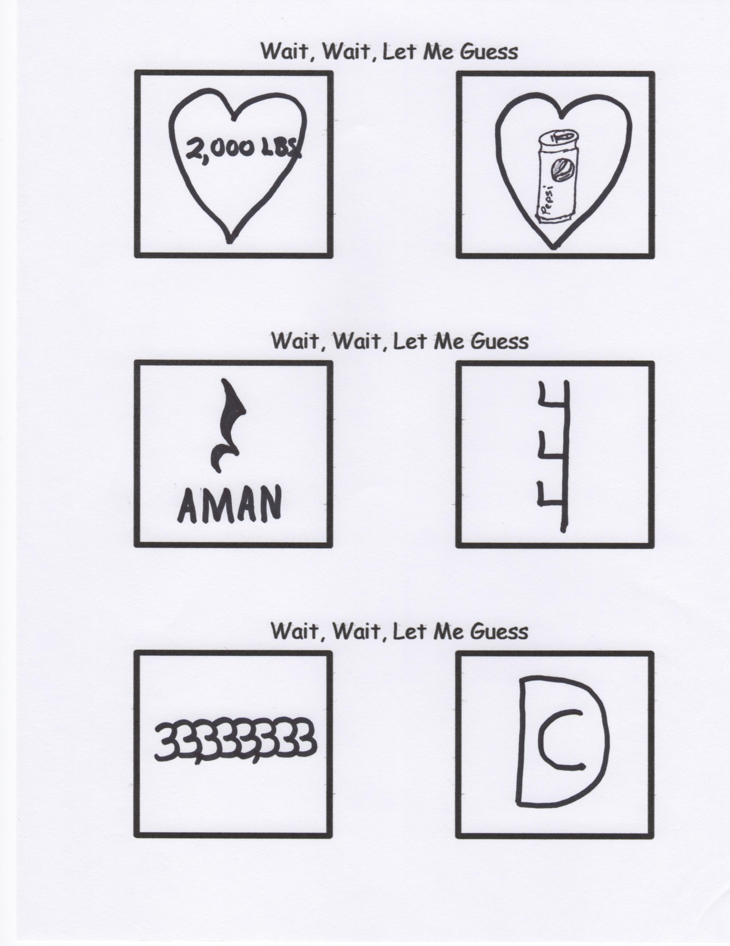

May I suggest a trip to Walmart to buy a very nice box of assorted chocolates. Be sure to get one with a “roadmap” of the flavors with their locations in the box. It may require you to spend a few extra dollars, but it is worth it.

Open the box, and take out the ones that you know your sweetheart doesn’t like. Save them for yourself. Next, take out some of the good ones for later—your sweetheart will never know the difference. (But be sure to keep the “roadmap”, or they will realize what you have done.)

And finally, duct tape the box closed. If they decide to throw the box at you in disgust, all that candy won’t go to waste.

Not a good idea you say?

If we are honest, there are times that we give to God but hold back for ourselves the choicest pieces of our lives. God wants the whole box of chocolates, not just part.

By Mr. Lyle (mrlyle1@gmail.com)

**For God so lo__ed the world**

**that He g__ve**

**His on__y**

**b__gotten**

**So__**

**__hat whosoever**

**bel__eveth in Him**

**should __ot perish**

**but have __verlasting life.**

**A Valentine for Mr. Lyle’s Wife**