**July 24, 2016**

**Volume 4, Issue 34**

Sunday School Times

# The Parable of the Pencil

***Stuff For Today***

• Wait, Wait, Let Me Guess!

• The Lord’s Prayer

* Pencil Trivia
* ?????????

Published almost weekly, but more like…..whenever, so get used to it, OK?

**By Mr. Lyle (mrlyle1@gmail.com**

***John 3:16***

***For God so loved the world that He gave His only begotten Son, that whosoever believeth in Him, should not perish, but have everlasting life.***

**Pencil Trivia**

1. Got time to kill? The average pencil holds enough graphite to draw a line 35 miles long. History doe not record anyone testing this statistic.

2. Most pencils sold in America have eraser tips, while those in Europe usually have none. Europeans are obviously more confident scribblers.

3. NASA discovered that pencils can write in zero gravity. So they were used on many of the first space missions.

4. Though very rare, left-handed pencils do exist. Most are to be found in private collections.

5. Where do pencils come from? Well, to not be too technical, a Mommy pencil and a Daddy pencil meet and get married, and have lots of baby pencils. They feed them and take care of them and they grow up and eventually go to school. And that’s where you usually find them.

**The Lord’s Prayer**

**(Technically)**

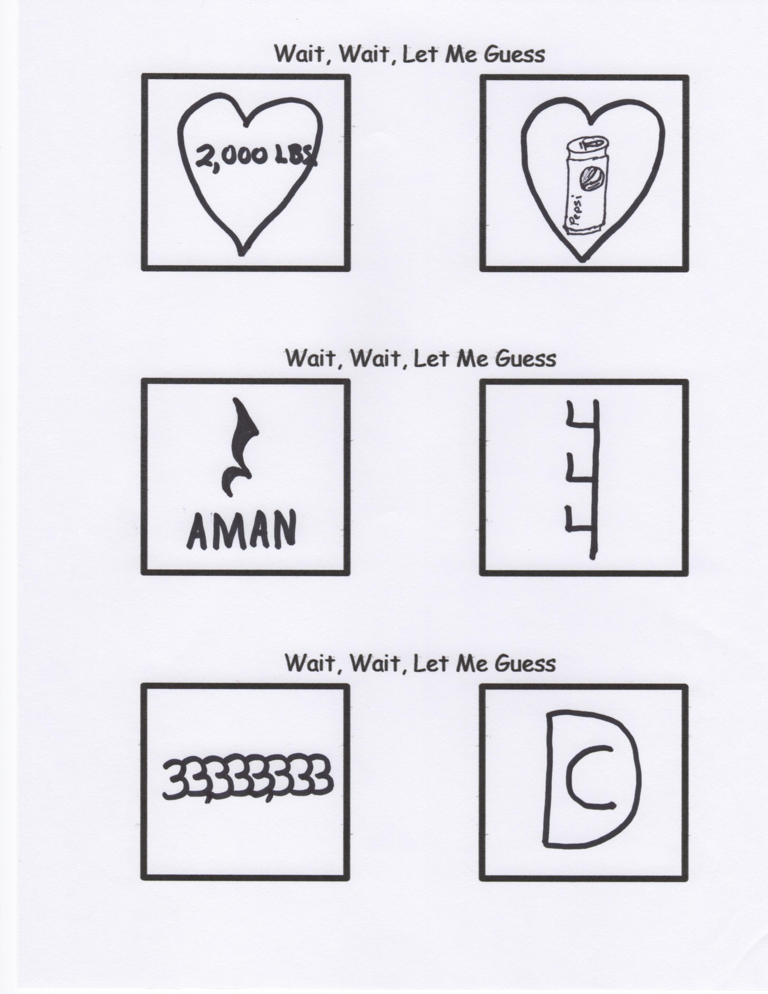

**Here we go again.**

I have to manage my anger because people can’t manage their stupidity!

Paternal relative associated with us established in a celestial position. The designation assigned to your person is inviolable.

Hasten the appearance of the sovereign theocracy retained by you.

Your expressed intensions and purpose be realized similarly upon this sublunary macrocosm as the extra-terrestrial commorancy. Bequeath upon us diurnally circadian triticum comestibles. Exculpate incumbrances as we exculpate conditional liabilities obligated towards us.

Cease inveiglement resulting in inducement, but emancipate us from perdition.

For you possess sovereign monarchial disposition, dynamic efficacy, and eminent illustriousness in perpetuity. So be it.

By Mr. Lyle (mrlyle1@gmail.com)