**May 18, 2014**

**Volume 2, Issue 33**

Sunday School Times

***Stuff For Today***

• Wait, Wait, Let Me Guess!

• The Internet

* Pretty Dog
* To Tell the Truth

# To Tell The Truth

Published almost weekly, but more like…..whenever, so get used to it, OK?

**By Mr. Lyle (mrlyle1@gmail.com**

***John 13: 36-38***

***36 Jesus said, “My kingdom is not of this world. If it were, my servants would fight to prevent my arrest by the Jewish leaders. But now my kingdom is from another place.” 37 “You are a king, then!” said Pilate. Jesus answered, “You say that I am a king. In fact, the reason I was born and came into the world is to testify to the truth. Everyone on the side of truth listens to me.” 38 “What is truth?” retorted Pilate****.*

Television in the late 50’s and early 60’s was much different than it is today. As a child of that era, I grew up enjoying a select few TV shows. One of my favorites was a show simply called “To Tell the Truth”. Airing in both an evening and a daytime time slot, it became one of the five most popular game shows of all time.

The premise of the show was quite simple. Three contestants would stand before a panel of well-known Hollywood celebrities who were poised and ready to ask questions of them. The show’s announcer would then read a unique or interesting story, many times recalling some strange or bizarre incident or accomplishment. The three contestants would proclaim to the celebrity panel that they were the subject of the story.

Questioning would then begin as the celebrities would try to determine which contestant was indeed telling the truth, and which two were not. The two who were essentially given free license to lie could say anything thing they liked to try to convince the panel that they were the right choice. Only the true, central character of the story was sworn to always tell the truth. Often it was remarkably difficult to determine simply from a few questions, who was indeed telling the truth and who was not.

John, in his Gospel, includes a conversation that took place between Jesus and Pilate. As Jesus stood before the Roman who had the power to condemn him to death, the subject of truth came up. Jesus explained to Pilate that there is absolute truth. Not understanding the concept, and probably well acquainted with a pagan world system that exceled at not telling the truth, Pilate responds with one of the most loaded questions recorded in the Bible.

“What is truth?” he asked. Today we still live in a world that struggles to always tell the truth, even when it is inconvenient to do so. As Christians, we are called to always be truthful.

**The Baseball Game Found in the King James Bible**

By Mr. Lyle (mrlyle1@gmail.com)

The people gathered *(Numbers 11.32)* to see the battle *(1 Sam. 14.28)* .

Eli sat upon a seat by a post *(1 Sam.1.9)* and he stretched himself *(1 Kgs. 17.21)* that he may see good. *(Ps. 34.12)* So the people shouted: *(Joshua 6.20)* "Where are the nine? *(Luke 17.17)* Let the young men now arise and play before us." *(2 Sam. 2.14)*

The first came out *(Gen. 25.25)* and went into the field *(Num. 22.23)* and stood every man in his place. *(Jdg. 7.21)* And Peter called, *(Mk. 14.72)* whether it be good or bad. *(Lev. 27.12)* As one mocketh, another do *(Job 13.9)* with loud voices: *(Lk. 23:23)* "Thou art blind!" *(Rev. 3.17)* And he stooped to *(1 Sam. 28.4)* make clean...the platter. *(Lk. 11.39)* And the trumpeters sounded: *(2 Chron. 29.28)* "Kohath shall pitch." *(Num. 3.29)* And Samson went and caught. *(Jdg 15:4)*

David was up *(2 Sam. 24.11)* on the left side *(Eze. 1.10)* and he struck it into the pan *(1 Sam. 2.14)* foul. *(Matt. 16.3)* The second was offered; *(Jdg. 6.28)* he striketh-- *(Job 34.26)* he missed! *(1 Sam. 20.18)* On the third *(Gen. 22.4)* he struck him out! *(2 Sam. 20.10)* So Levite went in; *(Jdg. 17.10)* he stood and measured the earth; he beheld, and drove *(Hab. 3.6)* for an homer. *(Hos. 3.2)* And all the people shouted with a great shout. *(Ezra 3.11)* And Noah went in, *(Gen. 7.7)* and did fly *(2 Sam. 22.11)* into the field. *(Num. 22.23)* And Jotham ran away *(Jdg.9.21)* and looking back *(Lk. 9.62)* gathered it. *(Isa. 62.9)* And Aaron went in, *(Ex. 5.1)* and he worketh it *(Isa. 44.12)* two and two. *(Gen. 7.9)* And Samson said: *(Jdg. 15.3)* "Strike it!" *(Ex. 12.7)* And Aaron spake: *(Ex. 4.30)* "A good man would *(Rom. 5.7)* be not one of them that strike." *(Prov. 22.26)* And the man refused to smite. *(1 Kgs 20.35)* And Aaron took, *(Numbers 16.47)* and he walked. *(1 Kgs. 15.3)* Amon sacrificed *(2 Chron. 33.22)* and Aaron ran *(Num. 16.47)* into the second, *(Heb. 9.7)* and overran! *(2 Sam. 18.23)* And with the bag *(Micah 6.11)* afar off-- *(Gen. 22.4)* a good man out. *(Matt. 12.35)*

Now Jeremiah came in; *(Jer. 37.4)* then he went out, *(Gen. 31.33)* being caused to fly, *(Daniel 9.21)* And the men of Israel retired. *(Jdg. 20.39)* Then the Philistines went up *(Jdg. 15.9)* And Joseph was...captain *(Gen. 39.1)* of the Philistines. *(Jdg. 3.31)* And Absalom pitched. *(2 Sam. 17.26)*

Then Joseph commanded to fill their sacks. *(Gen. 42.25)* Shimei came forth *(2 Sam. 16.5)* and stood and walked. *(Acts 3.8)* The pitcher *(Ecclesiastes 12.6)* looked this way and that; *(Ex. 2.12)* He stretched out *(Hos. 7.5)* and threw. *(Acts 22.23)* And Archers hit. *(1 Sam. 31.3)*

And it came to pass on second *(Lk. 6.1)* Job caught *(Job 38.5)* the line *(1 Kgs. 2.28)* and threw *(2 Sam. 16.13)* at the first; *(Gen. 13.4)* Therefore David ran and stood upon *(1 Sam. 17.51)* the first, *(Gen. 13.4)* put forth his hand, and caught *(Ex. 4.4)* the toss. *(Jer. 5.22)* This is the second death. *(Rev. 20.14)* Then Joseph could not refrain himself, and he cried: *(Gen. 45.1)* "Goodness, if thou continue in *(Rom. 11.22)* going down, *(Gen. 15.12)* our hope is lost *(Eze. 37.11)* and my garments *(Isa. 63.3)* and job." *(Job 32.3)*

And Abram went up *(Gen. 13.1)* and Abram drove *(Gen. 15.11)* into the air. *(Acts 22.23)* And Judah came in *(Gen. 38.8)* under it, *(Dan. 4.14)* and through idleness of the hands *(Eccl. 10.18)* the fly *(Isa. 7.18)* droppeth through *(Eccl. 10.18)* giving him a double. *(Lev. 21.17)* Abraham took wood and *(Gen. 22.6)* caught hold of *(2 Sam. 18.9)* an hard *(Matt. 25.24)* and high *(Rev. 21.12)* delivery *(Isa. 26.17)* and smote it *(Jdg. 7.13)* into left. *(Lev. 14.15)* Thus and thus *(Jdg. 18.4)* Israel fought against *(Josh. 10.29)* the Philistines *(1 Sam. 19.8)* till the ninth. *(Lev. 25.22)* For each, one *(Num. 7.3)* in the first, *(Jer. 25.1)* and seven times *(Lev. 25.8)* after that they *(Eccl. 9.3)* gathereth eggs. *(Isa. 10.14)*

In the ninth, *(1 Kgs. 25.1)* Israel went out *(1 Kgs. 20.21)* in a row, *(1 Kgs. 7.3)* and none came in. *(1 Sam. 18.13)* He sent divers sorts of flies among them *(Ps. 78.45)* And they caught them every one. *(2 Sam. 2.6)* The first man *(1 Cor. 15.45)* for the Philistines *(1 Sam. 28.15)* drew the third, *(Rev. 12.4)* and the fourth *(Dt. 28.20)* came to the outside; *(Jdg. 7.19)* he walketh. *(Job 22.14)* The pitcher *(Eccl. 12.6)* climbed up upon *(1 Sam. 14.13)* the mount *(Dt. 1.7)* and pitched. *(Ex. 19.2)* And Moses put it on a pole *(Num. 21.9)* for an homer, *(Hos. 3.2)* and Israel was beaten. *(2 Sam. 2.17)*

And behold, the man clothed with linen, which had the inkhorn by his side, reported the matter *(Eze. 9.11)* and wrote it in a book. *(1 Sam. 10.25)*

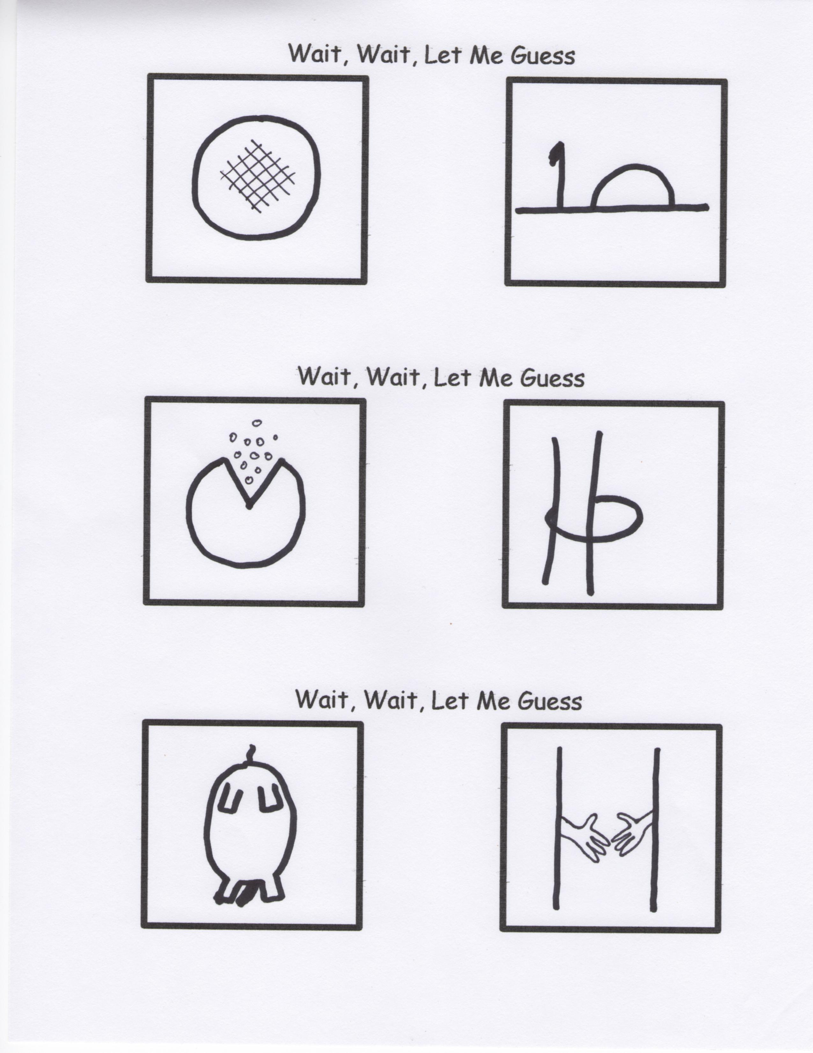

**What The Internet Was Like When I Was Young**

**Google Mail**

_Web _Images _Groups _News _Froogle

Please Print Query Clearly________________________________

Mail to: Google Search Request

1800 Amphitheater Parkway

Mountain View, CA 94043

Please allow four to six weeks for results