**June 29, 2014**

**Volume 2, Issue 38**

Sunday School Times

***Stuff For Today***

• Wait, Wait, Let Me Guess!

• Chocolate Chip

* Porpoise stuff
* Prayer
* Questions

# Cyrus Brown’s Prayer

Published almost weekly, but more like…..whenever, so get used to it, OK?

**By Mr. Lyle (mrlyle1@gmail.com**

The Bible describes God as one who is interested in having a deep relationship with us. While we do not have the luxury of physically hearing the voice of God, His Spirit residing in the heart of every Christian is capable of communicating directly with our heart and mind.

But we must be willing to listen to Him. God usually is not someone who shouts at us over the noise of our everyday life. Rather, His is a still, small voice that we must be attentive to hear.

For many, God is a sort of “vending machine” that they go to when they need something. It is true, He will be there if we need anything. But the deep relationship with God comes from walking with Him all the time. He is there, whether we recognize Him or not. Why not acknowledge His presence and live like He is right beside us all day long?

Prayer simply defined is “talking to God”. It can take the form of eyes closed and head bowed, but I find it nice to go through the day talking to God—maybe not out loud, but in my heart. It gives me the chance to talk to Him about even the smallest of things. I have found He cares about those things too!

***Philippians 4: 6***

***6 Be careful for nothing; but in every thing by prayer and supplication with thanksgiving let your requests be made known unto God.***

**A Prayer Poem**

The proper way for a man to pray,

Says Deacon Lemuel Keys,

And the only proper attitude

Is down upon his knees.

No, I should say the way to pray,

Says Reverend Doctor Wise

Is standing straight with outstretched arms

And rapt and upturned eyes.

Oh, no, no, no, said Elmer Slow.

Such posture is too proud.

A man should pray with eyes fast closed

And head contritely bowed.

It seems to me his hands should be

Austerely clasped in front.

Both hands pointing toward the ground,

Said Reverend Doctor Blunt.

Last year I fell in Hitchkins’ well,

Head first, said Cyrus Brown.

And both my heels were stickin’ up,

And my head was pointing down.

And I made a prayer right then and there,

The best prayer I ever said.

The prayin’est prayer I ever prayed

Was standin’ on my head.

Prayer is a great gift that God has given to each of us. We have the opportunity to talk to God directly from anywhere at anytime and we are allowed to talk for as long as we want. Your cell phone contract doesn’t even come close to that!

**Cleaning House and Had Some Leftover Porpoise Stuff**

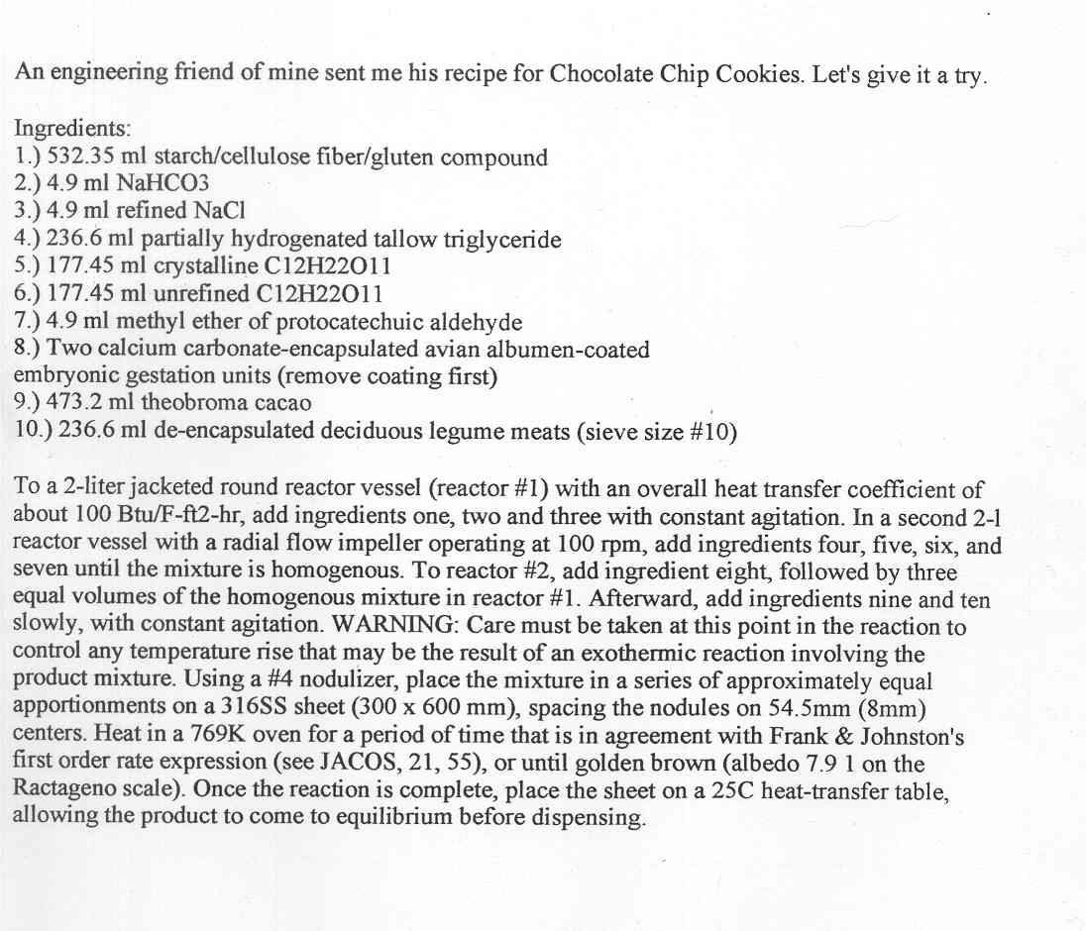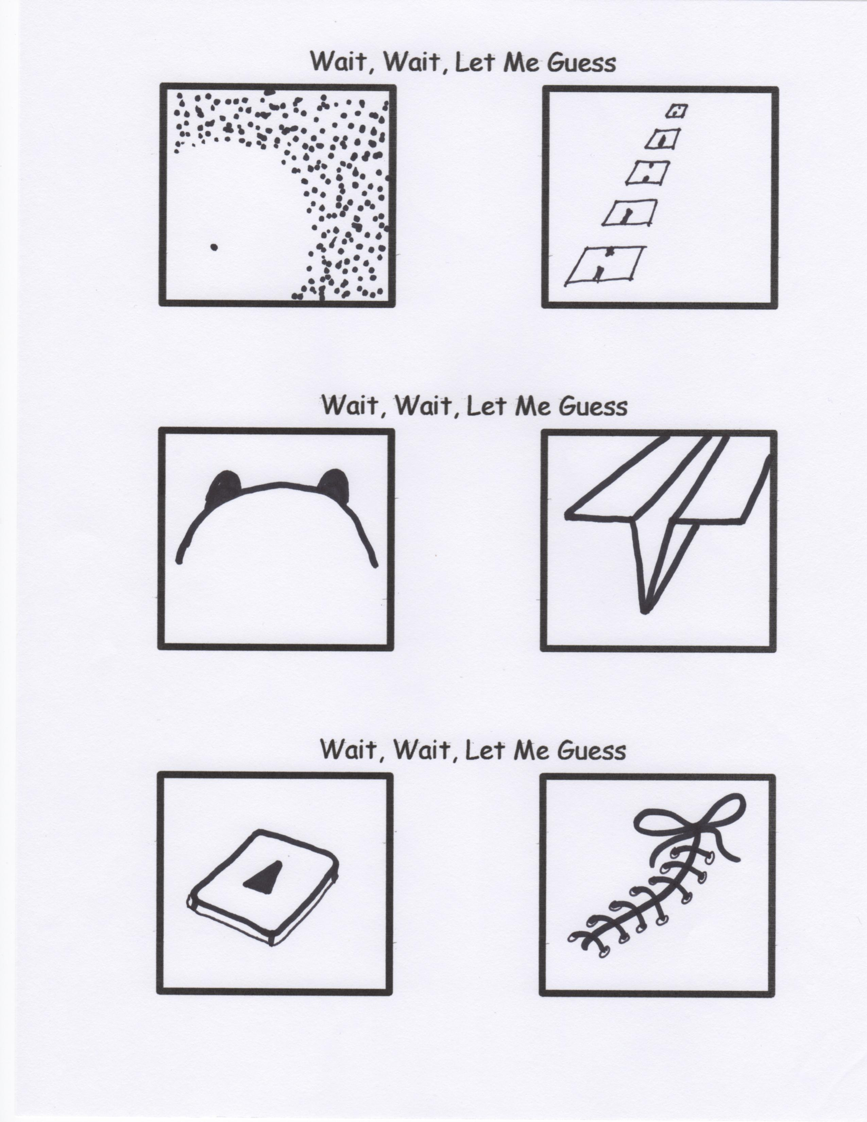

By Mr. Lyle (mrlyle1@gmail.com)

1. Old sailors never die, they just lose their porpoise.

2. I know a guy that works at Sea World, but I don’t think it’s on porpoise.

**A Porpoise Named Purpose**

A porpoise named “Purpose”

On purpose, I’m sure, was

Perplexingly perfect,

And persistently pure.

Now “Purpose” would purpose

To perform and be sweet,

And purchase a purple

Paraguayan parakeet.

It came in a parcel

Portrayed to be porous

And written on the side

“Hi, my name is ‘Porpoise’”

So “Purpose” had “Porpoise”

And “Purpose” had purpose:

A Porpoise with purpose;

A Porpoise with “Porpoise”

**Chocolate Chip Cookies**

**Questions and Answers**

If you haven’t had the chance to write down your question, please do so with Ms Jeanette.