**September 14, 2014**

**Volume 3 , Issue 3**

Sunday School Times

***Stuff For Today***

• Monarch butterflies—the handiwork of God!

• Everything you always wanted to know about Tootsie Roll Pops.

• What kind of fruit tree could change the course of human history?

Published almost weekly, but more like…..whenever, so get used to it, OK?

# How Do You Get To Heaven?

**By Mr. Lyle (mrlyle1@gmail.com)**

***Luke 10:25-37***

***On one occasion an expert in the law stood up to test Jesus. “Teacher,” he asked, “what must I do to inherit eternal life?” 6“What is written in the Law?” he replied. “How do you read it?” 27He answered: “‘Love the Lord your God with all your heart and with all your soul and with all your strength and with all your mind’[[c](http://www.biblegateway.com/passage/?search=luke%2010&version=NIV1984" \l "fen-NIV1984-25383c" \o "See footnote c)]; and, ‘Love your neighbor as yourself.’[***[***d***](http://www.biblegateway.com/passage/?search=luke%2010&version=NIV1984#fen-NIV1984-25383d)***]” 28“You have answered correctly,” Jesus replied. “Do this and you will live.” 29But he wanted to justify himself, so he asked Jesus, “And who is my neighbor?” 30In reply Jesus said: “A man was going down from Jerusalem to Jericho, when he fell into the hands of robbers. They stripped him of his clothes, beat him and went away, leaving him half dead. 31A priest happened to be going down the same road, and when he saw the man, he passed by on the other side. 32So too, a Levite, when he came to the place and saw him, passed by on the other side. 33But a Samaritan, as he traveled, came where the man was; and when he saw him, he took pity on him. 34He went to him and bandaged his wounds, pouring on oil and wine. Then he put the man on his own donkey, took him to an inn and took care of him. 35The next day he took out two silver coins[[e](http://www.biblegateway.com/passage/?search=luke%2010&version=NIV1984" \l "fen-NIV1984-25391e" \o "See footnote e)] and gave them to the innkeeper. ‘Look after him,’ he said, ‘and when I return, I will reimburse you for any extra expense you may have.’ 36“Which of these three do you think was a neighbor to the man who fell into the hands of robbers?” 37The expert in the law replied, “The one who had mercy on him.” Jesus told him, “Go and do likewise.”***

Notice verse 25. The most important question anyone can ask is “How can I get to Heaven?” And it has been asked of Jesus himself. I don’t know about you, but I would like to hear the answer! But before an answer is given, the man asks yet another question about who he should consider to be his neighbor. At first glance you might think that Jesus was distracted by the second query. However, the greatest teacher the world has ever known answered both questions with one story! Here is how it breaks down:

*A certain man*: Our relationship with God is based upon ourselves and Him—no one else.

*Went down from Jerusalem to Jericho*: Physically, the trip from Jerusalem to Jericho is a downhill trek. From mountain city to valley city is a drop in elevation of nearly two thousand feet. Jerusalem is where the temple was located, where God had stated that His presence would be seen. Jericho was a cursed city, a city of sin that Israel had destroyed many years earlier. The spiritual picture positions man travelling away from God toward sin, and it is a descent downward, a steep decline.

*And fell among thieves*: Satan, the ever present enemy of man, is described on several occasions in the Bible as a thief and a robber who has come to steal, kill, and destroy. Our memory of what happened in the Garden of Eden confirms that concept.

*Which stripped him of his raiment*: Recall that the first reaction of Adam and Eve was an attempt to procure for themselves clothing to cover their nakedness.

*And left him half dead*: A very interesting choice of words. Physically, it is impossible to be half dead—one is either dead or alive, not half one way or the other. When seen from a spiritual perspective though, it is entirely possible and accurate. Before Adam sinned, God had warned him that on the day he disobeyed, he would *surely die*. But the Bible says that Adam died at the old age of 930 years. Did God lie? Absolutely not, for though Adam did not die physically, he did die spiritually that day, and subsequently, everyone since has been born spiritually dead, in need of a Savior. In fact, he was personally in need of a Savior as well. He was left half dead, with no method of remedying his situation without help.

*A certain priest*: The most religious person in Israel journeyed by and refused to help. We will, likewise, not solve our circumstance with the church or other pious activity. They have no impact upon our dead spiritual condition. Religion cannot and will not save us.

*A Levite*: Known by all as a worker, it was the Levites who cut wood, carried water, cleaned, and successfully kept the temple in good repair. As he approached, he too avoided the man in need. Our accomplishments and our work are nothing compared to God and His majesty. Heaven will never be earned by our feeble attempts at good works.

*A certain Samaritan*: A most unlikely candidate for a solution. A despised half-breed, disdained by Jewish society, became the hero in the story. Jesus was a man of sorrows and acquainted with grief. The religious establishment of the day refused to recognize who He was, and treated Him with blatant contempt. The story pointed to a “certain” Samaritan, a precise, special one. Jesus was the only one who could fulfill all of the Scripture prophecies concerning Him. He was very specific, chosen and planned before the foundation of the world, to fulfill the task before Him—our salvation.

*Came where he was*: It is most humbling and remarkable that Jesus left the glory of Heaven, laid aside all of His heavenly prerogatives, and came to where we are. The great I AM set his foot upon the same dirt we do.

*Had compassion on him*: God loves us while we are still in our sinful state. That is beyond comprehension.

*Bound up his wounds*: By his wounds we are healed spiritually. The implication of the parable is that the victim had no possible method of taking care of himself and his deadly problem. Without help, he would surely die. Notice that the Samaritan did all the work. Likewise, our salvation is a product of “the strong arm of the Lord”, a solution we could never provide for ourselves.

*Pouring on oil*: Often in the Bible, oil is a picture of the Holy Spirit, and this is no exception. We understand from the New Testament that the Holy Spirit is poured into the life of everyone who becomes a Christian—we have the indwelling of the Holy Spirit in our hearts.

*When I come again*: The glorious hope and confidence of every saved individual is the eventual return of Jesus Christ someday.

So, do you know how to get to Heaven now?

## **Monarch Migration Expected This Week**

By Mr. Lyle (mrlyle1@gmail.com)

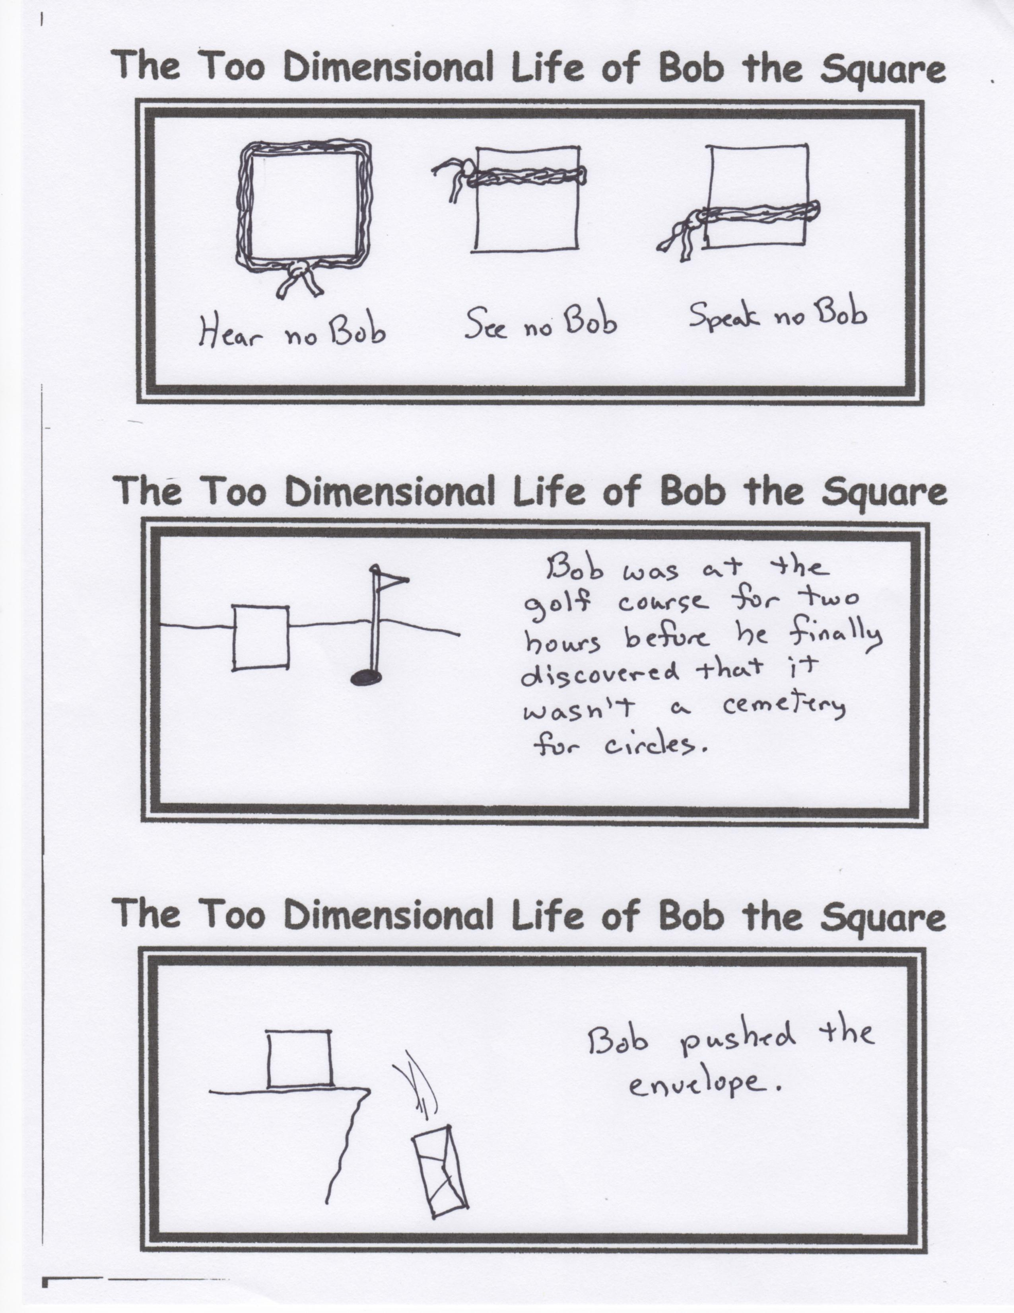

The annual migration of the Monarch butterfly has begun once again. A pasture in Pottsville has been a way stop for a large group each year. The bright yellow wild flowers growing there are a bit too difficult to resist, as they descend by the thousands to rest and feed. The migration should peak during the next few weeks, although numbers are expected to be down.