**August 9, 2015**

**Volume 3, Issue 40**

Sunday School Times

***Stuff For Today***

• Graduation Ceremony

• Parting Gifts

* Hasta La Vista Baby

Published almost weekly, but more like…..whenever, so get used to it, OK?

# Another Year Gone

**By Mr. Lyle (mrlyle1@gmail.com**

***Psalm 119:105***

***Thy Word is a lamp unto my feet and a light to my path always.***

To the departing seventh graders we bid farewell. Another year has passed and life continues. I trust that as you continue to grow and mature that you will always remember bits and pieces of what you have been taught here in this Sunday School class. I consider it a great honor to have had the opportunity to stand in front of all of you each Sunday.

I thought it might be fun to remember our year together. See how many of the lessons you can recall. In order:

1. An Olympic diving documentary and an up side down testimony picture.

2. A scale model of the universe and a needle through the arm.

3. Do not eat the Tootsie Roll Pops!

4. The Pineapple Story.

5. The Turbo Encabulator.

6. Frying bacon.

7. Are you a moose?

8. The 600 year story.

9. A Kroger Christmas.

10. Isaiah 59:17

11. A card trick looking for a perfect heart.

12. Hoosumaber.

13. The Real Estate Deal.

14. Leprosy, forgiveness and a paper cutter.

15. Mr. Lyle Bowl XV.

16. The Golden Lampstand.

17. Adam to Noah timeline.

18. My Tater collection.

19. Chocolate covered marshmallows

20. A wood crate that was a portal to another dimension.

21. Happy Hippy Hippo Hunters.

22. And many others.

**The Crested Porcupine**

God has created amazing animals to fill this world. One such creature is the crested porcupine. Technically considered a rodent, it can grow to 60 pounds. Almost exclusively nocturnal and unaggressive, it forages for food, wishing to be left alone.

If threatened by potential predators, its behavior is quite predictable. Its first line of defense is to simply run away, disappearing into the darkness. If cornered or threatened, it can bring its 12-18 inch quills to an erect position, creating a rather impressive display, and making it look much more massive. If the threat continues, it will stamp its feet and shake its tail, creating a sound very similar to a rattlesnake’s rattle. God has given it an impressive defensive strategy. But He has not left it without an offense maneuver as well.

When all else fails, and its life is in imminent danger, it will turn itself around, and run at its attacker in reverse! You can imagine the damage that hundreds of 12 inch quills could do if they were to contact skin with the force of an angry, desperate 60 pound animal! There are documented accounts of these creatures killing lions and tigers, and even humans.

As Christians, God has given us much needed defensive weaponry. Ephesians 6 reminds us that we have armor not unlike the crested porcupine. Instead of quills, we have the belt of truth, the breastplate of righteousness, our feet shod with the Gospel, the shield of faith, and the helmet of salvation. All of these are defensive in nature.

And like our little rodent friend, God has not forgotten that we need a “secret” offense as well. He has given us the Word of God as our security! **For the Word of God is alive and active. Sharper than any double-edged sword…**

We are in a spiritual battle. God has given us the armor we need to fight the good fight. May we do so.

**How to Say Goodbye Without Actually Saying Goodbye**

**Graduation Program**

Welcome and Prayer

Pomp and Circumstances beyond our control

The Reading of the Sunday School Times

Address by Class Valasalutadictatorian

Magnanimous

Canunimous

Laudinum

Presentation of Diplomas and Various Other Unsundry Items

Closing Prayer

You’re Outa Here!

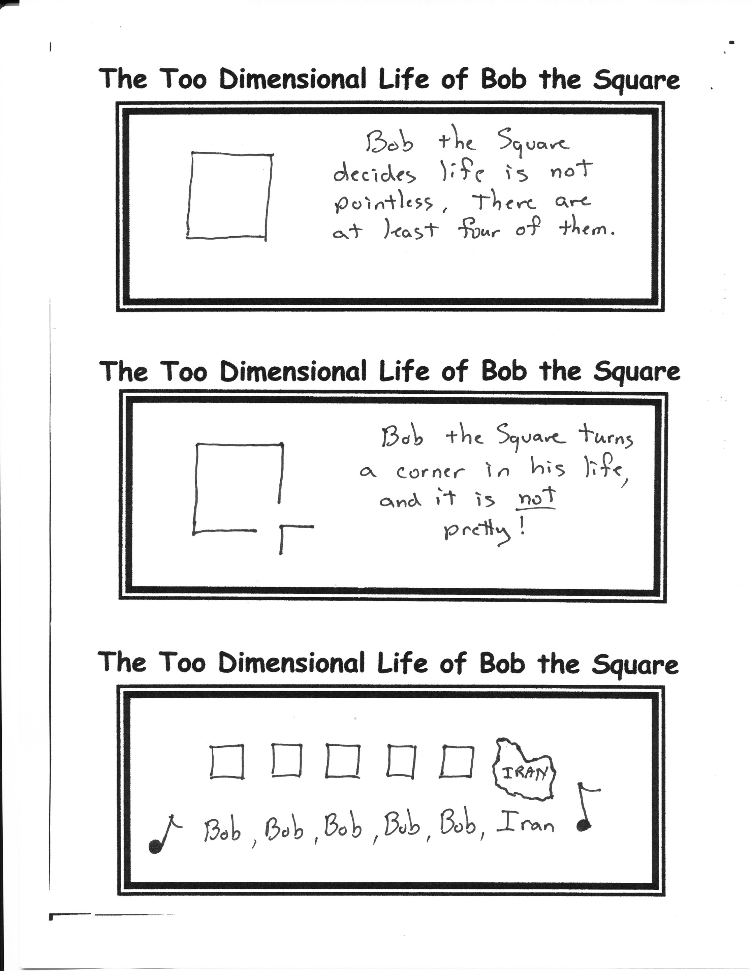

By Mr. Lyle (mrlyle1@gmail.com)

1. Cheerio

2. Toodle-oo

3. See ya later alligator

4. Take care

5. Take it easy

6. I need to scoot

7. Later, dude

8. See ya

9. See ya (wouldn’t wanna be ya)

10. Hold the fort down

11. Adios amigos

12. Gotta split

13. Catcha lataaa

14. Yo

15. Let us hope that before our next meeting humanity escapes extinction.