**October 26, 2014**

**Volume 3, Issue 9**

Sunday School Times

Published almost weekly, but more like…..whenever, so get used to it, OK?

# The Most Frightening Verse in the Bible

***Stuff For Today***

• Special Scripture reading for Halloween

• Q and A for next week

• A very scary lesson

**By Mr. Lyle (mrlyle1@gmail.com)**

***Luke 12***

***47“That servant who knows his master’s will and does not get ready or does not do what his master wants will be beaten with many blows. 48But the one who does not know and does things deserving punishment will be beaten with few blows. From everyone who has been given much, much will be demanded; and from the one who has been entrusted with much, much more will be asked.***

Our culture today is driven by the pursuit of money. It is an easy trap to fall in to, even for the Christian. Too often we judge the goodness of God toward us by how large our bank account happens to be.

A thorough study of Scripture reveals the fact that God counts far more than dollars when He looks at all that He has given us. Our abilities and our time are far more important to Him than is our cash. Money should be simply a tool that we use to accomplish His purposes.

Our asset of time is of incredible worth. How we use it is of great interest to God. We often place Sodom among the most depraved sinners in the Bible. It is interesting to note that when God numbers their sins in Ezekiel 16, immorality is not even mentioned. But the short list does include their misuse of leisure time.

Rarely do we consider our time and our talents when we talk of giving to God. The passage before us in Luke 12, along with many others in both the Old and New Testaments, reminds us that God does hold us to an expectation. It is not how much He has given each of us, but it is how **faithful** we have been with what He has given.

II Corinthians 5:10 puts it all very plainly. Each Christian will one day stand before Jesus and answer for all that he or she has and has not done during their short lifespan here on this earth. It is clear that we will be rewarded based upon our performance. May we use our gifts to honor God.

**Next Week:**

**Questions and Answers**

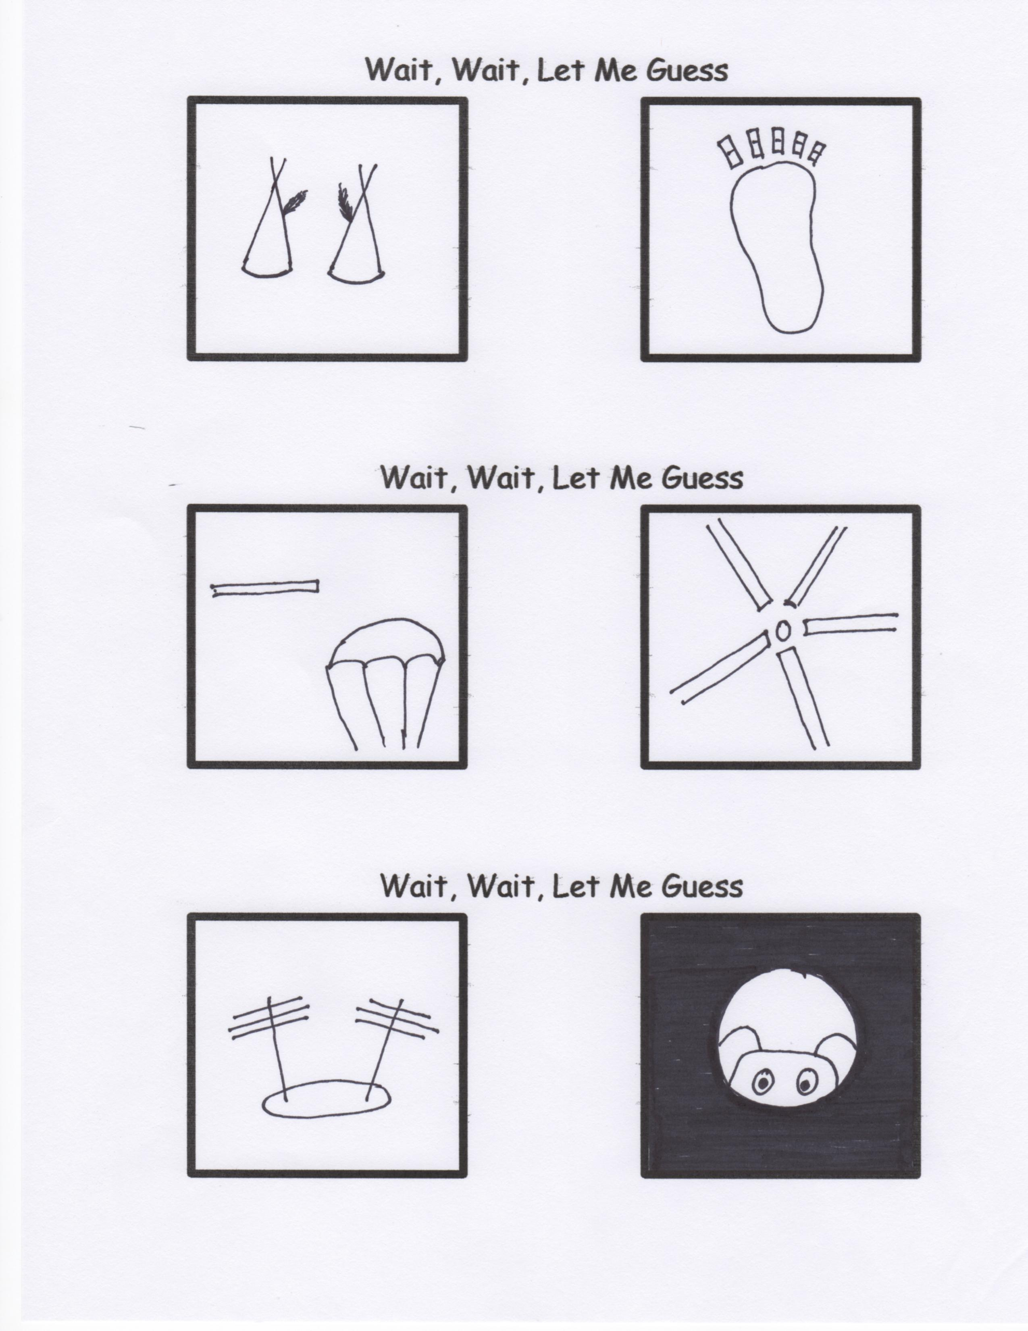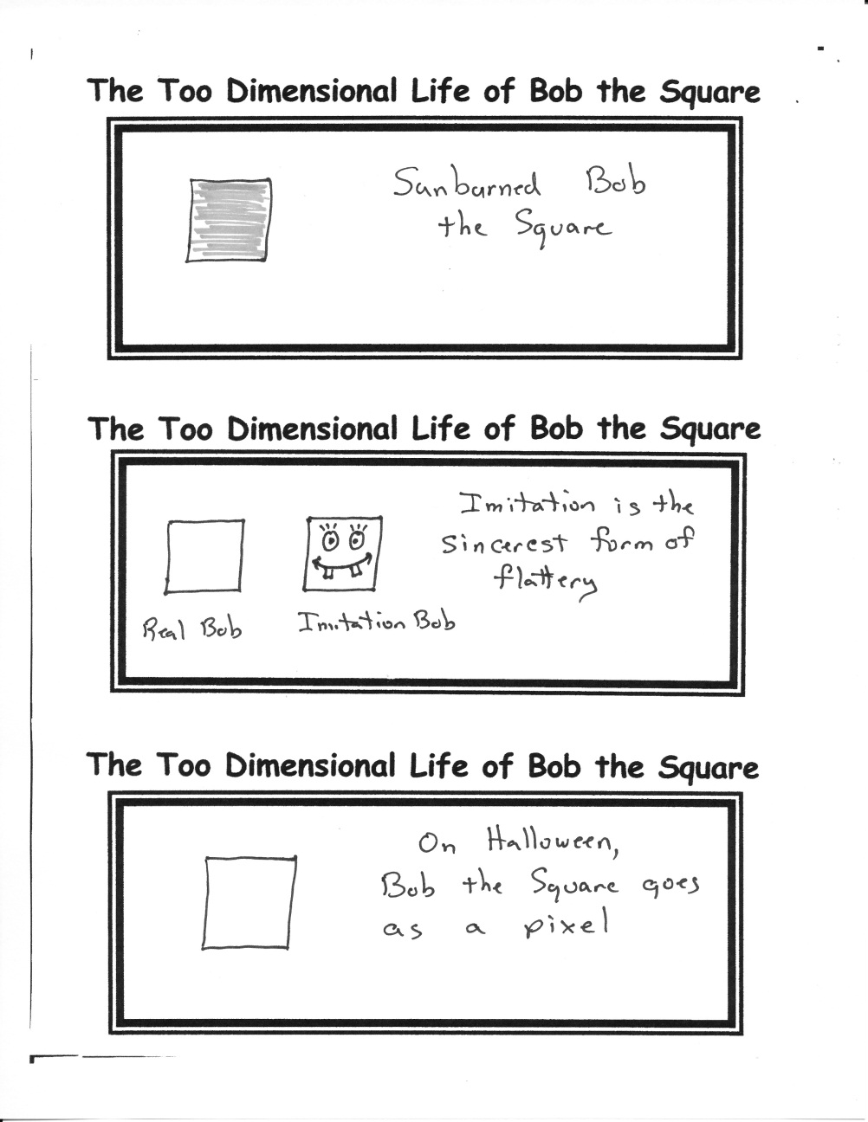

Have you ever had a question you wanted an answer for, but were afraid to ask? Next week is your chance to get that ellusive response.

Once per semester, Mr. Lyle accepts written, unsigned questions, which he will attempt to answer Biblically. You will be handed a small piece of paper and given a few minutes to write down your question. This event is entirely optional and entirely anonymous as well.

Typically, NO question is off the table! You may ask ANYTHING you like! It is a perfect chance to ask about the Bible, or some aspect of God, or church, or being a Christian

So, this week, be thinking and planning how you might use this opportunity.

***Exodus 7***

***9****“When Pharaoh says to you, ‘Perform a miracle,’ then say to Aaron, ‘Take your staff and throw it down before Pharaoh,’ and it will become a snake.”*

***10****So Moses and Aaron went to Pharaoh and did just as the Lord commanded. Aaron threw his staff down in front of Pharaoh and his officials, and it became a snake.****11****Pharaoh then summoned wise men and sorcerers, and the Egyptian magicians also did the same things by their secret arts:****12****Each one threw down his staff and it became a snake. But Aaron’s staff swallowed up their staffs*

**A Scripture Reading For Halloween**

By Mr. Lyle (mrlyle1@gmail.com)