**November 29, 2015**

**Volume 4, Issue 13**

Sunday School Times

***Stuff For Today***

• Wait, Wait, Let Me Guess

• Evolutionary Theory

* Christmas Begins
* The Redeemer says “yes”

Published almost weekly, but more like…..whenever, so get used to it, OK?

# Ruth Chooses A Redeemer

**By Mr. Lyle (mrlyle1@gmail.com)**



***The Book Of Ruth Chapter 3 and 4***

To a Hebrew, the New Testament term of redeemer would be more accurately defined as kinsman-redeemer. The Old Testament law of the kinsman-redeemer provides some interesting insights into the concept of calling Jesus our Redeemer. The Biblical narrative says that Ruth washed (we are washed, born again, forgiven), anointed herself (we have the anointing of the Holy Spirit), dressed in her best clothes (we are clothed in the righteousness of Christ), and she claimed her redeemer (we, too, must accept our Redeemer). Staking that claim was her only requirement. Everything else became the responsibility of Boaz. (God performs all the work in our salvation.)

There is also mention of a redeemer who was of closer relationship who refused to do his duty, and thus Boaz could fulfill the request. That nameless kinsman represents the Law. It cannot save, because no one is able to keep it. The kinsman-redeemer was also responsible for justice. If we claim Jesus to be our Redeemer, He is our Kinsman-Redeemer, and we have no need to seek personal revenge for wrong done to us, he will ensure that justice is applied.

The romance of redemption is a beautiful thing to behold.

**If you decide to build a snowman this year, may I suggest…**



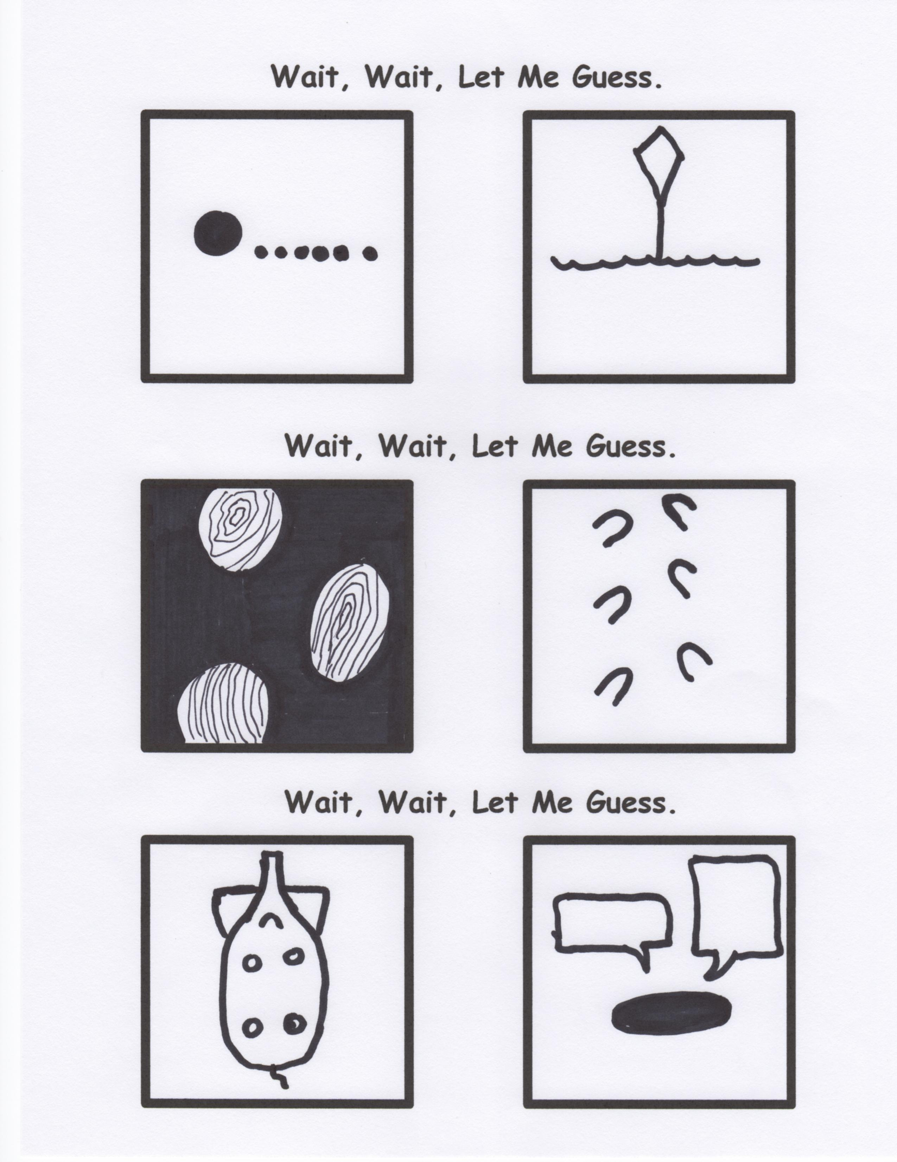

**Mr. Lyle Explains Evolutionary Theory**

By Mr. Lyle (mrlyle1@gmail.com)

120 million years ago this boulder looked remarkably like a 1983 Nissan Sentra. Isn’t evolution amazing?!