**March 27, 2016**

**Volume 4, Issue 23**

Sunday School Times

# Hunting For An Easter Egg

***Stuff For Today***

• Wait, Wait, Let Me Guess!

• Peter Piper

* How they pick Easter Day
* Easter Eggs

Published almost weekly, but more like…..whenever, so get used to it, OK?

**By Mr. Lyle (mrlyle1@gmail.com**

***John 12:1, 12-17***

***1 Six days before the Passover, Jesus came to Bethany, where Lazarus lived, whom Jesus had raised from the dead.***

***12 The next day the great crowd that had come for the festival heard that Jesus was on his way to Jerusalem. 13 They took palm branches and went out to meet him, shouting, “Hosanna!” “Blessed is he who comes in the name of the Lord!” “Blessed is the king of Israel!” 14 Jesus found a young donkey and sat on it, as it is written: 15 “Do not be afraid, Daughter Zion;     see, your king is coming,     seated on a donkey’s colt.” 16 At first his disciples did not understand all this. Only after Jesus was glorified did they realize that these things had been written about him and that these things had been done to him. 17 Now the crowd that was with him when he called Lazarus from the tomb and raised him from the dead continued to spread the word. 18 Many people, because they had heard that he had performed this sign, went out to meet him. 19 So the Pharisees said to one another, “See, this is getting us nowhere. Look how the whole world has gone after him!”***

***Exodus 12:1-6***

***The Lord said to Moses and Aaron in Egypt, 2 “This month is to be for you the first month, the first month of your year. 3 Tell the whole community of Israel that on the tenth day of this month each man is to take a lamb for his family, one for each household. 4 If any household is too small for a whole lamb, they must share one with their nearest neighbor, having taken into account the number of people there are. You are to determine the amount of lamb needed in accordance with what each person will eat. 5 The animals you choose must be year-old males without defect, and you may take them from the sheep or the goats. 6 Take care of them until the fourteenth day of the month, when all the members of the community of Israel must slaughter them at twilight.***

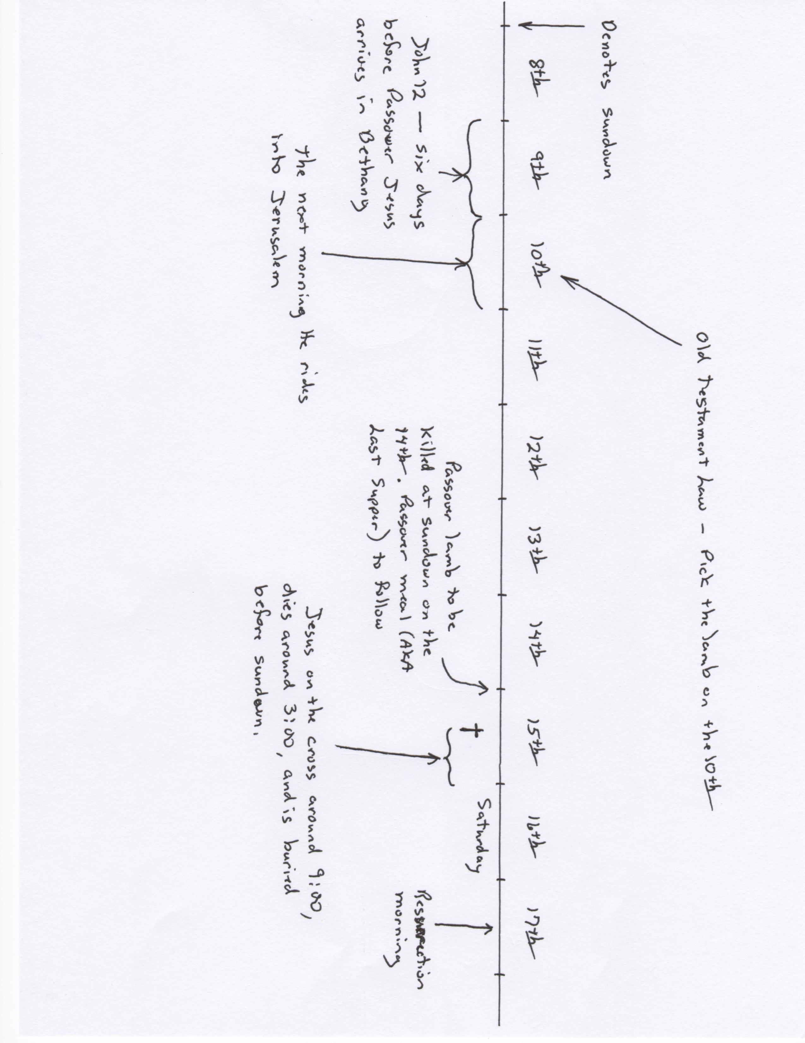

**Picking Easter**

By Mr. Lyle (mrlyle1@gmail.com)

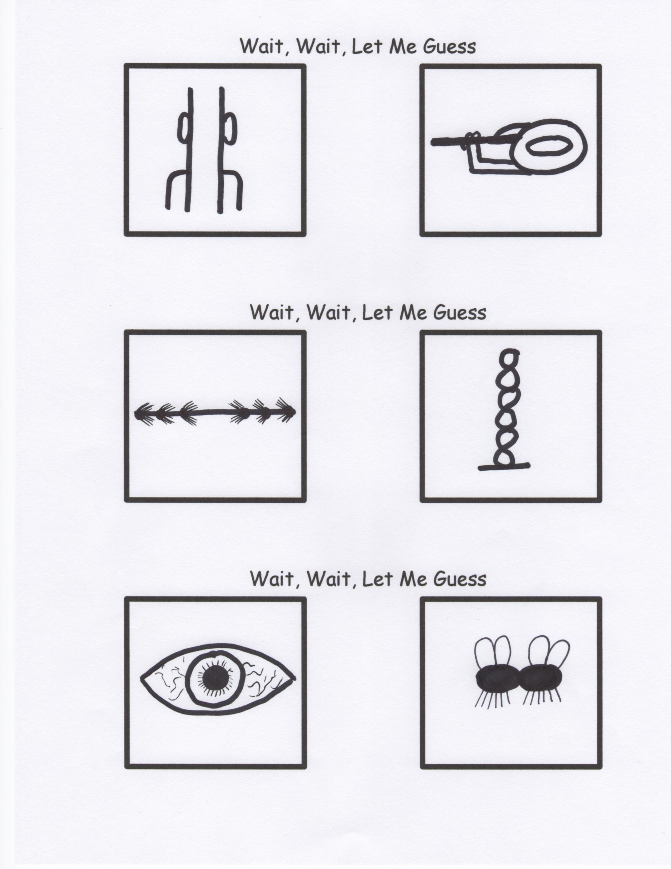

**Peter Piper Picked A Peck Of Pickled Peppers**

We all know that Peter Piper picked a peck of pickled peppers, but who in the world is Peter and why should we care if he’s got pickled or fresh peppers? As it turns out, this story is far more interesting than the simple tongue twister we’re all familiar with. First off, it’s important to know a little history about the spice trade. You see, a long, long time ago, all spices were referred to by the generic name of “peppers.” They were also incredibly expensive and the companies who ran the spice trade would go out of their way to keep the supply low by rubbing the seeds with lime before selling them so they couldn’t germinate if planted. The practice was called “pickling.” As for Peter Piper, he was actually a French pirate and horticulturalist named “Pierre Poivre” (which has become Anglicized into Peter Piper). Pierre was known for raiding spice stores so he could grow them in his garden in Seychelles and hopefully make spices more affordable and accessible for the average European. The rhyme comes from the fact that there were at least a few occasions where Peter Piper picked pickled peppers that wouldn’t grow in his garden.

Easter Day is the first Sunday after the full moon which happens upon, or next after the 21st day of March; and if the full moon happens upon a Sunday, Easter Day is the Sunday after."

Using this method, Easter can only occur between March 22 and April 25.