**May Day, 2016**

**Volume 4, Issue 24**

Sunday School Times

***Stuff For Today***

• Wait, Wait, Let Me Guess!

• Formula for Love

* Laundry hints
* The story of one roll of toilet paper

Published almost weekly, but more like…..whenever, so get used to it, OK?

# Of Toilet Paper and Canons

**By Mr. Lyle (mrlyle1@gmail.com**

***Romans 8:28-29***

***28 And we know that all things work together for good to them that love God, to them who are the called according to his purpose. 29 For whom he did foreknow, he also did predestinate to be conformed to the image of his Son***

Long before this class time began, I made plans.

**Long before He made the universe, God made plans.**

I wanted a roll of toilet paper, so I went to the store.

**God wanted a relationship with us, so He came to this earth.**

I found the roll I wanted on the shelf. It did not come looking for me first.

**God came looking for you and I first as well.**

I took the roll of toilet paper to the checkout stand and paid the price to make it mine.

**God went to a cross and shed His blood to pay the price to make you and I His property.**

The roll of toilet paper accepted my arrangement and I took it home.

**You and I need to accept God’s gift of salvation.**

Let me put this delicately—had I not rescued that roll of toilet paper from its predicament, it would have faced a life of unspeakably disgusting things!

**If God did not rescue us from our sin, we would be facing an even more disgusting and awful future ourselves!**

Now that the roll of toilet paper is mine, I can begin executing the plans I had for it.

**When we become Christians, we are in a position to be used by God for His planned purpose in our lives.**

I begin unrolling and removing the stuff I don’t want on the roll.

**We have stuff in our lives that doesn’t need to be there—sin—and God wants to rid us of those things.**

The roll of toilet paper does not resist my gentle process.

**We need to be willing to allow God to work in our lives.**

I know what I need the roll to be, and will continue the process of trimming and removing material until it finally becomes truly useful.

**God will clean up our sinful hearts if we let Him, because He has a plan for our lives.**

I have a target dimension for the roll of toilet paper. I want to remove everything that does not total 100 mm in diameter.

**God has a target for every Christian’s life—we are to become like Christ.**

Finally, the toilet paper is loaded into a 100mm canon and fired through the air in an amazing display. Everyone wonders in awe at the spectacle.

**God will do amazing, awesome things in your life as well. Let Him do the work in your heart, and go along for the ride! And we will all wonder in awe at the great things God has done!**

**Helpful Hints Regarding Laundry**

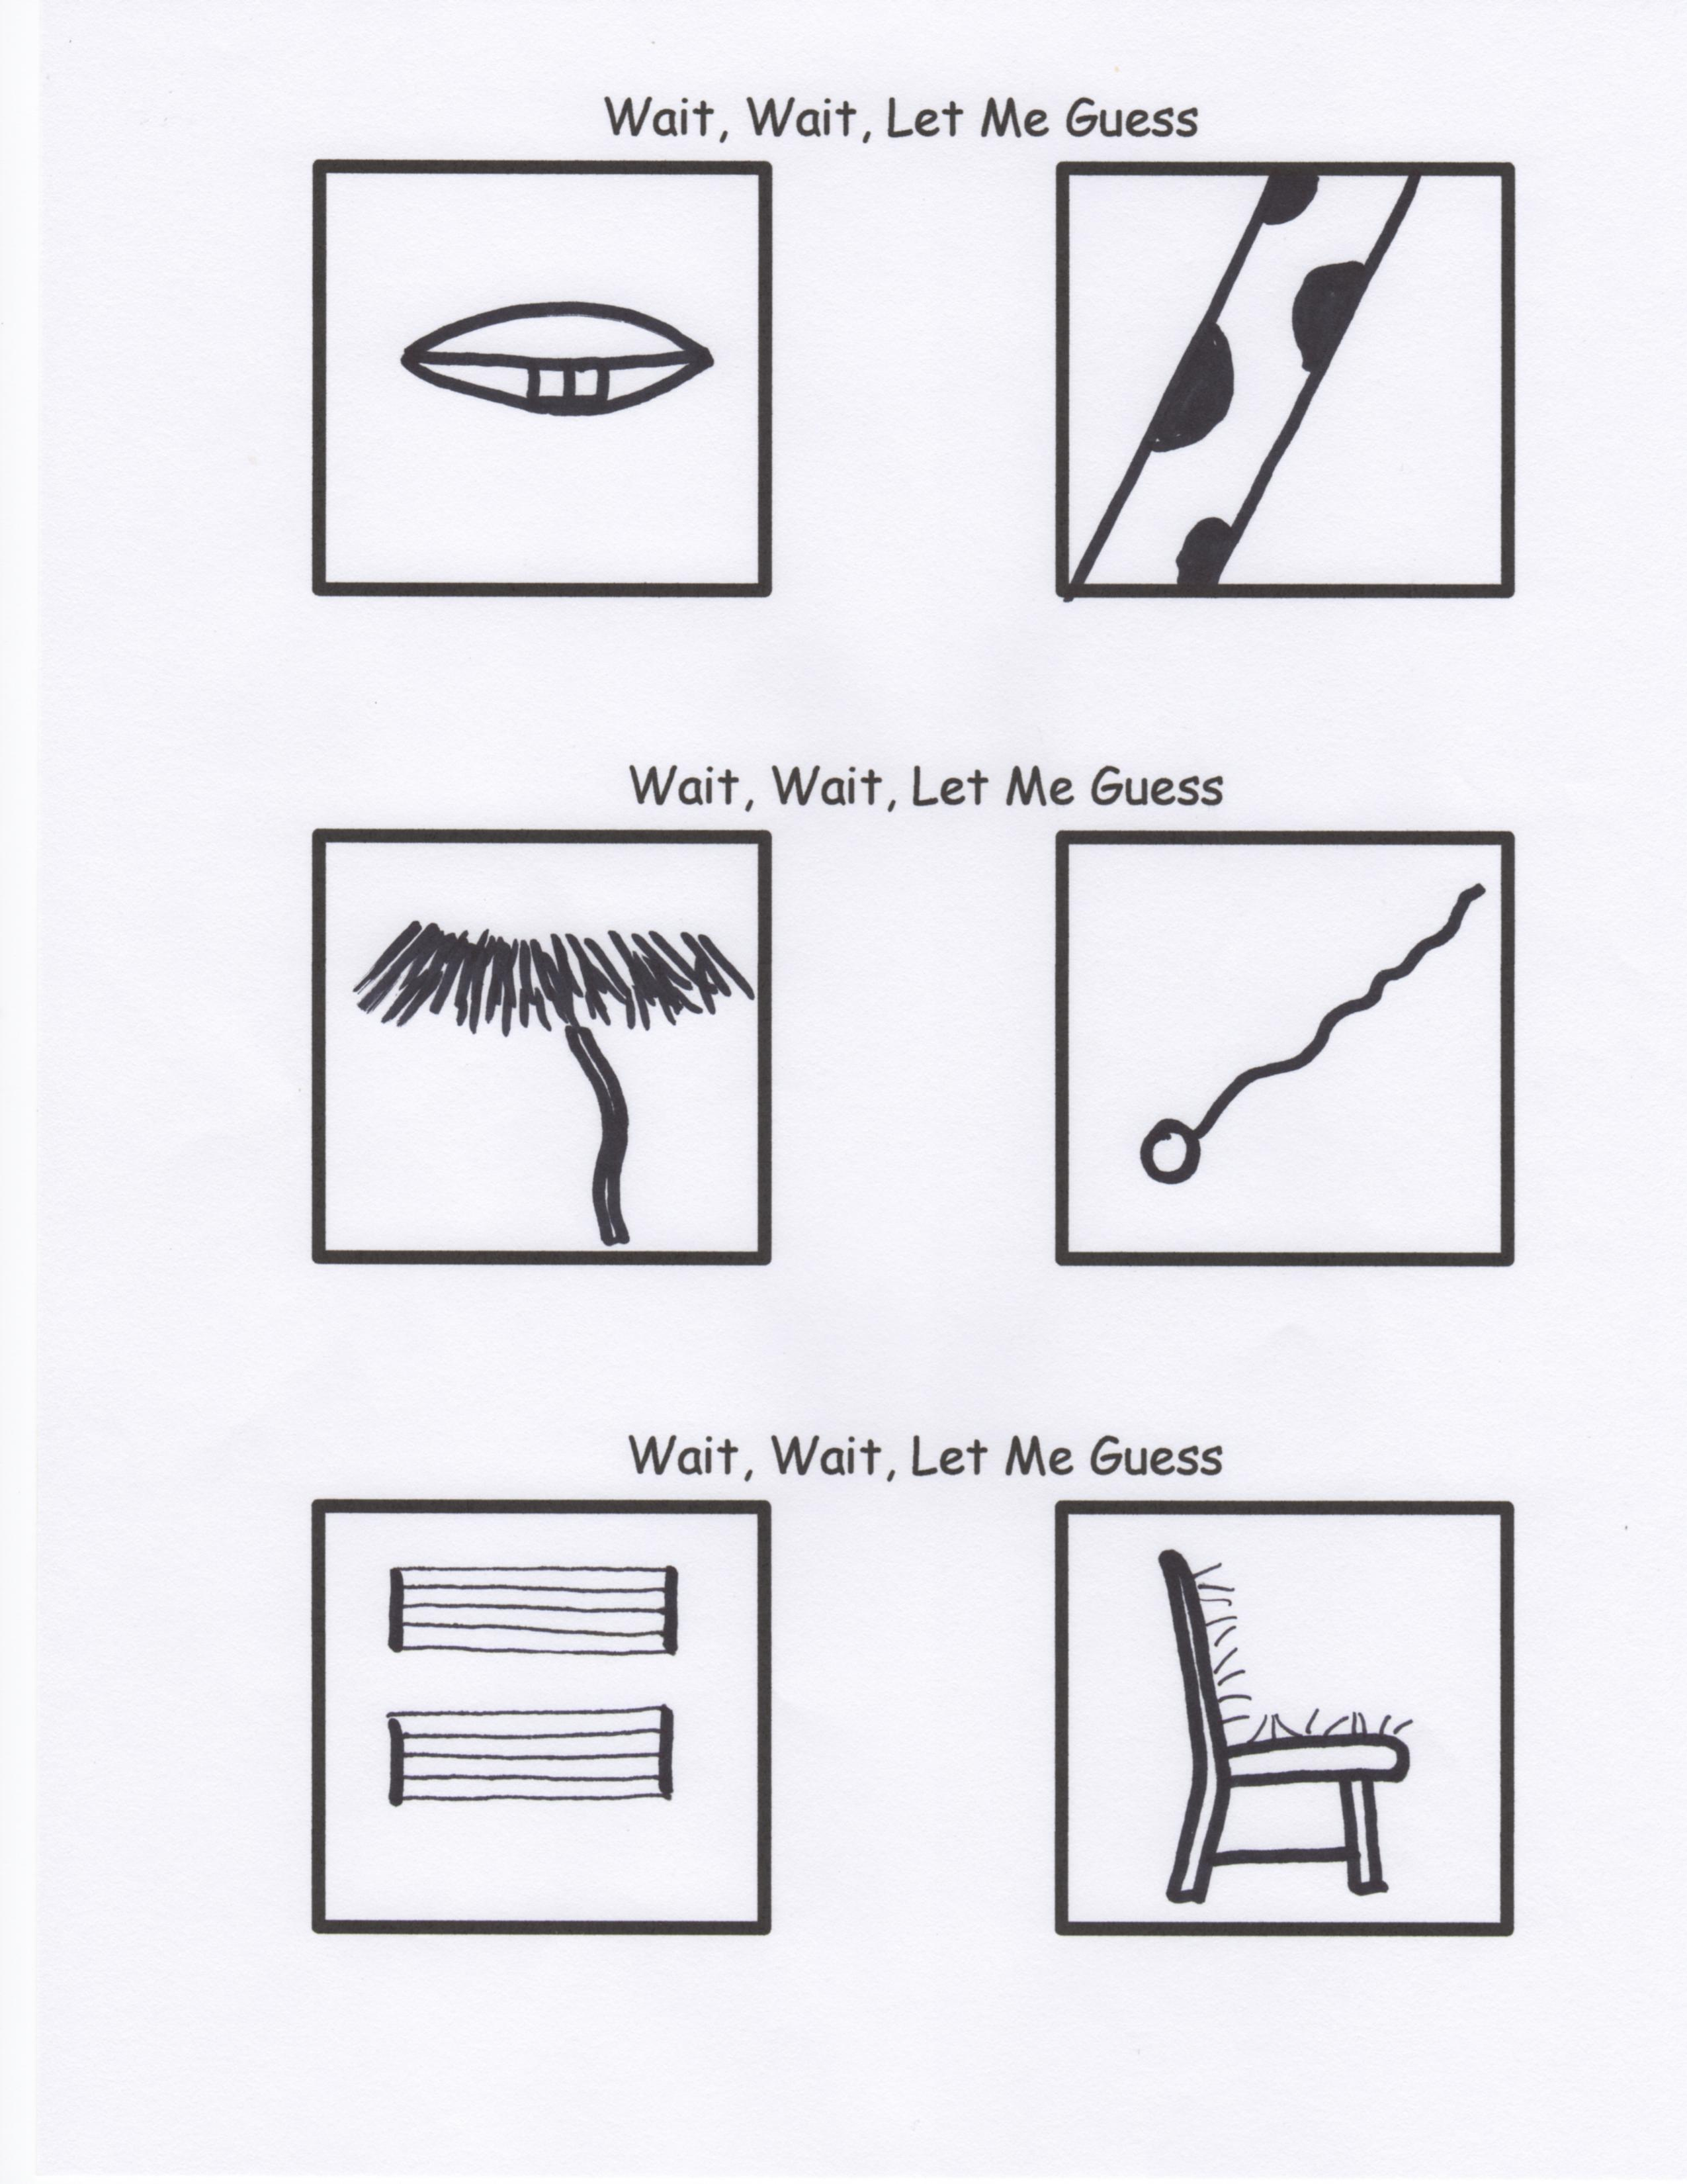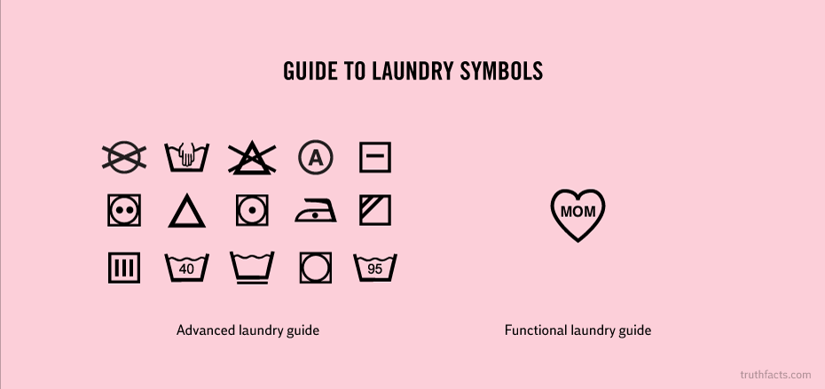

**For the True Scholars Among Us**

This week, remember to take an in-depth look at the literary works of Martin Handford.

Someday you will be doing your own laundry. These are a few things I have learned over the years.

1. Always remember the miracle of **Laundromatic Pressure.** The force exerted by the weight of clothes at the top of a pile of dirty laundry is inversely proportional the square of the number of days since laundry day. When factored with enough time and pressure, the dirty laundry at the bottom of the pile becomes clean.

(Sniff, sniff ...close enough!)

2. My handy Laundry symbol guide.

**The Formula For Love**

**(Solve for “I”)**

9x – 7i < 3(3x -7u)

9x – 7i < 9x -21u

-9x -9x

____________________________

-7i < - 21u

-7 -7

____________________________

i <3 u

By Mr. Lyle (mrlyle1@gmail.com)