**June 19, 2016**

**Volume 4, Issue 30**

Sunday School Times

# The Soap Opera of Daniel 11—Part 2

Published almost weekly, but more like…..whenever, so get used to it, OK?

***Stuff For Today***

• Wait, Wait, Let Me Guess!

* Father’s Day Stuff
* Soap Opera—Part 2

**By Mr. Lyle (mrlyle1@gmail.com**

***Daniel 11: 10-35***

There are those who question Daniel 11. Because it is so historically accurate, they claim that it could not have been written before these events came to be. The Bible is God’s word. He operates outside of the framework of time. He knows the past, present and the future. Those who doubt that reality are not ready to admit that God could ever be that amazing.

When secular world history is laid over Daniel 11, remarkable parallels can be seen. The symmetry is incredibly detailed.

We will finish our look at the Seleucids and Ptolemies as they fought, schemed, fell in love, spied, stole, cheated, murdered, lived and died. All the ingredients for the most sordid real life soap opera the world has ever seen.





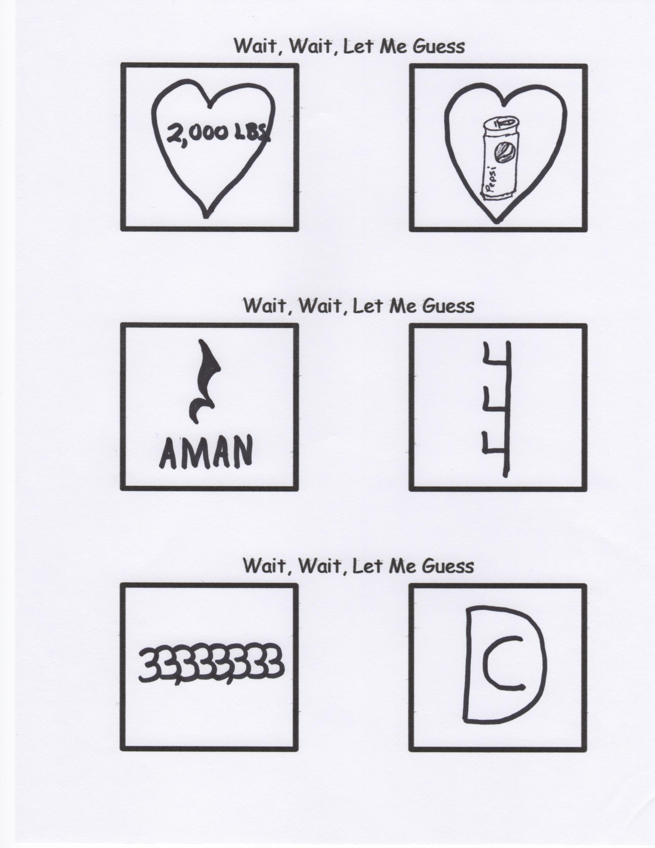

Exhortations, Guidance, and Encouragement from a Dad Who Has “Been There, Done That.”

#114

Developmental education may take many forms. The wise parent understands that each child is unique. And to be truly effective, discipline must be administered carefully. My parents corrected me as a child. I now suffer from a psychological condition known as “Respect of Others”.

Exhortations, Guidance, and Encouragement from a Dad Who Has “Been There, Done That.”

#31

Motivation is the fine art of inserting circumstances or events into the life of your child for the sole purpose of convincing them to do what you want them to do because THEY want to do it.