**July 24, 2016**

**Volume 4, Issue 34**

Sunday School Times

# ?????????

***Stuff For Today***

• Wait, Wait, Let Me Guess!

• The Lord’s Prayer

* Pencil Trivia
* ?????????

Published almost weekly, but more like…..whenever, so get used to it, OK?

**By Mr. Lyle (mrlyle1@gmail.com**

***John 3:16***

***For God so loved the world that He gave His only begotten Son, that whosoever believeth in Him, should not perish but have everlasting life.***

My challenge for you today is to make a very important choice. I want you to be a part of one of the most memorable opportunities you will ever be allowed to enjoy. It is known as “?????????”. ????????? is difficult to explain on paper. My expressed purpose here is that you have the opportunity to understand the wonderful things that are promised to all of those who are committed to being a part of this memorable experience.

In a few moments, each student here will be asked a very simple, but crucial question. A simple “yes” answer will ensure your position in ?????????. And all of the amazing things that are therein.

To turn down the incredible offer of ????????? will result in your removal from the rest of the class. Those who choose not to embrace the experience of ?????????, will be cast out into a dark hallway and required to sit on the floor until the rest of us have indulged ourselves.

My sincerest desire is that everyone partake of the wonders of ?????????.

The choices we make in life are crucial. Even those that we may think small and insignificant, can be life altering. Our decisions have consequences. God’s ultimate plan for our lives is that we learn to make wise, godly choices.

The implication is that we must read and study our Bibles. To know God’s way and live accordingly is the most rewarding life you can imagine. Anything less than that is second best or worse.

My prayer for you is that as you go through life, you will understand the importance of Bible study and prayer. Satan will try his best to sway your opinion. He will spare no effort to deceive you and take you down a road of misery.

The Bible describes Satan as “wicked”. Imagine a boat owner who must take his boat out into the ocean, but he understands that his boat is not seaworthy. He knows beyond a shadow of a doubt that it will sink when it gets out into deep water. Now consider the type of person who would then remove all of the lifeboats, and give away free trips to unsuspecting passengers, fill his boat to capacity, and set sail for deep water, knowing that he and all of his passengers will drown. That is a reasonable definition of wicked.

Satan knows his end. And is determined to take as many people with him as he can. Don’t let yourself be one of them.

The ultimate choice we must make is to have Jesus as our Lord and Savior. Is He yours?

**Pencil Trivia**

1. Got time to kill? The average pencil holds enough graphite to draw a line 35 miles long. History doe not record anyone testing this statistic.

2. Most pencils sold in America have eraser tips, while those in Europe usually have none. Europeans are obviously more confident scribblers.

3. NASA discovered that pencils can write in zero gravity. So they were used on many of the first space missions.

4. Though very rare, left-handed pencils do exist. Most are to be found in private collections.

5. Where do pencils come from? Well, to not be too technical, a Mommy pencil and a Daddy pencil meet and get married, and have lots of baby pencils. They feed them and take care of them and they grow up and eventually go to school. And that’s where you usually find them.

**The Lord’s Prayer**

**(Technically)**

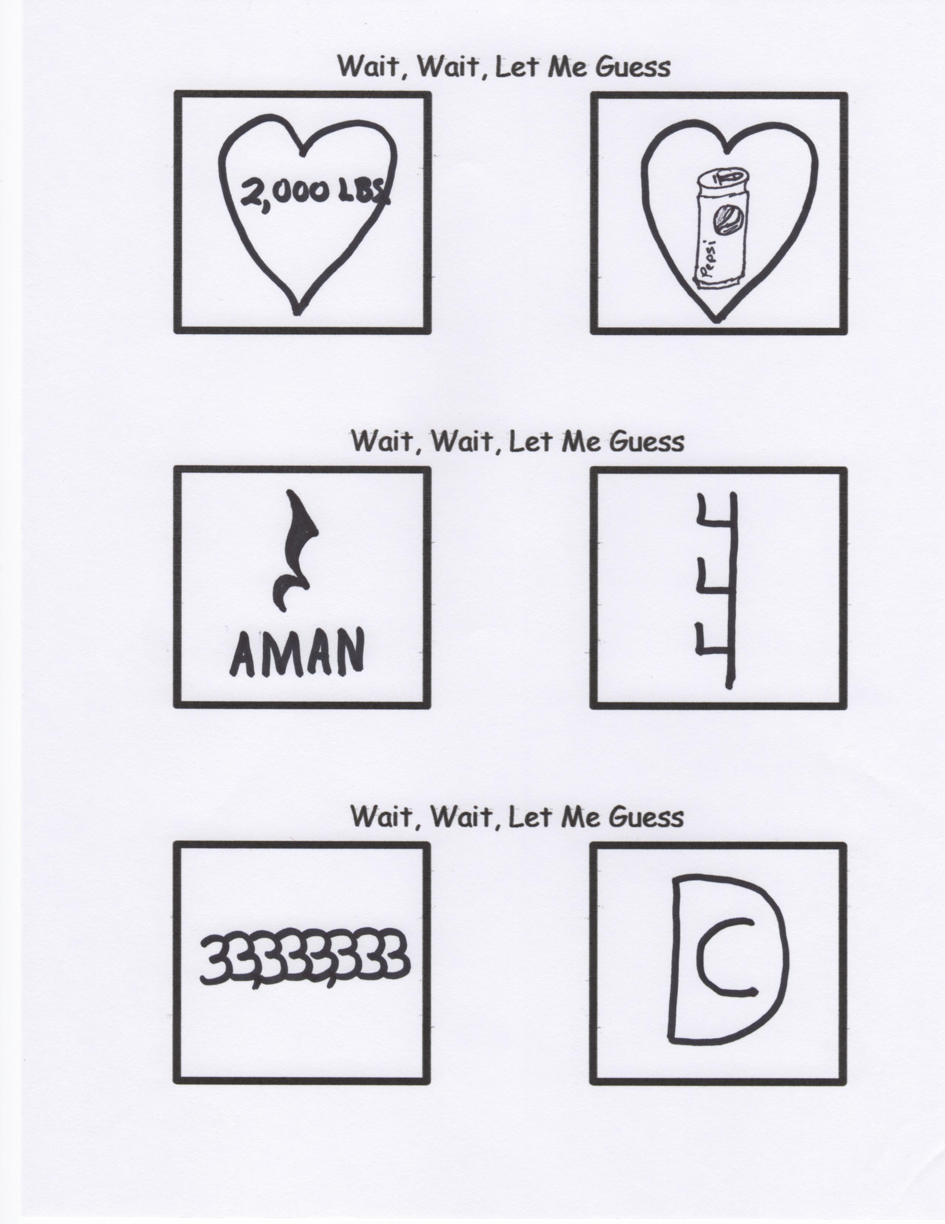

**Here we go again.**

I have to manage my anger because people can’t manage their stupidity!

Paternal relative associated with us established in a celestial position. The designation assigned to your person is inviolable.

Hasten the appearance of the sovereign theocracy retained by you.

Your expressed intensions and purpose be realized similarly upon this sublunary macrocosm as the extra-terrestrial commorancy. Bequeath upon us diurnally circadian triticum comestibles. Exculpate incumbrances as we exculpate conditional liabilities obligated towards us.

Cease inveiglement resulting in inducement, but emancipate us from perdition.

For you possess sovereign monarchial disposition, dynamic efficacy, and eminent illustriousness in perpetuity. So be it.

By Mr. Lyle (mrlyle1@gmail.com)