**July 31, 2016**

**Volume 4, Issue 35**

Sunday School Times

# The End

***Stuff For Today***

• Remembering

• Graduation

* Goodbye!

Published almost weekly, but more like…..whenever, so get used to it, OK?

**By Mr. Lyle (mrlyle1@gmail.com**

**How many of these lessons do you remember?**

1. Finding a watch under one of three cups.

2. George Wilson’s pardon.

3. Prince Charmin.

4. The rat trap

5. Hu Waru

6. The celebration of COTSA

7. 6 impossible things

8. Funeral for a friend

9. The story of Ruth

10. A Kroger Christmas

11. Famous artist Ly Lé

12. The Gospel in the gates of Jerusalem

13. Four faced creatures

14. The impossible football game. AKA Mr. Lyle Bowl XVI

15. RATZ: Reveal Another Terrific Zero

16. The 100 mm canon

17. Kung Fu Moses

18. Magnets

19. The trial of Gill Teaman

20. Bob and Darla’s wedding

21. Bearing fruit

22. Finding an Easter egg. AKA Picking the Lamb

23. The fisherman who mumbled

24. The huge rope

28. Gravity Corner

29. And who can forget the amazing “Wait, Wait Let Me Guess”

**Today’s Graduation Ceremony**

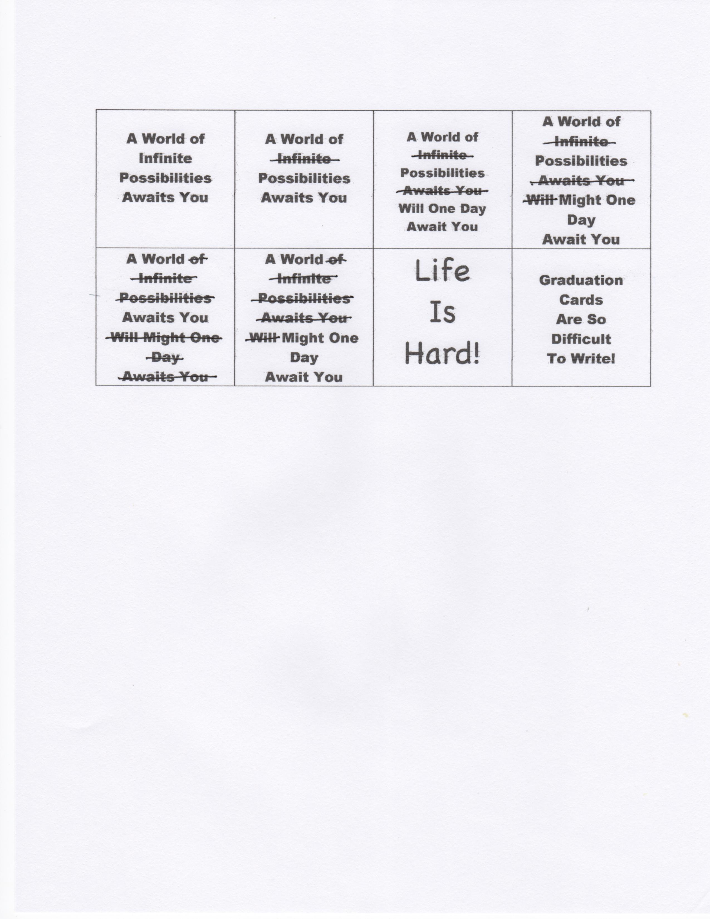

By Mr. Lyle (mrlyle1@gmail.com)

Welcome and Prayer

Pomp and Circumstances beyond our control

The Reading of the Sunday School Times

Announcments

Address by Class Valasalutadictatorian

Magnanimous

Canunimous

Laudinum

Presentation of Diplomas and Various Other Unsundry Items

Closing Prayer

You’re Outa Here!

**Good Bye**

See you later, alligator

After awhile, crocodile

In an hour, sunflower

Toodle-oo, kangaroo

Gotta go, buffalo

Adios, hippos

Chow chow, brown cow

See ya soon, baboon

Adieu, cockatoo

Better swish, jellyfish

Chop chop, lollipop

Bye Bye, butterfly

See ya mañana, iguana

Give a hug, ladybug

Can’t stay, blue jay

Farewell, gazelle

Take care, brown bear

Stay loose, bull moose

Good wishes, little fishes

Gonna hit the road, spotted toad

I’m outa here, white tailed deer

**I would just like to take a few moments to congratulate** **myself on sitting through your graduation ceremony.**