**October 5, 2015**

**Volume 4, Issue 6**

Sunday School Times

Published almost weekly, but more like…..whenever, so get used to it, OK?

# A “Victor Four Way” Rat Trap

***Stuff For Today***

• Wait, Wait, Let Me Guess!

• Rat facts

* Baby ducks
* Why a Victor 4-Way?

**By Mr. Lyle (mrlyle1@gmail.com**

***Proverbs 3: 5***

**Trust in the Lord with all your heart and lean not on your own understanding.**

Rodent control is much more reliable with the use of *Victor 4-Way Rat Traps.* Rat and mousetraps have evolved little over the many years, and the spring-loaded-rodent-crusher is still my method of choice.

Most would think it hardly a topic for a Sunday School lesson, but bear with me and perhaps I can draw things together sufficiently.

The writer in Proverbs is using a common technique for Hebrew poetry. No rhymes as we might want in our culture, but rather, a repetition of a phrase with a slightly different set of words with their implied subtle differences in meanings. Let’s look at this verse in two parts.

The first phrase is *Trust in the Lord with all your heart.* I have little problem in that area. I know and understand that God is able to do anything, and I don’t have to worry or fret about anything. He will take care of me always. I can trust Him completely!

It’s the second half that I personally struggle with. *And lean not on your own understanding* requires something from me that I am not comfortable giving up. I am by nature an inquisitive person. I want to know how things work, and how they operate. I want to understand them.

There are times in life when God does not find it necessary to explain to us all of the details. It is not important to Him that we completely understand everything.

At times He wants us to simply obey blindly, not knowing the future or the outcome. Only knowing that we are operating in the will of God, and that needs to be enough for us.

That is the ultimate test of trust--to obey blindly. Imagine the following.

Suppose you had a *Victor 4-Way Rat Trap* directly in front of you. It has been baited with several one dollar bills. Now suppose you are blindfolded and given the *opportunity* to reach in and grab the money but it will have to be done incredibly fast, so your hand is not crushed by the trap.

Would you follow the instructions, or would you balk at the idea because it made no sense to you to take that risk?

Welcome to our Sunday School Bible lesson!

**Rat Facts**

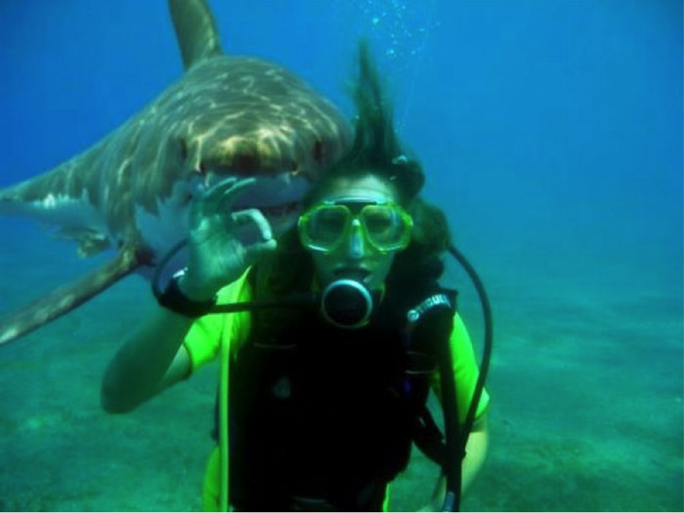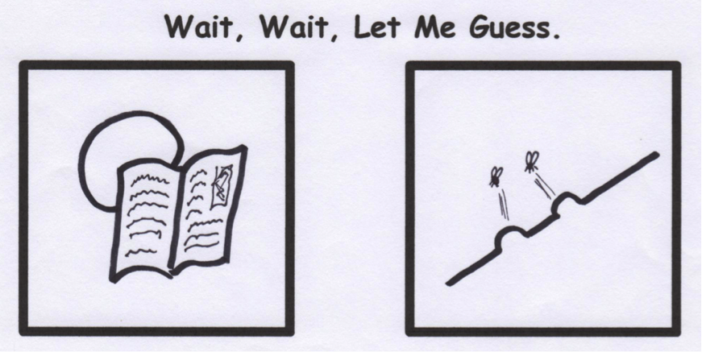

Trust me, there are no sharks around here.

Don’t trust anybody…..except a baby duck that thinks it’s a dog. He’s legit!

WOOF

1. Rats can go longer than a camel between drinks of water.

2. Rats are very sensitive to electromagnetic fields and can be very uncomfortable around today’s electronic devices.

3. Rats lack the ability to throw up.

4. Rats can survive being flushed down a toilet and can often find their way back up and out of it.

5. A group of rats is called a Mischief.

6. Rats are actually quite clean animals and will spend several hours a day grooming themselves.

7. Rats will blink if hit in the head with a hammer.

By Mr. Lyle (mrlyle1@gmail.com)