**January 22, 2017**

**Volume 5, Issue 17**

Sunday School Times

Published almost weekly, but more like…..whenever, so get used to it, OK?

# The “Forgotten” Character Trait

**By Mr. Lyle (mrlyle1@gmail.com**

***Stuff For Today***

• Enthusiasm defined

• Free advice you can take out into the world as you grow older.

• If you could use only four words to describe God, which four would you choose?

***Isaiah 59:17***

***He put on righteousness as His breastplate,  
 and the helmet of salvation on His head;***

***He put on the garments of vengeance***

***and wrapped Himself in zeal as in a cloak.***

A most interesting portrayal is found in Isaiah 59:17! Few are familiar with this verse, yet it describes the essence and character of God more succinctly than any other passage in the Bible. We find there four character traits that picture Him to us in an extraordinary way. An infinite God defined by four words.

*He put on righteousness as a breastplate.* Righteousness. God is absolutely, totally and completely perfect in every way. End of discussion. He cannot abide with sin. He loathes it. He will not allow anything less than His standard to prevail. Everything God does is righteous and good. Everything.

*And the helmet of salvation on His head.* Salvation. From before the creation of the world, God knew we would have a problem with sin. So He made plans for the redemption of man, salvation. It is the central theme of the Bible from beginning to end. Christ is the sacrifice, the Son of God. And if the references to the breastplate and helmet sound familiar, it is worthy of note that Paul, in writing to the Ephesian church, wasn’t the first to use an analogy of armor. A careful study of Isaiah 59 will reveal all the other items Paul mentioned as well.

*He put on garments of vengeance.*  Vengeance. God is a vengeful God. He is Judge, Jury, and Executioner. That description is discomforting to us. And yet, through the pages of the Bible we see over and over again God judging sin—harshly. It may even frighten us a bit. That is not all bad—*the fear of the Lord is the beginning of wisdom.*

The fourth character trait may surprise most. Few think of God in this light, which is truly unfortunate.

*And wrapped Himself in zeal as in a cloak.* Zeal. The “forgotten” character trait of God, zeal, is defined as “intense enthusiasm, to be deeply passionate about.” Everything God does, He accomplishes with eagerness and excitement. He is sincerely fervent about all He has ever done. That is an amazing idea. Just think what that can mean. Not only was He intensely passionate and enthusiastic about the big moments, like creation. But He is also as ardently interested when dealing with individual people on a day to day, moment by moment basis.

The zeal of God is awesome to behold. An example is found in Job 38:7. God was talking to Job, upbraiding him for his behavior, and reminding him about creation. He concluded with the phrase *while the morning stars sang together and all the angels shouted for joy.* The picture that comes to mind is of overwhelming scope. Imagine the entire population of Heaven gathered together. Billions and billions of the heavenly host are looking on. Jesus Himself steps out into the nothingness. With the enthusiastic and passionate zeal of God Almighty, He declares “Let there be light.” As He speaks the words, light comes into being, (and probably all the laws of physics and time as well). In His zeal, He acknowledges the awesome, perfect, amazing thing He has done and says “It is good!” All of heaven recognizes it too, and a deafening cheer goes up to God for the wonderful things He has done in that moment. The universe that we live in is not merely an average creation prepared by a mediocre God. It is an absolutely astonishing creation completed by an enthusiastic, passionate God intent on doing His very best, if that is even appropriate to say.

**Enthusiasm: (noun)**

**Great Excitement For, or Interest in, Some Thing**

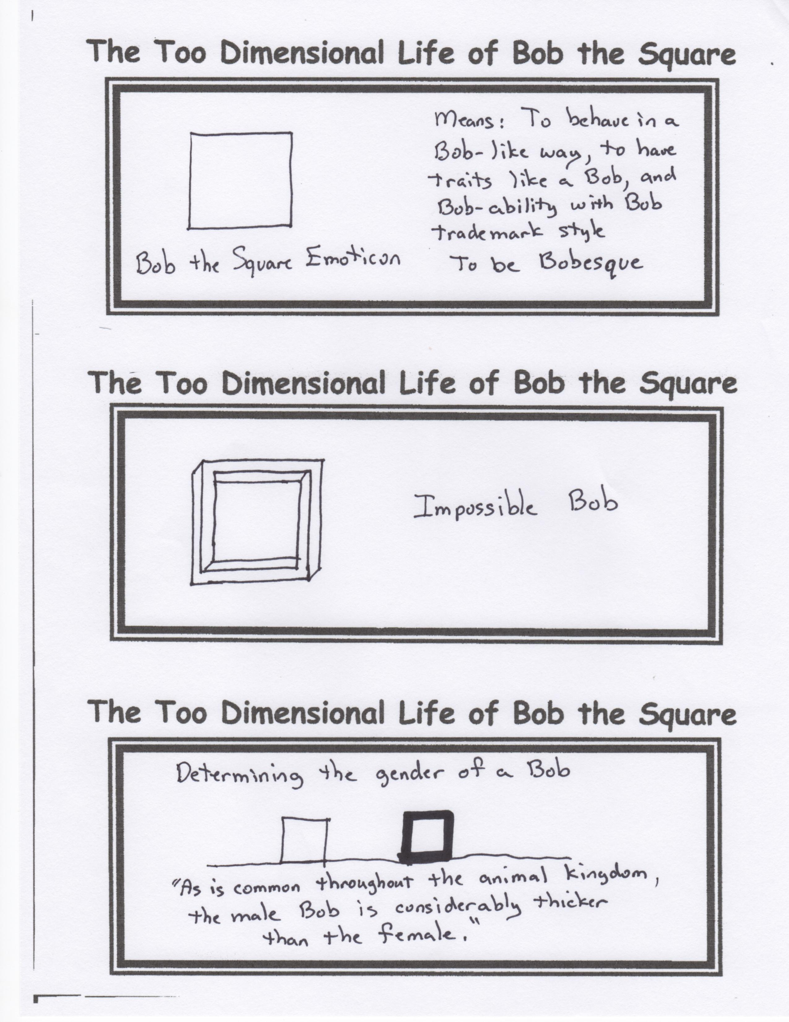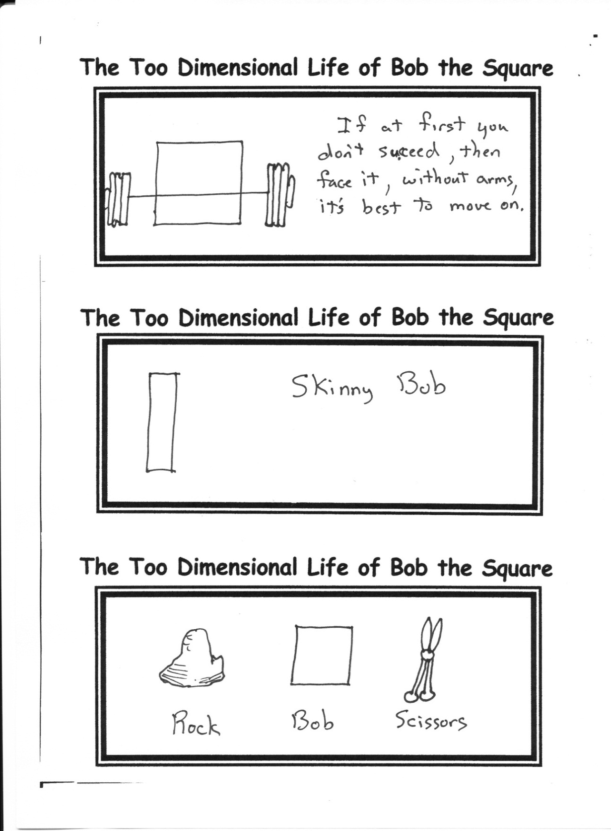

Every two years we have a very special meal. It is unlike anything that you have ever experienced! We will be giving you the time and place soon. But expect great food, a movie, and some live entertainment. This will be your only chance to see this. Reviews have been tremendous—5 out of 5 stars every year!!!!!!

By Mr. Lyle (mrlyle1@gmail.com)