**July 23, 2017**

**Volume 5, Issue 38**

Sunday School Times

***Stuff For Today***

• Ten Facts About You

• Bonus History Info

• Of hippos in Australia, wax, and pottery in Ancient Greece.

Published almost weekly, but more like…..whenever, so get used to it, OK?

# Sincerely Yours

**By Mr. Lyle (mrlyle1@gmail.com**

***Philippians 1:9-11***

***9 And this I pray, that your love may abound yet more and more in knowledge and in all judgment; 10 That ye may approve things that are excellent; that ye may be sincere and without offence till the day of Christ. 11 Being filled with the fruits of righteousness, which are by Jesus Christ, unto the glory and praise of God.***

My suspicion is that in a world where we are constantly chatting, texting, or twittering, very little is actually being said. We substitute human emotions with punctuations :p :) and emoticons, hoping somehow they can convey the subtle nuances of our lives.

An art form is all but lost to this generation—the simple letter. To handwrite a letter required time, thought, and care. In my case, my letters were to my fiancé (who is now my wife). Telephone was a luxury for the wealthy, and we were separated by a great distance covered easily, albeit slowly, by the envelope and stamp. Great attention and thought was given to the words used and their meanings. A posted letter might travel for days before arrival in my sweetheart’s hand, and a reply would come back no faster.

Those of us who grew up using this medium of communication learned to appreciate the time and care required to transmit thoughts and feelings. The ebb and flow of the pen upon the paper made it very personal—I knew my letter was something tangible that would be held and carried and kept.

The greeting at the beginning of the letter was vital, but it was also important to finish well. Those last two or three words before I signed my name were crucial.

Technically referred to as the closing, this part of any letter to many may seem more like a tradition than a real necessity. Words such as *cordially, regards,* and *sincerely* are most common.

*Sincerely* is a fascinating word study. I have heard it’s origin may have come from two Greek words: ***Sin*** and ***Cerae*.** *Sin* is a negating word, and *cerae* means wax. Respectable ancient Greek pottery vendors might have those two words in their storefront window, telling all who came by that their pottery had *no wax!*

Charlatan dealers would fill cracks and defects in their pottery with wax and simply paint over them. You can imagine the problems that might become evident the first time the pot encountered heat and the wax began to melt.

As Christians in this world, we have an obligation to be honest, trustworthy, worthy of respect, authentic, truthful, and without wax—sincere.

The next time you write a letter and sign it *sincerely yours*, remember the message you wish to convey: you are without wax!

**Top Ten Facts About You**

By Mr. Lyle (mrlyle1@gmail.com)

1. You are reading this right now.

2. You’re realizing that this is a stupid fact.

4. You didn’t realize I skipped 3.

5. You’re checking now.

6. You’re smiling.

7. You’re still reading this even though it’s stupid.

9. You didn’t realize I skipped 8.

10. You’re checking again and smiling about how you fell for it again.

11. You’re enjoying this.

12. You didn’t realize that there were only supposed to be ten facts on this list…Hey, wait a minute, there are only ten after all!

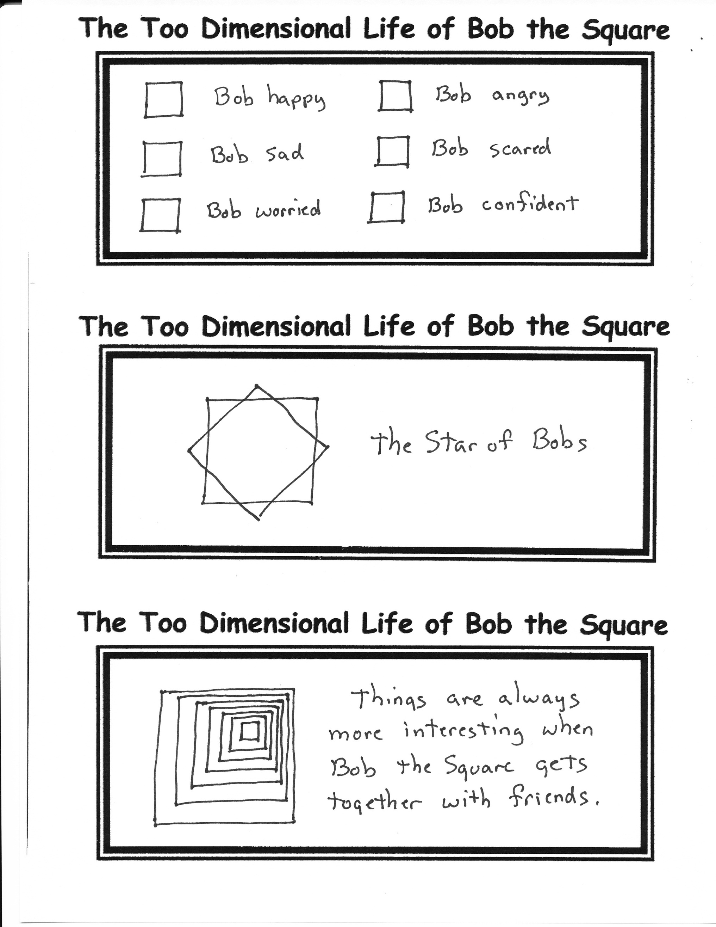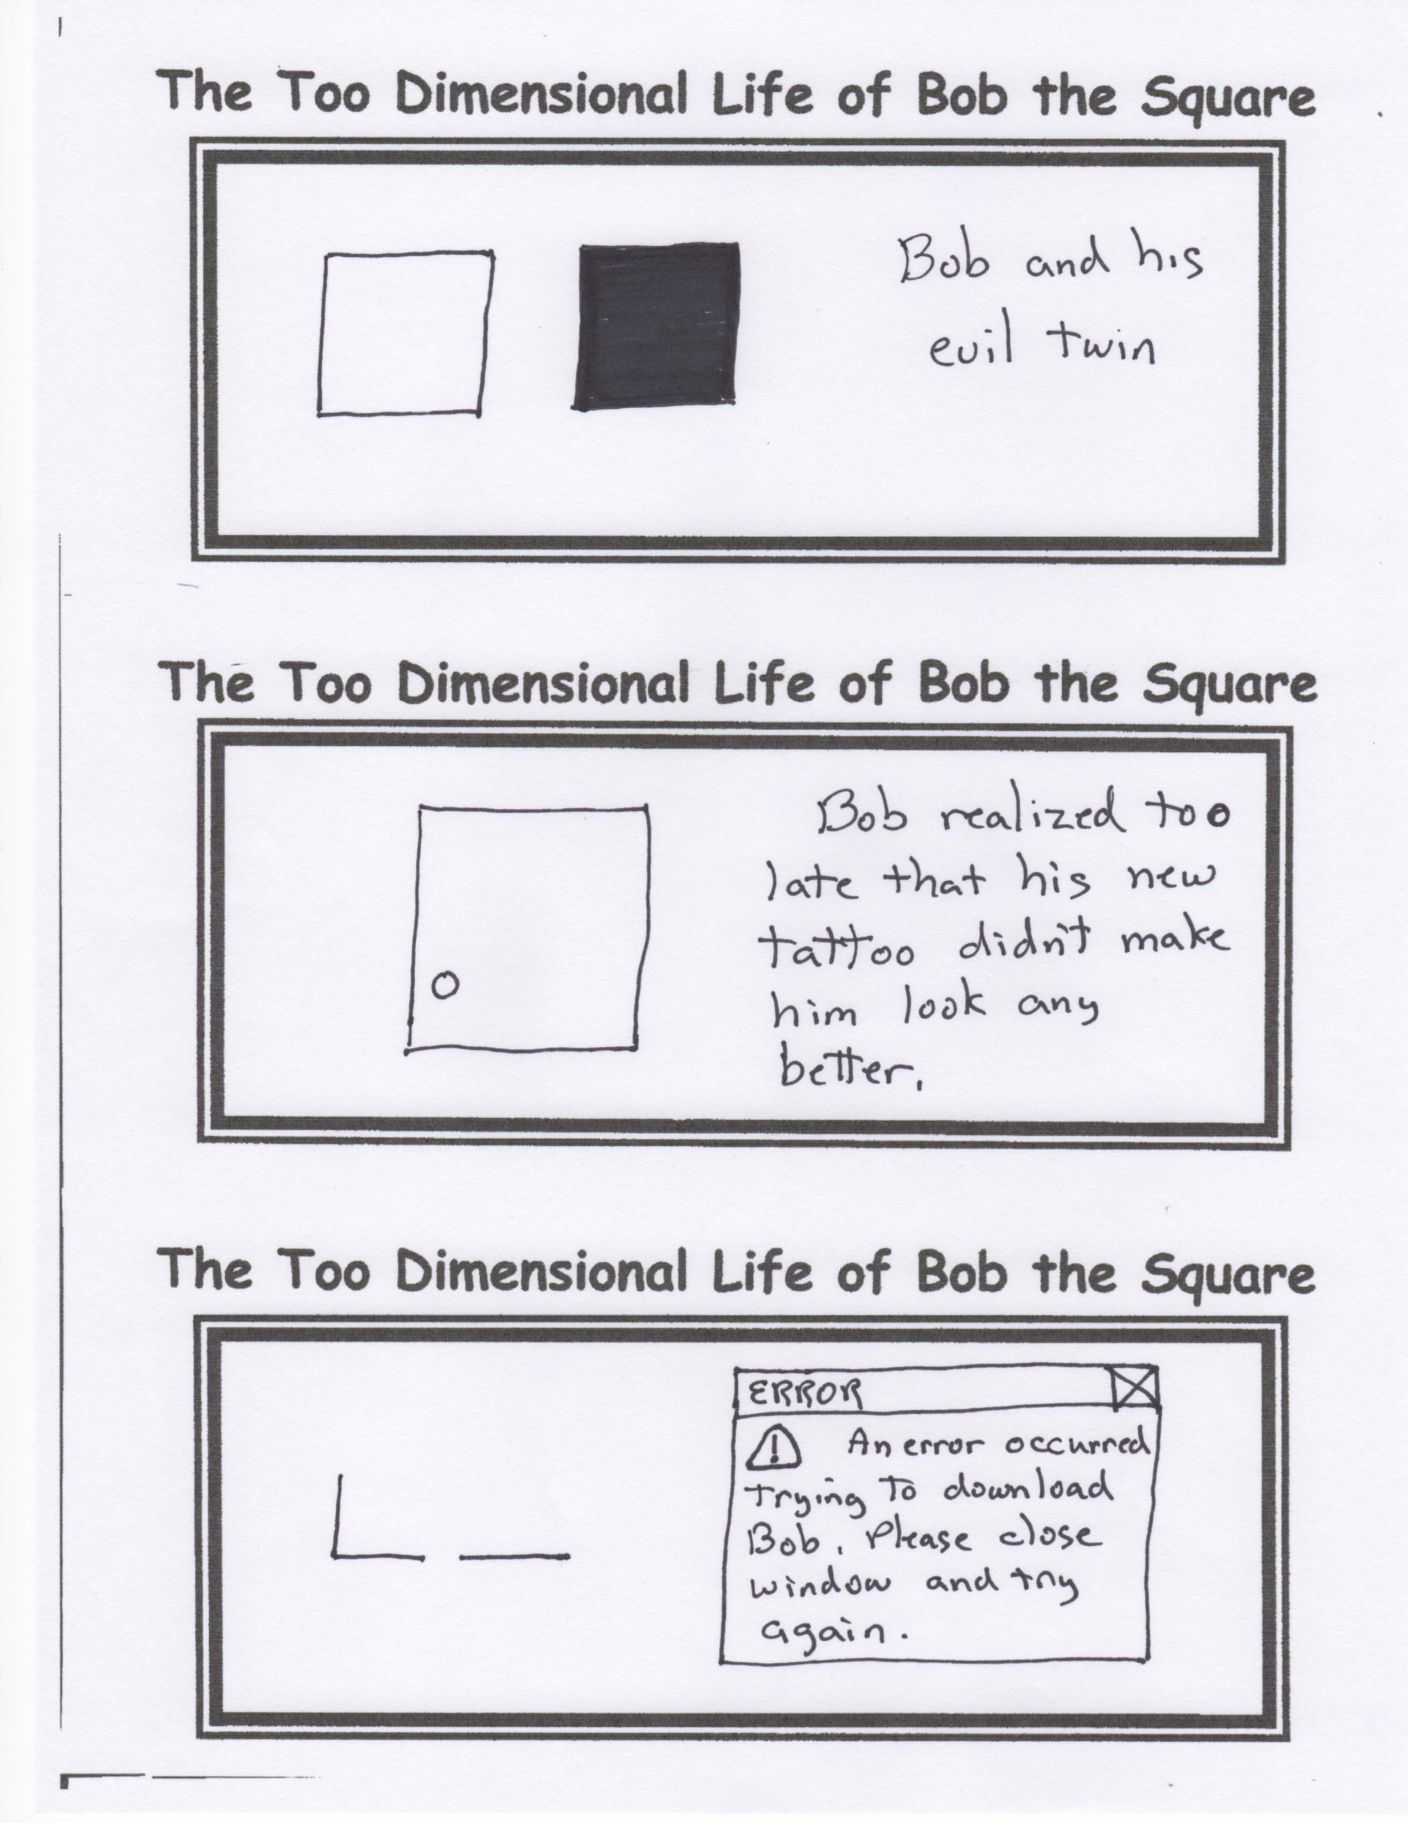

**Mr. Lyle Answers Your Questions About History**

***Question:*** If Robert E. Lee had a helicopter, would the South have won the Civil War?

***Answer:*** Probably not. By this time, all of the Confederate aviation fuel depots were surrounded by Union forces.