**October 9, 2016**

**Volume 5, Issue 5**

Sunday School Times

Published almost weekly, but more like…..whenever, so get used to it, OK?

# The Definition of Freedom in 2016

***Stuff For Today***

• Bob the Square

• The National Anthem, signs, a pendulum, rope, chain, sales label, tape, tea bags, and a wooden jaw clamp.

**By Mr. Lyle (mrlyle1@gmail.com)**

**John 8:32**

**3*2****And ye shall know the truth, and the truth shall make you free.*

The nation that we live in was founded upon the very principles of freedom. And contrary to what many in our country would like to believe, our fore fathers placed their extraordinary confidence in the Bible. Their thoughts, ideas, and actions were grounded in the pages of Scripture.

The result of that understanding of the Bible has given our nation two incredibly solid documents the Declaration of Independence, and the Constitution of the United States.

In many other nations in our world today, the desire to come to America is quite prevalent. All too often, we take our freedom for granted and assume that everyone else enjoys the same rights and privileges that we have. We do not live in One World.

The Bible is filled with support for freedom. God wants His children to be free, in all aspects of life.

Jesus said that we will serve a master during our life here upon this earth. And He also said that His yoke was easy and His burden light. Life can be difficult, to be sure, but for the Christian, the peace of mind from knowing that God is in control, and that He loves us dearly, is quite comforting.

Christ was, and is, the ultimate dispenser of freedom. Because of the cross, we can now be free from sin, free to serve Him, and free from our entanglements with this world .

**Our Lesson for Today**

1. We will all rise and sing the National Anthem—well almost all of it, anyway.

2. We will discuss signs on the lavatory onboard a commercial aircraft.

3. We will experience the peculiarities of a swinging pendulum.

4. We will practice the fine art of tying knots in rope..

5. We will examine the security features of chain and padlock.

6. We will discuss sales and promotional ideas used by small businesses.

7. We will decide if it is better to remove tape that is covering the mouth very slowly, or simply rip it off.

8. We will discuss an important moment in US history.

9. We will see firsthand a typical torture device in use.

10. We will decide whether Heaven or Hell is the preferred destination for most.

**Abraham Lincoln Concerning Freedom**

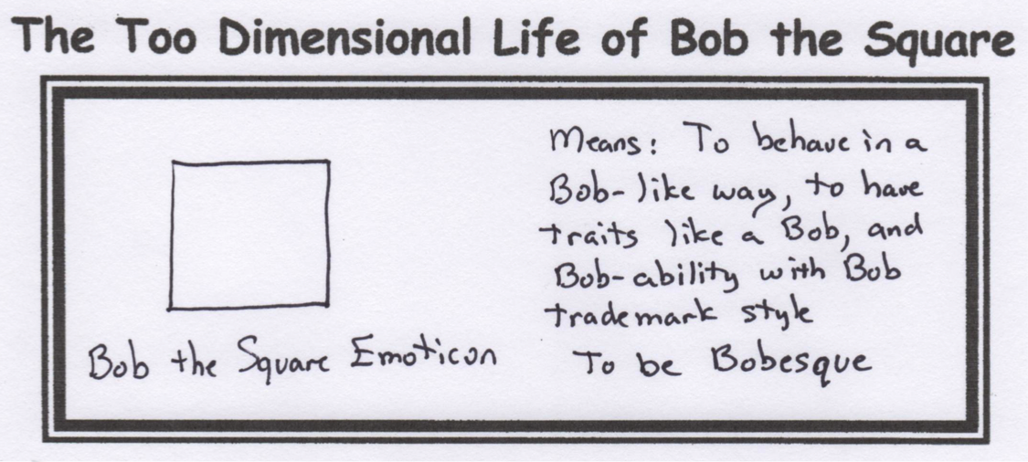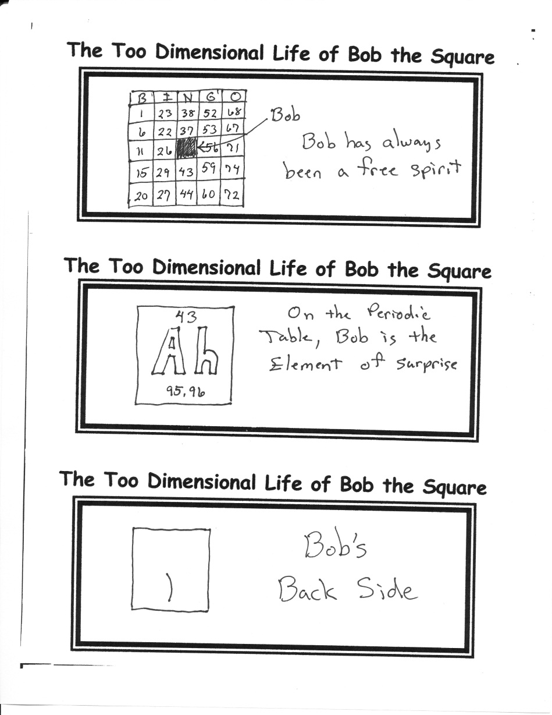

Freedom is not the right to do what we want, but what we ought.

Those who deny freedom to others, deserve it not for themselves.

Whenever I hear anyone arguing for slavery, I feel a strong impulse to see it tried on him personally.

Four score and seven years ago our fathers brought forth on this continent, a new nation, conceived in Liberty, and dedicated to the proposition that all men are created equal.

By Mr. Lyle (mrlyle1@gmail.com)