**December 10, 2017**

**Volume 6, Issue 12**

Sunday School Times

***Stuff For Today***

• Wait, Wait, Let Me Guess

• Evolutionary Theory

* Christmas Begins
* The Redeemer says “yes”

Published almost weekly, but more like…..whenever, so get used to it, OK?

# Ruth Chooses A Redeemer

**By Mr. Lyle (mrlyle1@gmail.com)**

***The Book Of Ruth Chapter 3 and 4***

To a Hebrew, the New Testament term of redeemer would be more accurately defined as kinsman-redeemer. The Old Testament law of the kinsman-redeemer provides some interesting insights into the concept of calling Jesus our Redeemer. The Biblical narrative says that Ruth washed (we are washed, born again, forgiven), anointed herself (we have the anointing of the Holy Spirit), dressed in her best clothes (we are clothed in the righteousness of Christ), and she claimed her redeemer (we, too, must accept our Redeemer). Staking that claim was her only requirement. Everything else became the responsibility of Boaz. (God performs all the work in our salvation.)

There is also mention of a redeemer who was of closer relationship who refused to do his duty, and thus Boaz could fulfill the request. That nameless kinsman represents the Law. It cannot save, because no one is able to keep it. The kinsman-redeemer was also responsible for justice. If we claim Jesus to be our Redeemer, He is our Kinsman-Redeemer, and we have no need to seek personal revenge for wrong done to us, he will ensure that justice is applied.

The romance of redemption is a beautiful thing to behold.

**Reindeer Biology**

**Observation A:** Santa has nine reindeer

1. Dasher

2. Dancer

3. Prancer

4. Vixen

5. Comet

6. Cupid

7. Donder

8. Blitzen

9. Rudolph

**Observation B**. It is a biological fact that both male and female reindeer have antlers.

**Observation C**: It is also a biological fact that male reindeer shed their antlers each year around October. Only the females would have antlers during the Christmas Season.

**Conclusion:** All of Santa’s reindeer are ladies. Including Rudolph!

**If you decide to build a snowman this year, may I suggest…**

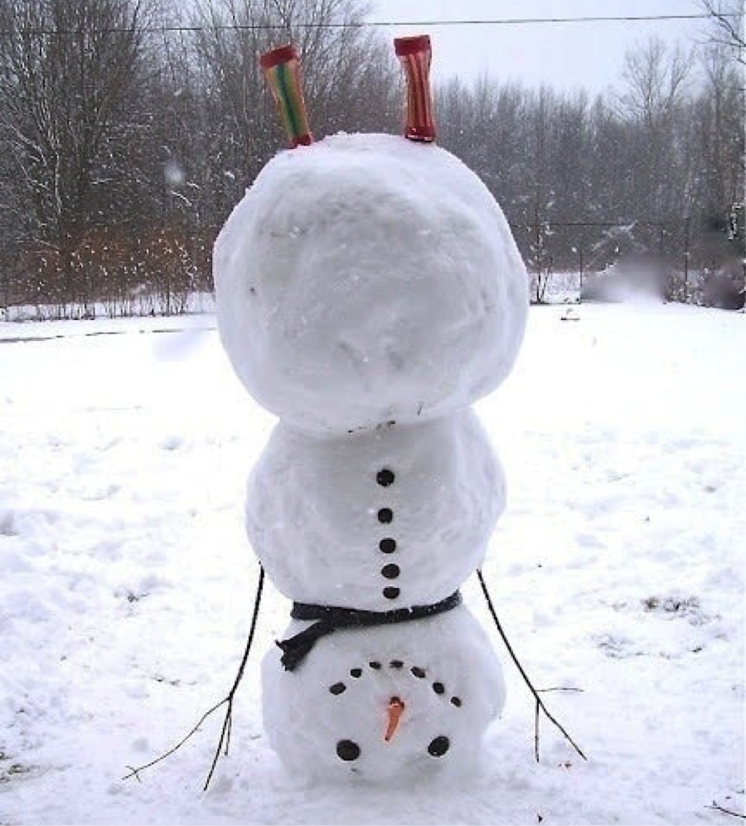

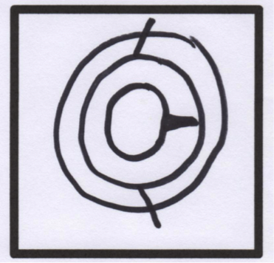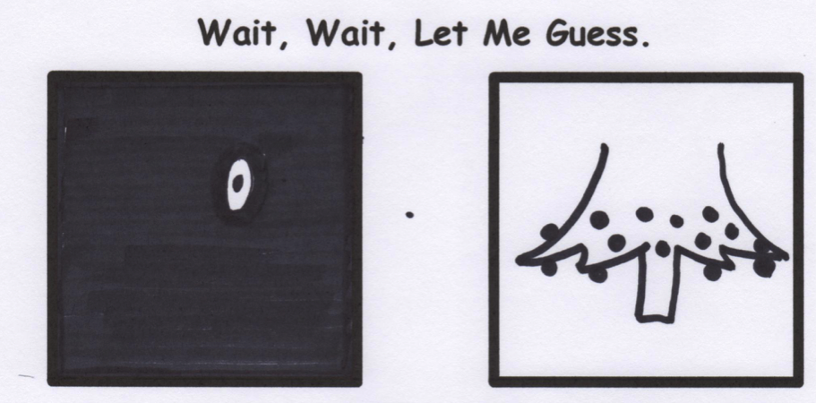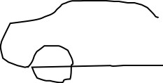

**Our Christmas Vacation Last Year**

Most of our vacation was in **Consequential.** Our best friends asked us to meet them in **Vitation**, I must have misunderstood them, because they were actually in **Terpret.** We spent a miserable afternoon in **Tolerable**, and the bugs were really bad in **Sect**. I fell off a horse in **Jure,** and when we went to find a doctor, we couldn’t find on in **Visible**. So we stopped for directions in **Quire.** We took a wrong turn in **Verse** and ended up in **Variably.** The wound became very red and swollen in **Fection**. Things got worse in **Crease**. And there was one thing that happened in **Cident** that I’d rather not talk about.After an anxious day in **Secure**, we decided to cut our trip short and spend our last night in **Complete.** On the last night we were in **Sane.** Apparently they have no airport because we have been driven there often by friends, family, and co-workers.

Hope yours this year will be better than ours.

120 million years ago this boulder looked remarkably like a 1983 Nissan Sentra. Isn’t evolution amazing?!

**Mr. Lyle Explains Evolutionary Theory**

By Mr. Lyle (mrlyle1@gmail.com)