**February 25, 2018**

**Volume 6, Issue 21**

Sunday School Times

***Stuff For Today***

• Wait, Wait, Let Me Guess

• Seasonal Fruits and Veggies

* Texting Shorthand
* 4 x 4 x 4
* Questions and Answers

Published almost weekly, but more like…..whenever, so get used to it, OK?

# 4 Faces, 4 Gospels, 4 Names

**By Mr. Lyle (mrlyle1@gmail.com)**

***Ezekiel 1: 5-11***

***5 and in the fire was what looked like four living creatures. In appearance their form was human, 6 but each of them had four faces and four wings. 7 Their legs were straight; their feet were like those of a calf and gleamed like burnished bronze. 8 Under their wings on their four sides they had human hands. All four of them had faces and wings, 9 and the wings of one touched the wings of another. Each one went straight ahead; they did not turn as they moved. 10 Their faces looked like this: Each of the four had the face of a human being, and on the right side each had the face of a lion, and on the left the face of an ox; each also had the face of an eagle. 11 Such were their faces. They each had two wings spreading out upward, each wing touching that of the creature on either side; and each had two other wings covering its body.***

Ezekiel struggles to find words to adequately describe the scene before him in the first chapter of his prophecy. One cannot read through the entire narrative without asking “What in the world are we seeing?” Four creatures are introduced in the passage, completely beyond our comprehension, with four faces each. That particular attribute is more than just a bizarre oddity, it has significance. The Bible is not a mere piece of literature. It is an amazingly intricately interwoven collection of writings obviously inspired by God and put together by Him for our use to understand Him.

Each creature had four faces; the first, the face of a man, the second, the face of a lion, the third, the face of an ox, the fourth, the face of an eagle. A parallel can be drawn to the four Gospels found in the New Testament. Luke wrote his gospel from the viewpoint of a medical doctor. He saw first-hand the humanity of Jesus. Jesus was indeed a human being, and Luke referred to Him often as the Son of Man. The first face mentioned was the face of a man. The second face was that of a lion, a symbol of kings throughout history. A beginning to end reading of Matthew reveals that he saw Christ as a king. Matthew begins that portrayal with his record of the Magi visiting the Child shortly after His birth. Mark saw Jesus through the lens of a servant. He recognized that Jesus came as the Servant of God, a man who learned obedience as an example to us. An ox is a beast of burden whose life is dedicated to serving its master. The final face was that of an eagle. The eagle represents divinity. Jesus was and is divine—He is God. No other inspired writer explained that more clearly than did John in the first verse of his gospel. And through the remainder of his book, he focuses on the reality that Jesus was God in human form.

Revelation 19 describes for us in detail, a rider on a white horse. That rider, found in verses eleven through sixteen, is Jesus Christ. When He returns in the fullness of His glory, He is described by four specific names.

*Whose rider is called Faithful and True.* No one is more loyal than is the faithful servant. Mark mentioned that attribute. *His name is the Word of God.* Immediately, we recall John’s opening words. Jesus is the Alpha and the Omega, the great I AM. *He has this name written: KING of KINGS and LORD of LORDS. M*atthew couldn’t have said it better. *He has a name written on him that no one knows but he himself.* The fourth name is actually a secret in Revelation. The greatest mystery of Scripture is this simple fact: Why would God, the Creator, the Almighty, lower Himself to the condition of his creation, man, and walk among us? His love for us is astounding, a great unknown quality to us were it not for the fact that He demonstrated His love toward us by going to a cross and dying a very human death on our behalf. Luke recounts in detail the human being he touched and talked to face to face, who he also recognized to be God.

Four unique Gospels, four unique faces, four key attributes of God, masterfully intertwined in the Bible. The Word of God is unlike any other piece of literature, and the deeper one looks into Scripture, the more there is to be learned. Never discontinue that thrilling discovery.

**What Texting Shorthand Will Look Like When Your Generation Reaches 60**

ATD—At the doctor’s

BFF—Best friend fell

BTW—Bring the wheelchair

FWIW—Forgot where I was

IMHO—Is my hearing aid on?

TTYL—Talk to you louder

LMDO—Laughing my dentures out

AIFOTV—Asleep in front of TV

WTALOS—Wow that’s a lot of stairs!

WRU—Who are you?

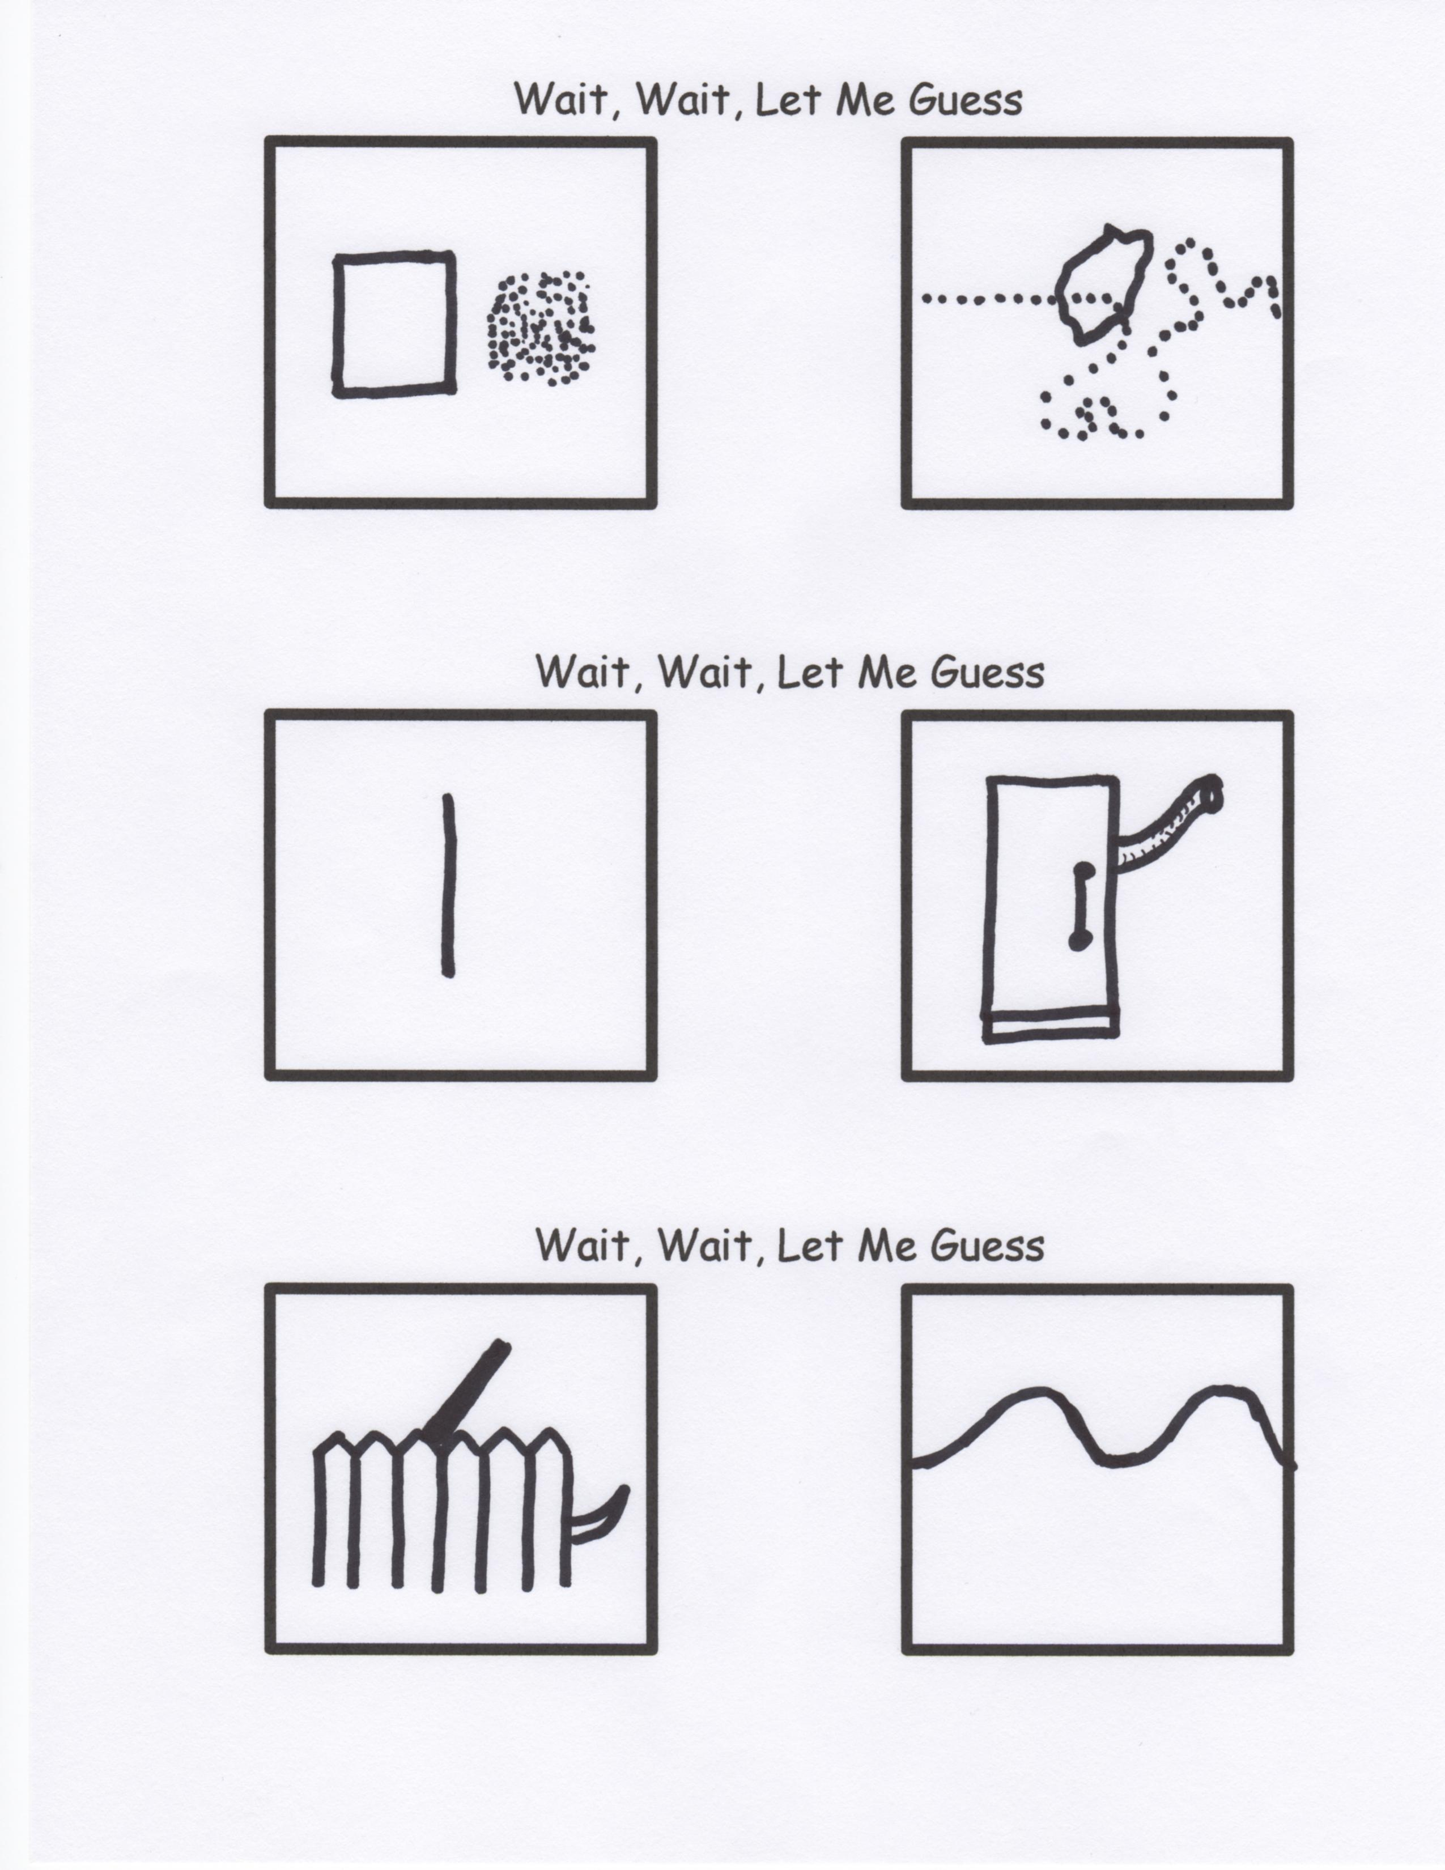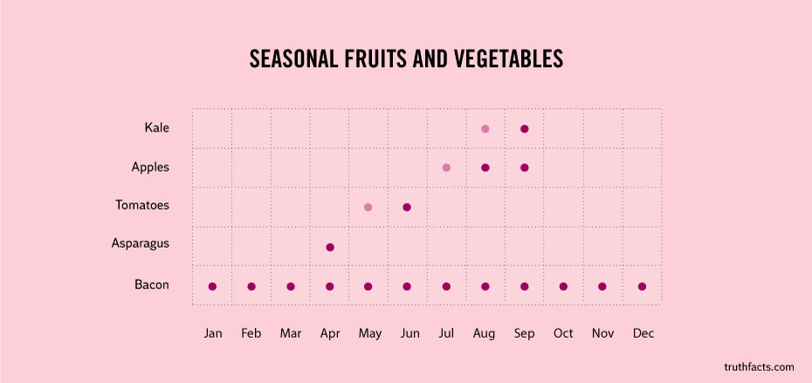

Today is the tomorrow we worried about yesterday.

Now, yesterday’s tomorrow is today and likewise, tomorrow’s yesterday is today. And, tomorrow just as it nears arrival, suddenly becomes today, and today then becomes yesterday. It follows that yesterday’s tomorrow and today’s tomorrow are tomorrow’s yesterday and today’s tomorrow respectively. However, today, when seen from tomorrow’s today is yesterday. And yesterday’s tomorrow, as seen from today, is tomorrow’s yesterday.

Yesterday’s yesterday’s tomorrow’s tomorrow is actually tomorrow’s yesterday—AND THAT’S TODAY!

So why worry about tomorrow?