**April 15, 2018**

**Volume 6, Issue 26**

Sunday School Times

# Six Impossible Things

***Stuff For Today***

• My Little Poem Corner

• Impossible stuff

* Six impossible things

Published almost weekly, but more like…..whenever, so get used to it, OK?

**By Mr. Lyle (mrlyle1@gmail.com**

***Matthew 19:26***

***Jesus looked at them and said, “With man this is impossible, but with God all things are possible.”***

In Lewis Carroll’s sequel to *Alice in Wonderland* called *Through the Looking Glass,* Alice is complaining to the White Queen. “There is no use trying”, she says, “one can’t believe impossible things.”

But the White Queen responds, “I daresay you haven’t had much practice. When I was your age, I always did it for half-an-hour a day. Why, sometimes I’ve believed as many as six impossible things before breakfast.”

I believe in six impossible things, and I didn’t have breakfast today, so it still counts, right?! Here is my list.

1. God created this universe, and everything in it, from nothing. He spoke it all into existence in six, literal, days. And gave us a record of it all in the book of Genesis. That’s impossible.

2. God created Adam and Eve with a free will to do as they wish. They/we failed, we sinned, and God still loves us. That’s impossible.

3. God despises sin so intensely, that a relatively short time after creation, He destroyed the world with a cataclysmic, world-wide flood. And only 8 people, and two of every kind of animal aboard an ark, survived that catastrophe. That’s impossible.

4. God loves us so much that He made a plan to redeem us so that we can live forever with Him in Heaven. Jesus, who is God, came to this earth, laying aside His Heavenly prerogatives while He was here, and lived a perfect sinless life as an example to us. He died and was buried and rose again. He still lives! That’s impossible.

5. God is coming again some day to take all believers to be with Him forever. And we will live happily ever after FOREVER! That’s impossible.

6. God will soon judge sin completely and finally as time and this earth come to an end. Hell is very, very real and worse than we can possibly imagine. That’s impossible.

I hope you understand I am being facetious as I recount these things as impossible. The world we live in counts all of these six items to be preposterous and blatantly impossible to even consider. However, for the Christian, these impossible things are the very basis of everything that we believe. Without them, we have nothing.

As you continue your walk with the Lord, cement these six “impossibles” into the foundation of everything that you believe. Don’t allow the world to create doubts in your mind. All things are possible with God—even the impossible things! He tells us that all we need do is to believe.

That’s a bit tough in our world. Many have the erroneous idea that visual proof is necessary before they can believe. Our senses will fool us. Many a magician has made a very good living capitalizing on that idea. The only thing that is solid and

completely trustworthy is God’s word, the Bible.

I believe in as many as six impossible things before breakfast. I hope you will also.

**Alice’s Six Impossible Things**

By Mr. Lyle (mrlyle1@gmail.com)

Near the end of the 2010 movie remake of “Alice in Wonderland”, Alice is about to fight the dreaded *Jabberwocky.* As she prepares herself mentally for the battle, she counts six impossible things that she now believes in:

1. There is a potion that can make you shrink

2. There is a cake that can make you big.

3. Animals can talk

4. Cats can disappear.

5. There is a place called Wonderland.

6. And she completes her list by admitting to herself that she can indeed dispatch the ugly *Jabberwocky.*

And having convinced herself, she slays the horrible animal.

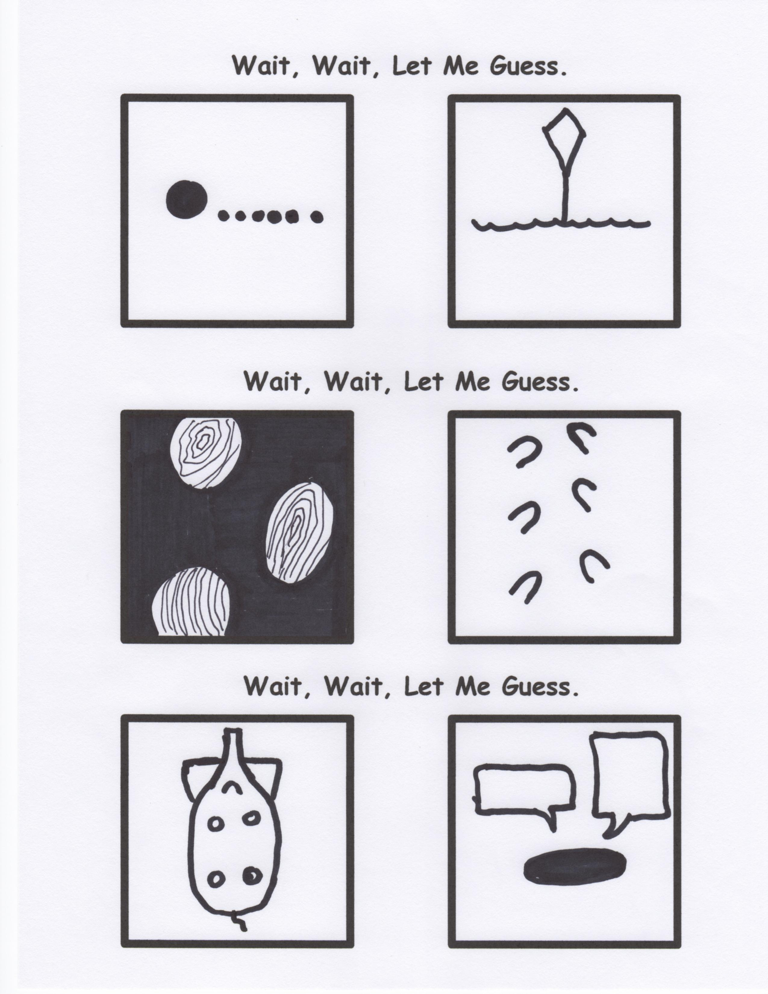

**On This Day in History…**

the RMS Titanic sank. A perspective.

Children of first class passengers—only 1 lost.

Children of second class passengers—none lost

Women in first class—3% lost

Women in second class-14% lost

Men in first class—67% lost

Men is second class—92% lost

Crew—80% lost

I wonder if chivalry is still alive and well today. Would the numbers look the same if the tragedy had happened this morning?

**Danger:** handle this newspaper with extreme care! If mishandled or used carelessly, this paper can cause paper cuts leading to loss of blood and in extreme cases a long, slow, painful “good by”. I highly recommend our “Paper Use Safety Training” course. In this course we cover such topics as “Don’t lick the edge of the paper with your tongue” and “Don’t drag your finger along the edges of a piece of paper. The life you save could be your own. Thank you.