**April 22, 2018**

**Volume 6, Issue 27**

Sunday School Times

***Stuff For Today***

• Wait, Wait, Let Me Guess!

• Essential English

* Seasons in the South
* Ezra—my hero

Published almost weekly, but more like…..whenever, so get used to it, OK?

# The First Pulpit

**By Mr. Lyle (mrlyle1@gmail.com**

***Ezra 9:4***

***Then were assembled unto me every one that trembled at the words of the God of Israel, because of the transgression of those that had been carried away; and I sat astonied until the evening sacrifice.***

Accomplishments define a man. Look at what he does, and you will also see the focal point of his heart. That was true of the prophet Ezra. We find a man whose life and actions revolved around his lifelong pursuit of the Word of God. He is described as a student of the Word, a scribe, and his achievements stand as testimony to that fact.

Ezra was of the priestly line, but because there was no temple in Jerusalem, he could not serve in that capacity. So he devoted himself to the study of God’s Word, sharpening his understanding in preparation for his role in the plan of God. He probably wrote the books of I and II Chronicles, Ezra, and Nehemiah and was the one responsible for organizing the Psalms, playing a large part in settling the canon of Scripture. It was he who stood before those who had returned to Jerusalem from Babylon, and positioned on the first pulpit mentioned in the Bible, simply read the text of Scripture to those listening and explained the meaning as he went. The revival and reformation that took place from this unassuming act was stunning. The Word of God is very sharp and will cut the heart in places no other implement can reach.

If a theme were to be assigned to the book of Ezra, it would be “The Word of the Lord”. There are ten direct references to the Word of God in this short book, with the key verse found in Ezra 9:4. They “*trembled at the words of the God of Israel*”. Seventy years of captivity had an effect upon the people, but there was no revival seen during their time in Babylon. It was not until the day that all the people gathered in front of the Water Gate, and stood in reverence as Ezra read from the Scripture for over six hours, that something began to stir in their hearts. They began to see that the commands of God demanded performance. Obedience and holiness before an Almighty God finally became an issue to be dealt with, and it changed the lives of many, drastically. God’s Word is powerful. Ezra understood that well, and his life reminds us of what is truly important.

**Essential English**

**(Words you can use in your next term paper)**

By Mr. Lyle (mrlyle1@gmail.com)

Adolescence—The period when a young man or a young woman refuses to believe that someday they will be as stupid as their parents.

Ants—People who marry uncles.

Cashew—The sound of a nut sneezing.

Adult—A person who has stopped growing at both ends and is now growing in the middle.

Aquarium—Interactive TV for cats.

Bananosecond—The time elapsed between slipping on a banana peel and smacking the pavement.

Boy—Noise with dirt on it.

Dust—Mud with all of the juice squeezed out.

ecnalubmA —An emergency vehicle that can only be seen in a rear view mirror

Gross Ignorance—144 times worse than regular ignorance.

Me—What Geronimo yells when he jumps out of an airplane.

Ow—The first word spoken by a child with an older sibling.

Calories—Tiny creatures that hide in your closet and sew your clothes a little bit tighter every night.

Clapping—Repeatedly high-fiving yourself for someone else’s accomplishments.

Subdued—Like, a guy who, like, works on one of those, like, submarines, dude.

Vegetarian—A not so skilled hunter

Feet—A device used for finding Legos in the dark.

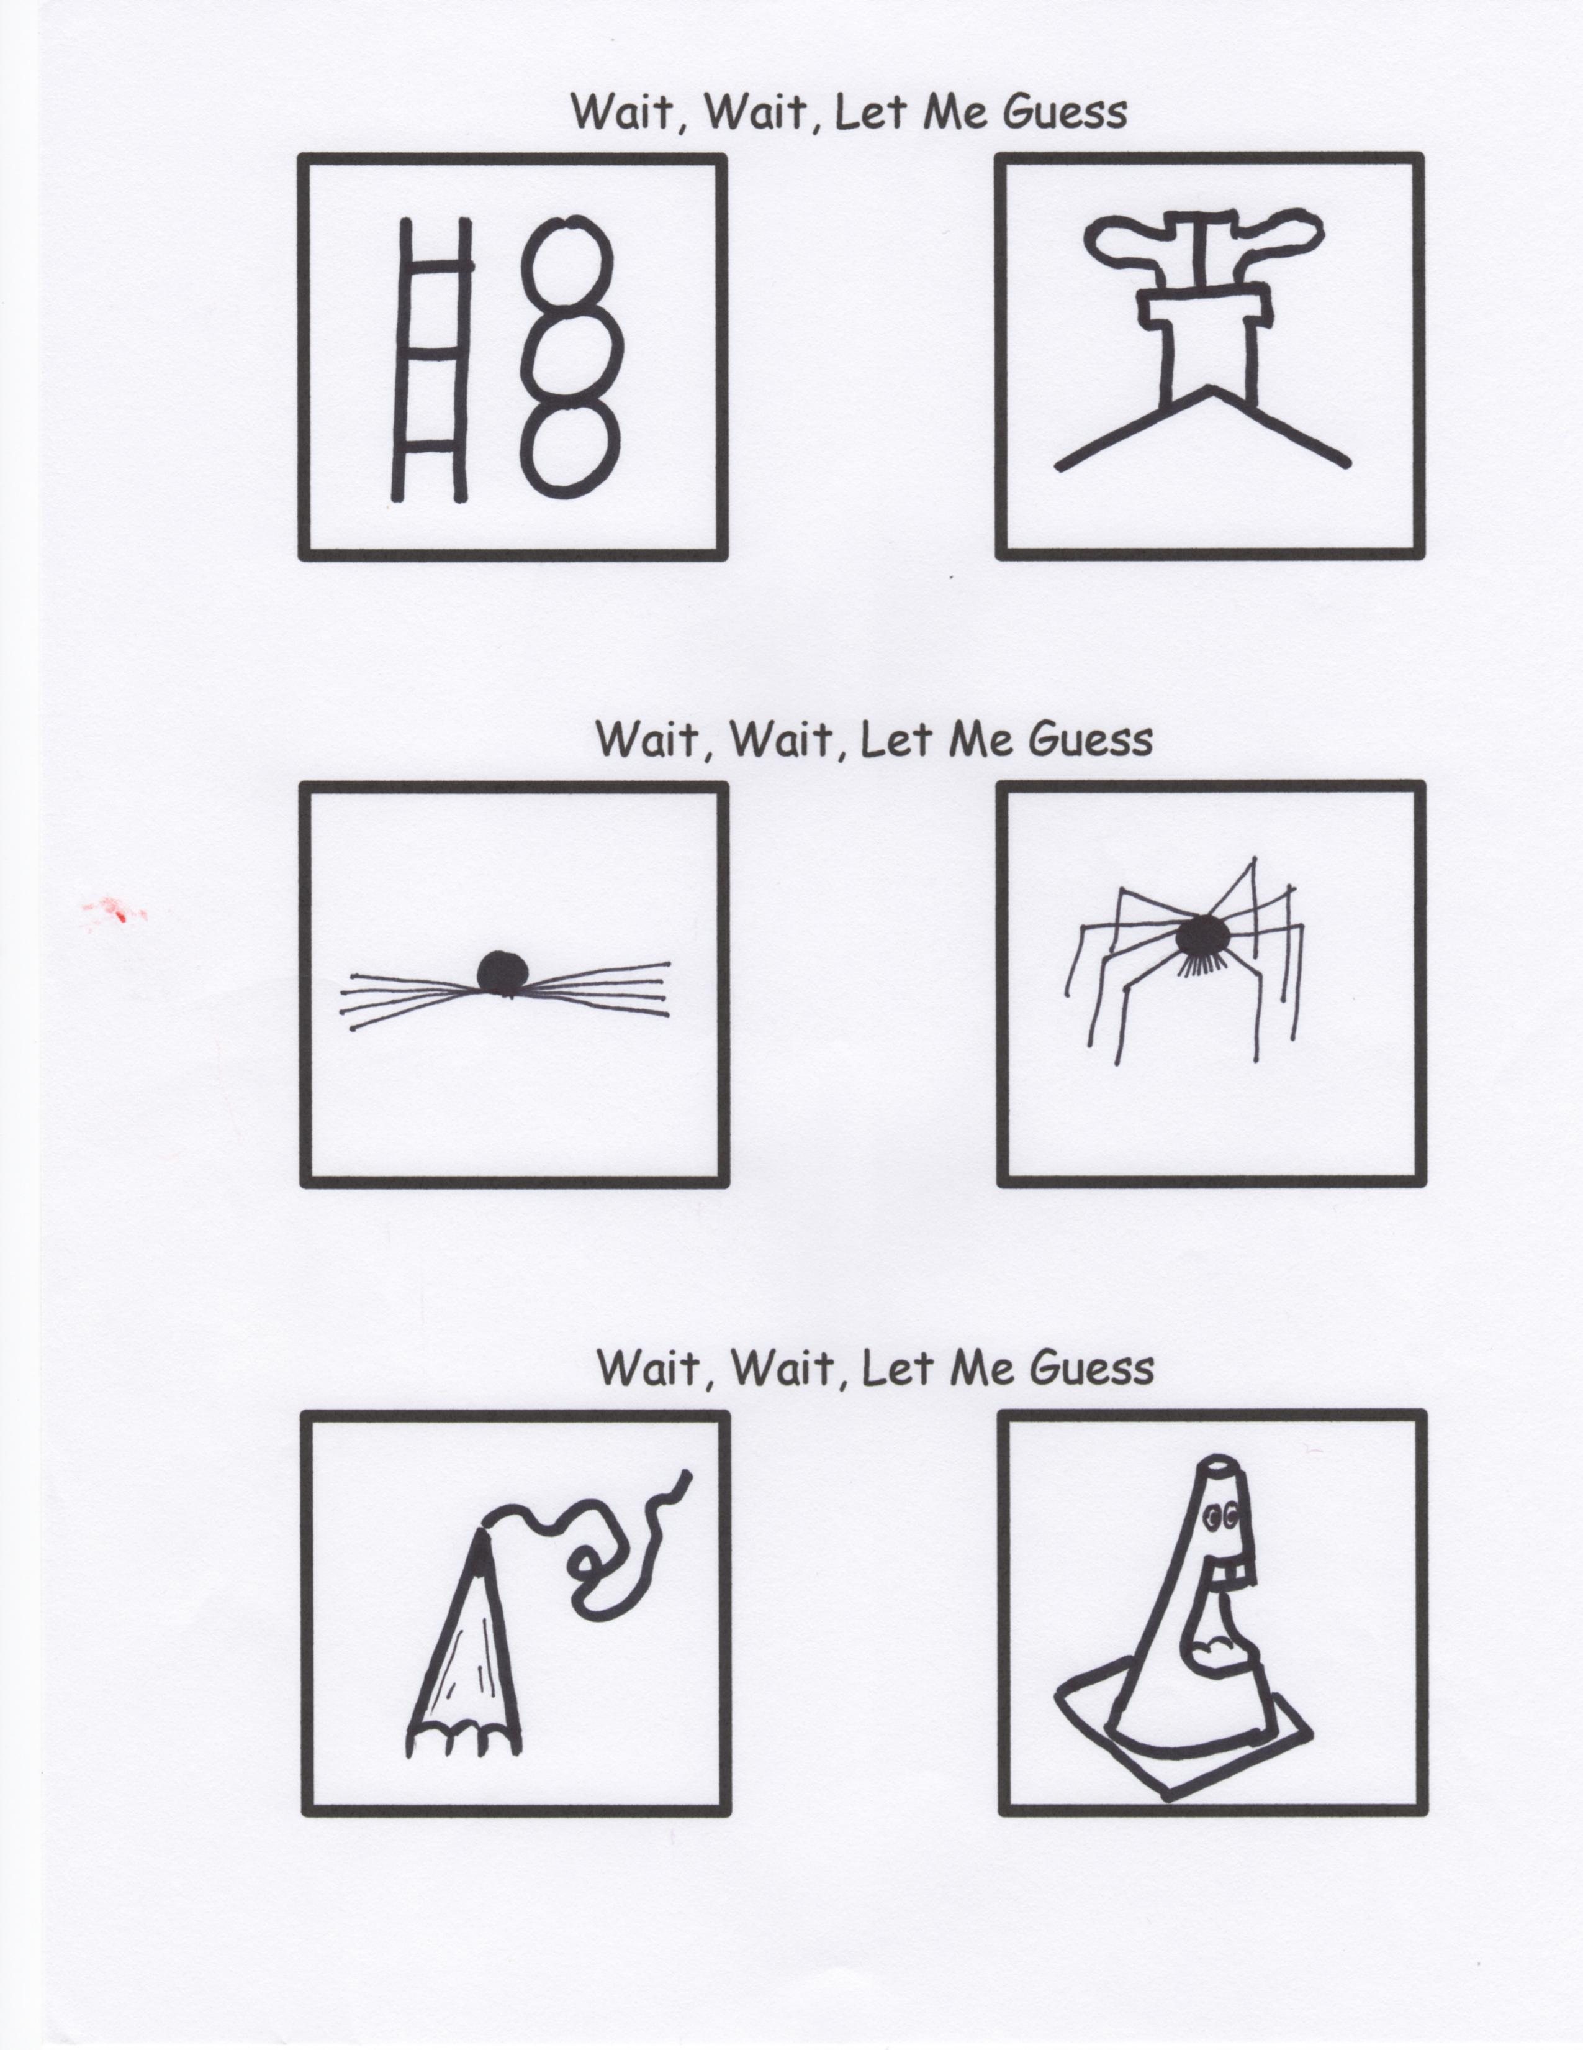

**A Handy Guide For Seasons in the South**

After moving to the South, I expected to experience four seasons just like everywhere else. I was soooo wrong! These are the 20 seasons I have learned to enjoy:

Hunting

Winter

Pollen

Winter

Tornado

So Much Pollen!!!!

One More Winter

Tornado

Attack of the Mosquitoes

Summer

More Summer

Even More Summer

Please, Lord! Make This Summer End!

Football

Tornado

Fall

Just Kidding, Here’s Some More Summer

Winter

Christmas

Maybe One More Summer