**June 3, 2018**

**Volume 6, Issue 31**

Sunday School Times

***Stuff For Today***

• Wait, Wait, Let Me Guess!

• The Internet

* My Summer Vacation
* To Tell the Truth

# To Tell The Truth

Published almost weekly, but more like…..whenever, so get used to it, OK?

**By Mr. Lyle (mrlyle1@gmail.com**

***John 13: 36-38***

***36 Jesus said, “My kingdom is not of this world. If it were, my servants would fight to prevent my arrest by the Jewish leaders. But now my kingdom is from another place.” 37 “You are a king, then!” said Pilate. Jesus answered, “You say that I am a king. In fact, the reason I was born and came into the world is to testify to the truth. Everyone on the side of truth listens to me.” 38 “What is truth?” retorted Pilate****.*

Television in the late 50’s and early 60’s was much different than it is today. As a child of that era, I grew up enjoying a select few TV shows. One of my favorites was a show simply called “To Tell the Truth”. Airing in both an evening and a daytime time slot, it became one of the five most popular game shows of all time.

The premise of the show was quite simple. Three contestants would stand before a panel of well-known Hollywood celebrities who were poised and ready to ask questions of them. The show’s announcer would then read a unique or interesting story, many times recalling some strange or bizarre incident or accomplishment. The three contestants would proclaim to the celebrity panel that they were the subject of the story.

Questioning would then begin as the celebrities would try to determine which contestant was indeed telling the truth, and which two were not. The two who were essentially given free license to lie could say anything thing they liked to try to convince the panel that they were the right choice. Only the true, central character of the story was sworn to always tell the truth. Often it was remarkably difficult to determine simply from a few questions, who was indeed telling the truth and who was not.

John, in his Gospel, includes a conversation that took place between Jesus and Pilate. As Jesus stood before the Roman who had the power to condemn him to death, the subject of truth came up. Jesus explained to Pilate that there is absolute truth. Not understanding the concept, and probably well acquainted with a pagan world system that exceled at not telling the truth, Pilate responds with one of the most loaded questions recorded in the Bible.

“What is truth?” he asked. Today we still live in a world that struggles to always tell the truth, even when it is inconvenient to do so. As Christians, we are called to always be truthful.

**Now That The Summer is Here, Remember…**

By Mr. Lyle (mrlyle1@gmail.com)

How I Spent My Summer Vacation

(An Essay)

Most of our vacation was in Consequential. Our best friends asked us to meet them in Vitation. We couldn’t decide where to spend our first night so we stayed in Decision. We thought about staying in Considerate, but felt it might offend them. Our stay in Eptitude was a fail. In short, our vacation was awful!

No one seemed to even notice us while we stayed in Conspicuous. We spent a miserable afternoon in Tolerable, and the bugs were terrible in Sect. Nothing went right for us during out time in Correct. I started keeping track of all of our difficulties when we travelled in Dex. We were treated like animals in Human, and the temperature was unbearable in Ferno. We were very careful while in Trepid, and never got a good night’s sleep during our stay in Somnia. I thought our time in Finity would never end. We never felt safe in Secure, and our evening walks in Cline were always uphill. Things got worse in Crease!

There was a problem in Cident that we wanted no part of, so we never stayed in Volved. In fact, we had to spend the night in Nocent to clear our names with the local law enforcement. And our trip got even worse in Ferior. Our hotel room was robbed in Vasion, our credit cards quit working while we were in Active, and I had to undergo minor surgery in Cision. I fell off of a cliff in Jure and we got lost looking for a hospital. We finally got directions when we stopped in Quire. By the time we stopped for lunch in Fection, it was really getting bad. We then took a wrong turn in Variably, and the pain became unbearable in Tensify. A stranger came to our rescue in Tervene. On our last day we were in Sane. Apparently they have no airport. We were driven there by friends and family.

I wrote this during our stay in Coherent.

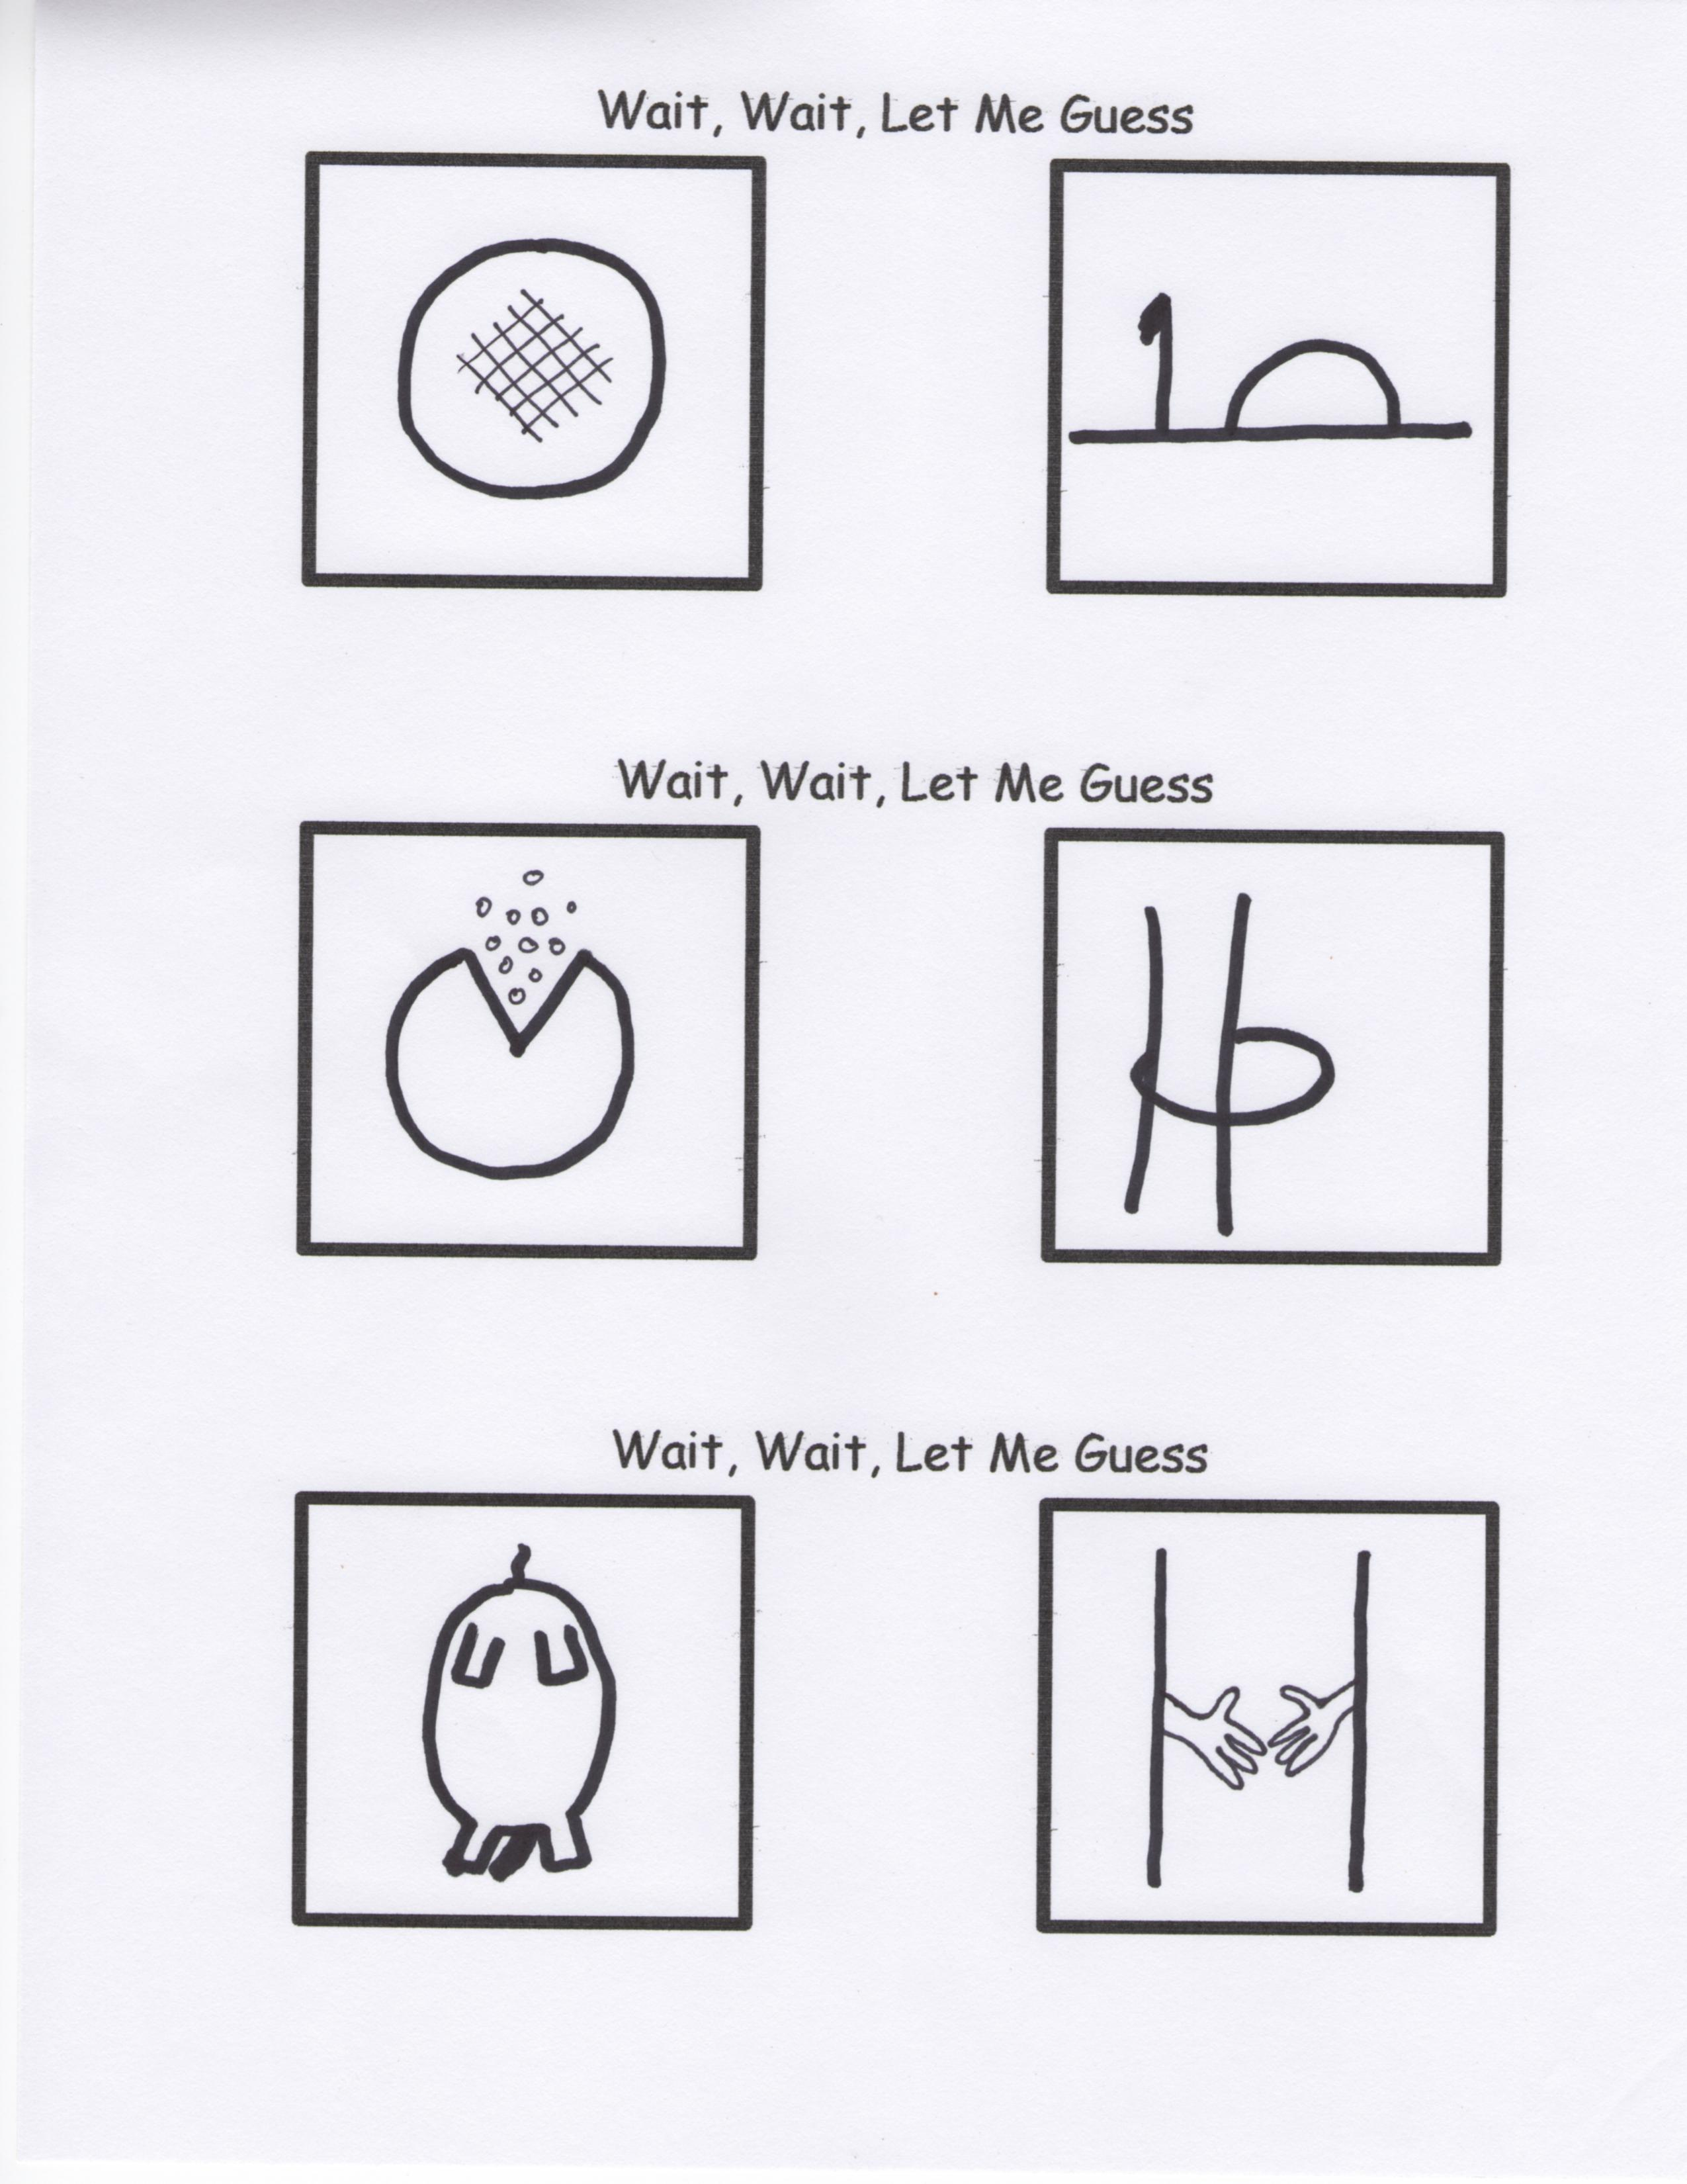

**What The Internet Was Like When I Was Young**

**Google Mail**

_All _Images _News _Videos _More

Please Print Query Clearly________________________________

Mail to: Google Search Request

1800 Amphitheater Parkway

Mountain View, CA 94043

(Please allow four to six weeks for results)