**June 24, 2018**

**Volume 6, Issue 34**

Sunday School Times

# KLEW

***Stuff For Today***

• Wait, Wait, Let Me Guess!

• A Father’s Story

* Thanks Dad
* KLEW

Published almost weekly, but more like…..whenever, so get used to it, OK?

**By Mr. Lyle (mrlyle1@gmail.com**

**A Father’s Story**

A young woman brought home her fiance to meet her parents. After dinner, her mother told her father to find out about the young man. The father invited the fiance to his study for a talk.

"So what are your plans?" the father asked the young man.

"I am a Bible scholar," he replied.

"A Bible scholar. Hmmm," the father said. "Admirable, but what will you do to provide a nice house for my daughter to live in, as she's accustomed to?"

"I will study," the young man replied, "and God will provide for us."

"And how will you buy her a beautiful engagement ring, such as she deserves?" asked the father.

"I will concentrate on my studies," the young man replied, "God will provide for us."

"And children?" asked the father. "How will you support children?"

"Don't worry, sir, God will provide," replied the fiance.

The conversation proceeded like this, and each time the father questioned, the young idealist insisted that God would provide.

Later, the mother asked, "How did it go, Honey?"

The father answered, "He has no job and no plans, but the good news is he thinks I'm God."

***Matthew 28: 19-20***

***Go ye therefore, and teach all nations, baptizing them in the name of the Father, and of the Son, and of the Holy Ghost: 20 Teaching them to observe all things whatsoever I have commanded you: and, lo, I am with you always, even unto the end of the world. Amen.***

In 1944 England, World War II was an ever-present concern. When air raid alarms would sound, people scrambled for shelters and sat. Anthony Pratt decided a new board game might amuse some folks and help pass the interminable time. Originally titled “Murder”, it was later published in England as “Cluedo” and in America, marketed as “Clue”.

I grew up playing this game at family gatherings and such. We didn’t own a copy of our own, so it was a treat to play it with family.

I have re-engineered the basic game to fit our Sunday School format. It’s new name is KLEW. That is an acronym for “Keep Living an Excellent Witness”.

The basic premise of the game is that someone became a Christian! And it is up to the contestants in the classroom to determine who was saved, where did they make their decision for Christ, and what brought about their choice.

The cast of characters include All American Billy Boy Bob, Sugar and Spice and Everything Nice Young Yolanda Yorgensen, Grumpy Old Man Mr. Hrumph, Weaqlthy Businessman Mr. Dollar Bill, Alcoholic Loser Gwatno Name, and Road Hog Mike on a Bike.

Their conversion took place at one of these places: at a ballgame, at church, at school, at the shopping center, at home, in Africa, in jail, or while on vacation.

And something you did led them to realize they needed Christ as their Savior. Was it your Bible, your personal testimony, your lifestyle, your friendship, your inviting them to church, or your help in sending a missionary?

We are called to tell the world about Jesus. In our culture, that is becoming more and more difficult to do. KLEW focuses more on our day to day witness than the mission trips we might take on occasion. I do not want to take away from those at all. But this is where we live and walk each day and where we can have a profound effect on those around us.

You may not know who, but there is someone watching you. Someone who maybe even looks up to you. Are you the example that you should be—always?

Be a good example of what a Christian should look like. Live as though someone is watching your every move. Not because you have to, but because of what Jesus did for you many years ago when He went to a cross and paid for your sins and mine. Good News!

**Thanks**

**Dad**

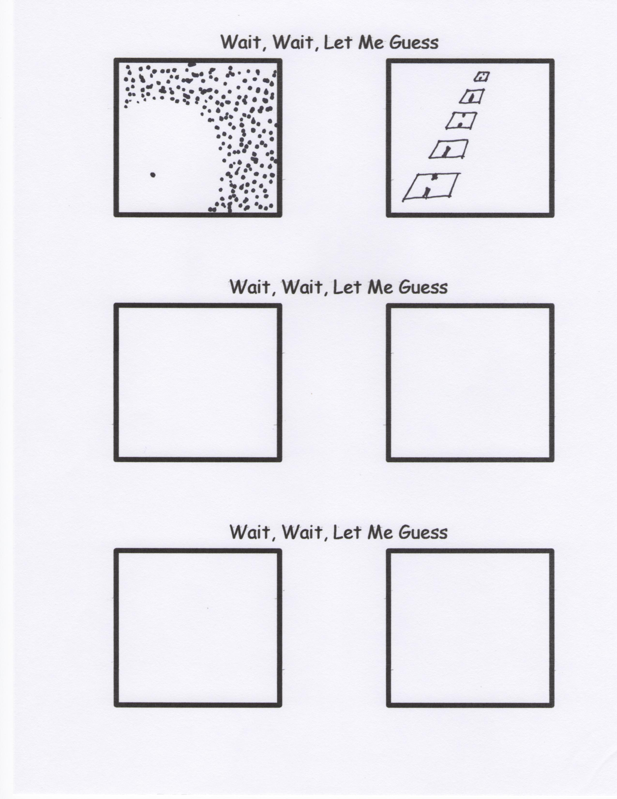

By Mr. Lyle (mrlyle1@gmail.com)

Dad,

thanks for never missing

a display of the

disappointing athleticism

I inherited from you!

Dad,

I love how

we don’t even need

to say out loud

that I’m your

favorite child!

Dad,

you’re the

World’s Greatest Dad…

although my

frame of reference

is rather limited!

Dad,

thanks for

never taking me

to the zoo.

I remember

how you used to say

“If they want him,

they’ll come and get him!”

Here is a bunch of Father’s Day stuff I forgot to put in the paper last week. Sorry about that.