**July 15, 2018**

**Volume 6, Issue 36**

Sunday School Times

***Stuff For Today***

• Wait, Wait, Let Me Guess!

• A chicken in the library

* Lions
* If Jesus were here…
* Cutting Wood

# Divine Wood Cutters

Published almost weekly, but more like…..whenever, so get used to it, OK?

**By Mr. Lyle (mrlyle1@gmail.com**

***Philippians 1: 12***

***But I would ye should understand, brethren, that the things which happened unto me have fallen out rather unto the furtherance of the gospel.***

Paul is in prison in Rome, writing to his friends the Philippians. He is assuring them that the circumstances in which he finds himself are contributing to, rather than hindering, the advance of the Gospel. He says in this passage that the things that have happened to him have fallen out rather to the furtherance of the Gospel.

The word “furtherance” is from a Greek word used in the first century to refer to a company of woodcutters preceding the progress of an army. You see, with far fewer roads, an army often traveled cross country. The woodcutters would go ahead of an advancing army, clearing away trees and brush, creating a road capable of handling everything that an army might wish to carry with them.

So what was Paul saying when he said his circumstances were divine woodcutters? His liberty was gone. He was chained to a Roman soldier night and day. God had built a fence around the apostle. He had put limitations about him. He had placed handicaps upon him. And Paul says that these were God’s woodcutters making a road for the Gospel.

The Gospel was now being proclaimed from the pulpit in the Roman empire. The Praetorium guard of 10,000 hand picked Roman soldiers was hearing the Good News from the soldiers chained to Paul. The jealous brothers in Rome were preaching Christ more energetically, out of envy of course, but yet preaching about Him. And the friends of Paul were even more zealous in their preaching.

And so it is in every Christian’s life. The things that hedge us in, the things that handicap us, the tests that we all go through, are all divinely appointed woodcutters used by God to hew a path for our presentation of the Gospel to those we meet each day.

It may be that our fondest dreams are not realized. We may be in difficult circumstances. Illness may be our lot. Yet if we are in the center of God’s will, all these are contributing to the progress of the Gospel.

They draw us closer to God, so that the testimony of our lives will count for more.

Thank God for the handicaps and problems you face. They are blessings in disguise. When we have limitations imposed upon us we do our best work for the Lord, for it is then that we are most dependent upon Him.

Paul told the Corinthians, “Most gladly therefore will I glory in my infirmities, that the power of Christ may rest upon me.” (II Cor. 12:9).

Paul had plenty of woodcutters.

**The Chicken in the Library**

A chicken marches into the library, walks up to the library desk, and says: “Book, book, BOOK!”

The librarian hands over a couple of slim children’s paperbacks, and watches the chicken as it leaves the library, walks across the street, through a field, and disappears down the hill.

The next day, the chicken is back. And walks right up to the librarian, drops the books on her desk, and says, “Book, Book, BOOK, BOOK!” The librarian hands over a few books and again watches the chicken drag them away.

The next day, the chicken comes for a third time. Drops the books on the desk, and says, “Book, Book, Book, BOOK!!”

This time, once the chicken is out the door, the librarian follows — across the street, through a field, and down the hill to a small pond.

On a rock on the edge of the pond is the biggest frog the librarian has ever seen. The chicken walks up to the frog, drops the book on the pond’s edge, and says, “Book, Book, Book!”

The frog hops over, uses the front leg to push through the pile, and says: “Read it, read it, read it…”

**If Jesus Were Here Today He Might Say…**

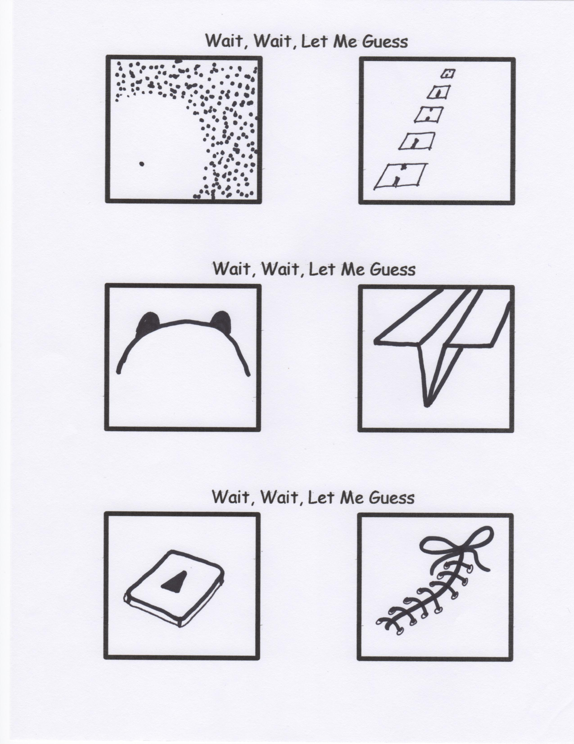

A young missionary on his first term in Africa was reading his Bible in a clearing when a lion came up and laid down beside him. As he quietly prayed for deliverance, another lion came out of the bush and laid down by his other side.

Convinced that this was a test of his faith, he returned to reading his Bible. As soon as he did, the two lions pounced on him and devoured him.

Moral: Don’t try to read between the lions.

“No, I’m not talking about Twitter! I literally want you to follow me.”

“Sorry, but the Ark was too full for those two unicorns.”

“If anyone asks you “What would Jesus do?’, remind them that flipping over tables and chasing people with a whip is within the realm of possibilities.”

“You need an Ark? I Noah guy.”

“Honk if you love me. Keep on texting if you want to meet me.”

“

By Mr. Lyle (mrlyle1@gmail.com)