**October 1, 2017**

**Volume 6, Issue 4**

Sunday School Times

***Stuff For Today***

• Wait, Wait, Let Me Guess!

• A Love Story

* A little lost dog
* Why a Victor 4-Way?

Published almost weekly, but more like…..whenever, so get used to it, OK?

# A “Victor Four Way” Rat Trap

**By Mr. Lyle (mrlyle1@gmail.com**

***Proverbs 3: 5***

**Trust in the Lord with all your heart and lean not on your own understanding.**

Rodent control is much more reliable with the use of *Victor 4-Way Rat Traps.* Rat and mousetraps have evolved little over the many years, and the spring-loaded-rodent-crusher is still my method of choice.

Most would think it hardly a topic for a Sunday School lesson, but bear with me and perhaps I can draw things together sufficiently.

The writer in Proverbs is using a common technique for Hebrew poetry. No rhymes as we might want in our culture, but rather, a repetition of a phrase with a slightly different set of words with their implied subtle differences in meanings. Let’s look at this verse in two parts.

The first phrase is *Trust in the Lord with all your heart.* I have little problem in that area. I know and understand that God is able to do anything, and I don’t have to worry or fret about anything. He will take care of me always. I can trust Him completely!

It’s the second half that I personally struggle with. *And lean not on your own understanding* requires something from me that I am not comfortable giving up. I am by nature an inquisitive person. I want to know how things work, and how they operate. I want to understand them.

There are times in life when God does not find it necessary to explain to us all of the details. It is not important to Him that we completely understand everything.

At times He wants us to simply obey blindly, not knowing the future or the outcome. Only knowing that we are operating in the will of God, and that needs to be enough for us.

That is the ultimate test of trust--to obey blindly. Imagine the following.

Suppose you had a *Victor 4-Way Rat Trap* directly in front of you. It has been baited with several one dollar bills. Now suppose you are blindfolded and given the *opportunity* to reach in and grab the money but it will have to be done incredibly fast, so your hand is not crushed by the trap.

Would you follow the instructions, or would you balk at the idea because it made no sense to you to take that risk?

Welcome to our Sunday School Bible lesson!

**Lost Dog Found**

By Mr. Lyle (mrlyle1@gmail.com)

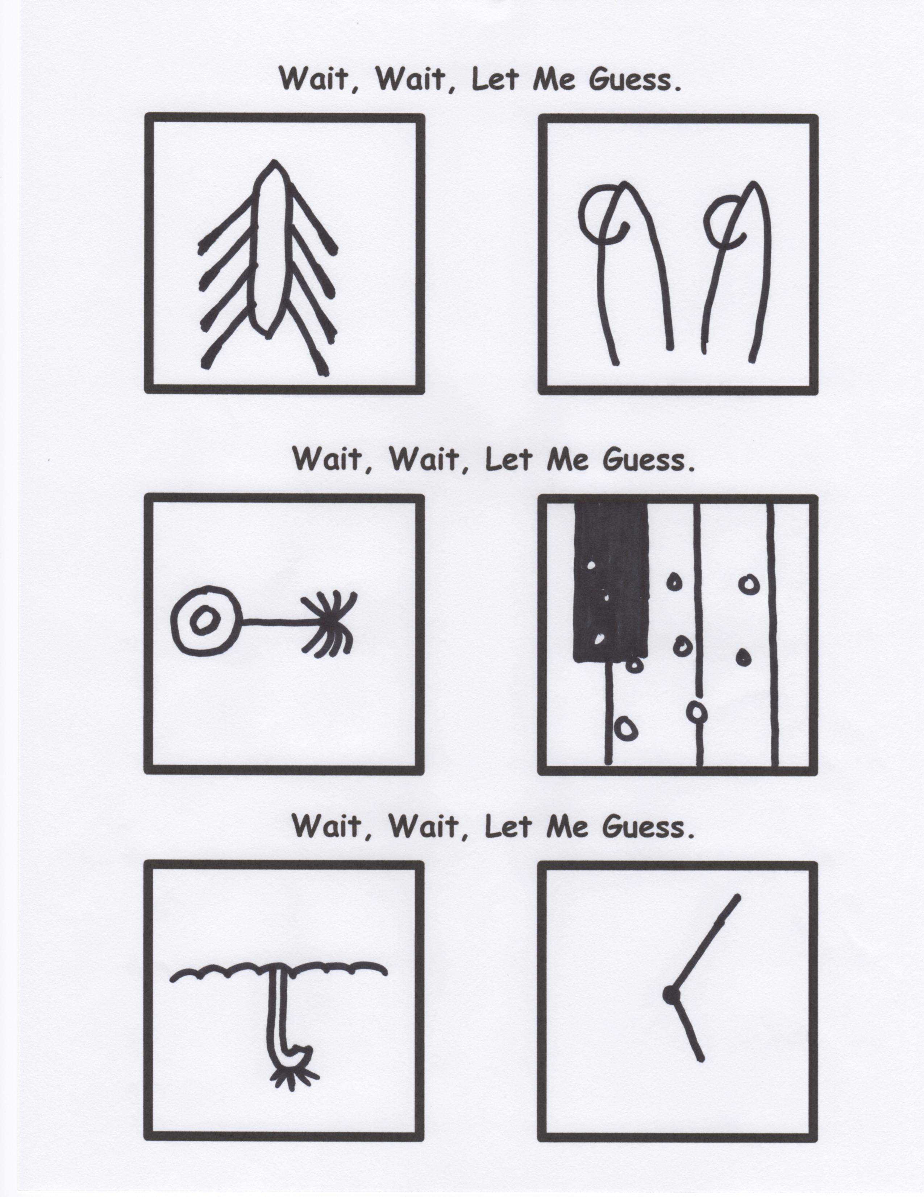

A male beagle was found around 11:30 AM on September 23rd on the corner of 14th and Pine. Approximately six months old and mostly brown with cute patches of white on his nose and feet. A slightly crooked tail, and a blue collar but no tags. Very friendly, and loves kids. Tasted a lot like chicken.………………………………..He licked me first, so I licked him back. What, did you think I ate him?!!!

Books of the Bible Puzzle

Can you find the 34 books of the Bible hidden in this paragraph? This is a most remarkable puzzle. From this point on, everything is dynamic ahead. If you row a shipment of Honolulu kerosene to Oregon in a john boat while playing a banjo eleven hours straight-- even that would be easier than this challenge. Perhaps alms giving might help. One of my friends judges the job of solving this puzzle so difficult that she brews a cup of tea to help her nerves. There is one fact. Some people will soon find themselves in a jam, especially since the book names are not necessarily capitalized. Truthfully, from answers we get, we are forced to admit it usually requires a seminary degree to see some of them at the worst. And it is very likely that something in our genes is the reason for our difficulty. The local paper, The Chronicle, said that when they featured this puzzle in the paper, the Alpha Delta Phi lemonade booth set a new record. As my friend Daniel, eating a banana, humorously put it, "The books are all right here in plain view hidden from sight." Those able to find all of them will hear great lamentations from those who have to be shown. One revelation that may help is that books like Timothy and Samuel may occur without their numbers. Also, keep in mind, that punctuation and spaces in the middle are normal. A chipper attitude will help you compete really well. And wear a fez rather than a baseball cap. It doesn’t take a pro. Verbs and nouns all need to be considered. Remember, there is no need for a mad exodus; there really are 34 books of the Bible lurking somewhere in this paragraph waiting to be found.

**A Love Story**

*He knew it would never work between them.*

*The girl had been born into a wealthy family.*

*He was just a third person singular masculine subject pronoun*