**October 22, 2017**

**Volume 6, Issue 6**

Sunday School Times

Published almost weekly, but more like…..whenever, so get used to it, OK?

# An Amazing Celebration of COTSA

***Stuff For Today***

• Wait, Wait, Let Me Guess!

• Veterinary Corner

* Fairy Tales
* What is COTSA?!

**By Mr. Lyle (mrlyle1@gmail.com**

***Matthew 20: 1-16***

***“For the kingdom of heaven is like a landowner who went out early in the morning to hire workers for his vineyard. 2 He agreed to pay them a denarius[a] for the day and sent them into his vineyard. 3 “About nine in the morning he went out and saw others standing in the marketplace doing nothing. 4 He told them, ‘You also go and work in my vineyard, and I will pay you whatever is right.’ 5 So they went. “He went out again about noon and about three in the afternoon and did the same thing. 6 About five in the afternoon he went out and found still others standing around. He asked them, ‘Why have you been standing here all day long doing nothing?’ 7 “‘Because no one has hired us,’ they answered. “He said to them, ‘You also go and work in my vineyard.’ 8 “When evening came, the owner of the vineyard said to his foreman, ‘Call the workers and pay them their wages, beginning with the last ones hired and going on to the first.’ 9 “The workers who were hired about five in the afternoon came and each received a denarius. 10 So when those came who were hired first, they expected to receive more. But each one of them also received a denarius. 11 When they received it, they began to grumble against the landowner. 12 ‘These who were hired last worked only one hour,’ they said, ‘and you have made them equal to us who have borne the burden of the work and the heat of the day.’ 13 “But he answered one of them, ‘I am not being unfair to you, friend. Didn’t you agree to work for a denarius? 14 Take your pay and go. I want to give the one who was hired last the same as I gave you. 15 Don’t I have the right to do what I want with my own money? Or are you envious because I am generous?’ 16 “So the last will be first, and the first will be last.”***

Every second year we observe the ***C****elebration* ***O****f* ***T****he* ***S****tuffed* ***A****nimals*in this class. It is a wonderful time for those familiar with “Beanie Babies”. My two daughters collected them when they were young, and their collection is actually quite impressive! The activities associated with COTSA are an object lesson to help us understand a little better, the sovereignty of God.

We humans tend to define God down to our level. Our belief that He thinks and acts the same way we do is often misguided. God is not bound by our rules or understanding. He conducts the affairs of this world as He wishes. We would do well to acknowledge that.

In the parable found in Matthew 20, the landowner represents God. 1. We find Him to have an overall plan that He is executing. 2. He is just and fair. 3. He is caring enough to go to where the workers are to be found and hire them. He doesn’t just put up a *Help Wanted* sign. 4. He did the choosing of His workers, not the other way around.

As an employer myself, I see one more concept here that would apply to us as Christians. Our work for God is not just something to be endured. It should be an honor and a pleasure to work for such a just, fair, loving and caring boss. And He does pay well—Heaven is an amazing place!

**Veterinary Corner**

By Mr. Lyle (mrlyle1@gmail.com)

**How to Give Your Cat a Pill**

Pick cat up and cradle it in the crook of your left arm as though holding a baby.

Position right forefinger and thumb on either side of the cat’s mouth and lightly apply pressure to its cheeks.

When the cat opens its mouth, gently drop the pill into the mouth.

The cat will then close its mouth and swallow.

Apply bandages as necessary to arms and face.

Retrieve pill from the floor and cat from behind sofa.

Repeat the process.

Retrieve the cat from the bedroom and throw the soggy pill away.

Kneel on the floor with the cat wedged firmly between your knees, immobilizing front and rear paws

Ask assistant to hold cat’s head firmly with one hand while forcing a wooden ruler into the cat’s throat.

Remove next pill from foil wrap.

Flick pill down the ruler with forefinger and rub cat’s throat vigorously.

Retrieve cat from living room curtains.

Carefully sweep shattered figurines from hearth and set aside for later gluing.

Apply bandages as necessary to your legs and feet.

Remove next pill from foil wrap.

Wrap cat in beach towel, and ask assistant to lie prone on cat with cat’s head visible under assistant’s armpit.

Put pill into the end of a paper tube that you have made for this purpose.

Force cat’s mouth open with pencil and insert the end of the paper tube.

Take a deep breath and blow the pill into its mouth.

Check label to make sure the pill is not lethal to humans.

Sip enough water to take terrible taste away.

Apply bandage to assistant’s forearm, and remove blood from carpet with soap and water.

Call 911, and ask fire department to retrieve cat from tree in front yard.

Remove remaining pill from foil wrap.

Tie cat’s front paws to rear paws with bailing twine and secure to leg of dining table.

Put on heavy duty welding gloves.

Force cat’s mouth open with tire iron.

Drop pill into cat’s mouth.

Hold your head vertically with nose pointed to ceiling to stop nose bleed resulting from collapsed dining table.

Don’t worry, lots of people get concussions and survive.

Ask assistant to drive you to emergency room.

Sit quietly while doctor administers anesthetic, stitches arm and removes pill remnants from your eye.

Drop off cat with a generous donation at an animal shelter.

Go to Walmart and adopt a goldfish.

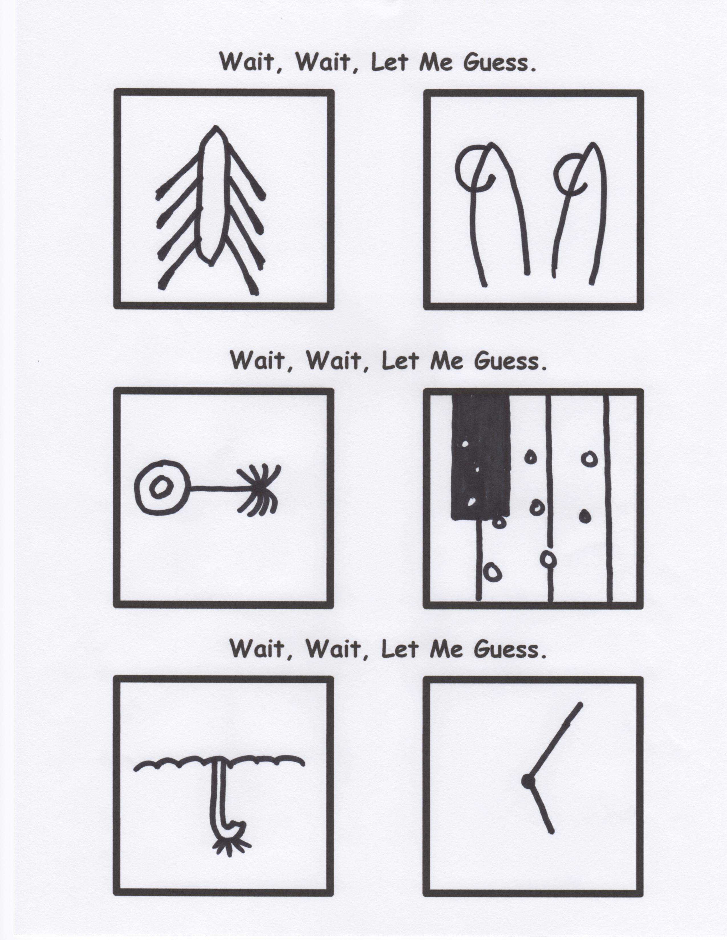

**The Difference Between Northern Fairy Tales and Southern Fairy Tales**

Northern: “Once upon a time…”

Southern: “Y’all ain’t gonna believe this…”