**November 25, 2018**

**Volume 7, Issue 13**

Sunday School Times

***Stuff For Today***

• Bob the Square

• Handy Movie Guide for Dads

• Questions and Answers Continue

Published almost weekly, but more like…..whenever, so get used to it, OK?

# The Windsor Guildhall

**By Mr. Lyle (mrlyle1@gmail.com**

In the sixteen hundreds (aproximately 1688) Christopher Wren, a well known architect, was commissioned by the Windsor town councillors to build the Windsor Guildhall - a picture of which is shown below.

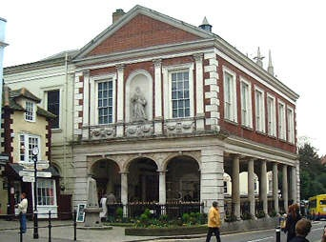

As you can see from the picture, the ground floor of this building is completely open, with the main part of the building being supported by 18 pillars around the edge. This open space was designed to be used as a public market.

When the town councillors saw what Wren intended to do, they (in their infinite architectural wisdom) protested to the great architect that his design would never work. Eighteen pillars would not be enough to support the weight of the building, and the whole thing would collapse.

Christopher Wren insisted that his design was solid and safe, and an argument ensued. The upshot of it all was, Christopher Wren agreed to add four more columns into his design. These four columns were interior columns, and can be seen in the picture below.

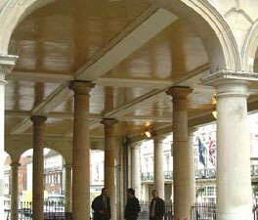

But Christopher Wren had the last laugh; when he designed the four inner pillars, he deliberately designed them to be two inches too short; the tops of the columns do not even touch the beams of the ceiling. They bear *no weight at all!*

Over the centuries, many people have had a good laugh at Christopher Wren's subtle jab at the town councillors (although today, if you visited the guildhall you would discover that at some point wooden shims have been placed above the pillars, so they really do bear weight.)

But Christopher Wren obviously knew what he was doing; for centuries this building stood strong and tall without those center columns supporting any weight.

The book of I Peter describes the church as a building...not made of stone, but of *living stone*. We, as Christians, make up the structure of the church.

***I Peter 2:4-5 says: And coming to Him as to a living stone which has been rejected by men, but is choice and precious in the sight of God, you also, as living stones, are being built up as a spiritual house for a holy priesthood, to offer up spiritual sacrifices acceptable to God through Jesus Christ.***

(Continued on Page 2)

By Mr. Lyle (mrlyle1@gmail.com)

**A Movie Guide for Your Dad**

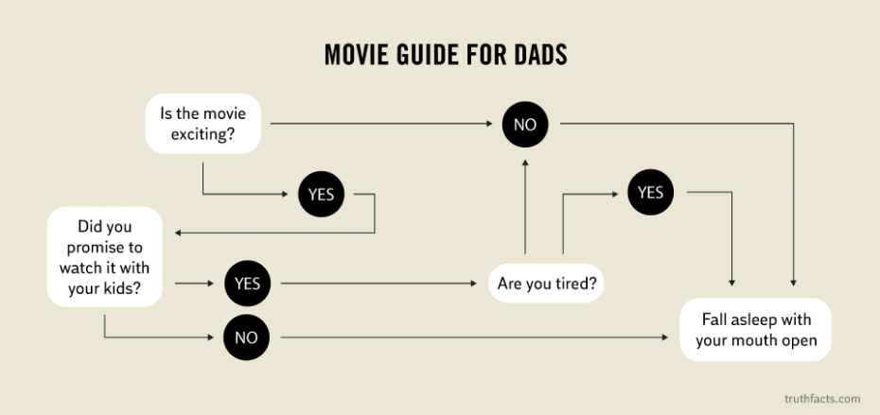

(An empty corner—how disappointing!)