**March 3, 2019**

**Volume 7, Issue 25**

Sunday School Times

Published almost weekly, but more like…..whenever, so get used to it, OK?

***Stuff For Today***

• Bob the Square

• Japanese Proverb

• A Family Tree

# A Family Tree—1656 Years Long

**By Mr. Lyle (mrlyle1@gmail.com**

***Genesis 5***

*This is the written account of Adam’s family line.*

*When God created man, he made them in the likeness of God.****2****He created them male and female and blessed them. And he named them “Man”****[***[***a***](http://www.biblegateway.com/passage/?search=gen%205&version=NIV#fen-NIV-108a)***]****when they were created.*

***3****When* ***Adam*** *had lived 130 years, he had a son in his own likeness, in his own image; and he named him* ***Seth****.****4****After* ***Seth*** *was born,* ***Adam*** *lived 800 years and had other sons and daughters.****5****Altogether,* ***Adam*** *lived a total of 930 years, and then he died.*

***6****When* ***Seth*** *had lived 105 years, he became the father****[[b](http://www.biblegateway.com/passage/?search=gen%205&version=NIV" \l "fen-NIV-112b" \o "See footnote b)]****of* ***Enosh****.****7****After he became the father of* ***Enosh****,* ***Seth*** *lived 807 years and had other sons and daughters.****8****Altogether,* ***Seth*** *lived a total of 912 years, and then he died.*

***9****When* ***Enosh*** *had lived 90 years, he became the father of* ***Kenan****.****10****After he became the father of* ***Kenan, Enosh*** *lived 815 years and had other sons and daughters.* ***11****Altogether,* ***Enosh*** *lived a total of 905 years, and then he died.*

***12****When* ***Kenan*** *had lived 70 years, he became the father of* ***Mahalalel. 13****After he became the father of* ***Mahalalel, Kenan*** *lived 840 years and had other sons and daughters.****14****Altogether,* ***Kenan*** *lived a total of 910 years, and then he died.*

***15****When* ***Mahalalel*** *had lived 65 years, he became the father of* ***Jared****.****16****After he became the father of* ***Jared, Mahalalel*** *lived 830 years and had other sons and daughters.****17****Altogether,* ***Mahalalel*** *lived a total of 895 years, and then he died.*

***18****When* ***Jared*** *had lived 162 years, he became the father of* ***Enoch. 19****After he became the father of* ***Enoch, Jared*** *lived 800 years and had other sons and daughters****20****Altogether,* ***Jared*** *lived a total of 962 years, and then he died.*

***21****When* ***Enoch*** *had lived 65 years, he became the father of* ***Methuselah****.****22****After he became the father of* ***Methuselah, Enoch*** *walked faithfully with God 300 years and had other sons and daughters.****23****Altogether,* ***Enoch*** *lived a total of 365 years.****24Enoch*** *walked faithfully with God; then he was no more, because God took him away.*

***25****When* ***Methuselah*** *had lived 187 years, he became the father of* ***Lamech****.****26****After he became the father of* ***Lamech, Methuselah*** *lived 782 years and had other son and daughters.****27****Altogether,* ***Methuselah*** *lived a total of 969 years, and then he died.*

***28****When* ***Lamech*** *had lived 182 years, he had a son.****29****He named him* ***Noah[***[***c***](http://www.biblegateway.com/passage/?search=gen%205&version=NIV#fen-NIV-135c)***]****and said, “He will comfort us in the labor and painful toil of our hands caused by the ground the Lord has cursed.”****30****After Noah was born,* ***Lamech*** *lived 595 years and had other sons and daughters.****31****Altogether,* ***Lamech*** *lived a total of 777 years, and then he died.*

***32****After* ***Noah*** *was 500 years old, he became the father of* ***Shem, Ham and Japheth.***

(Continued on Page 2)

By Mr. Lyle (mrlyle1@gmail.com)

**Ancient Japanese Proverb**



**Our Family Tree**

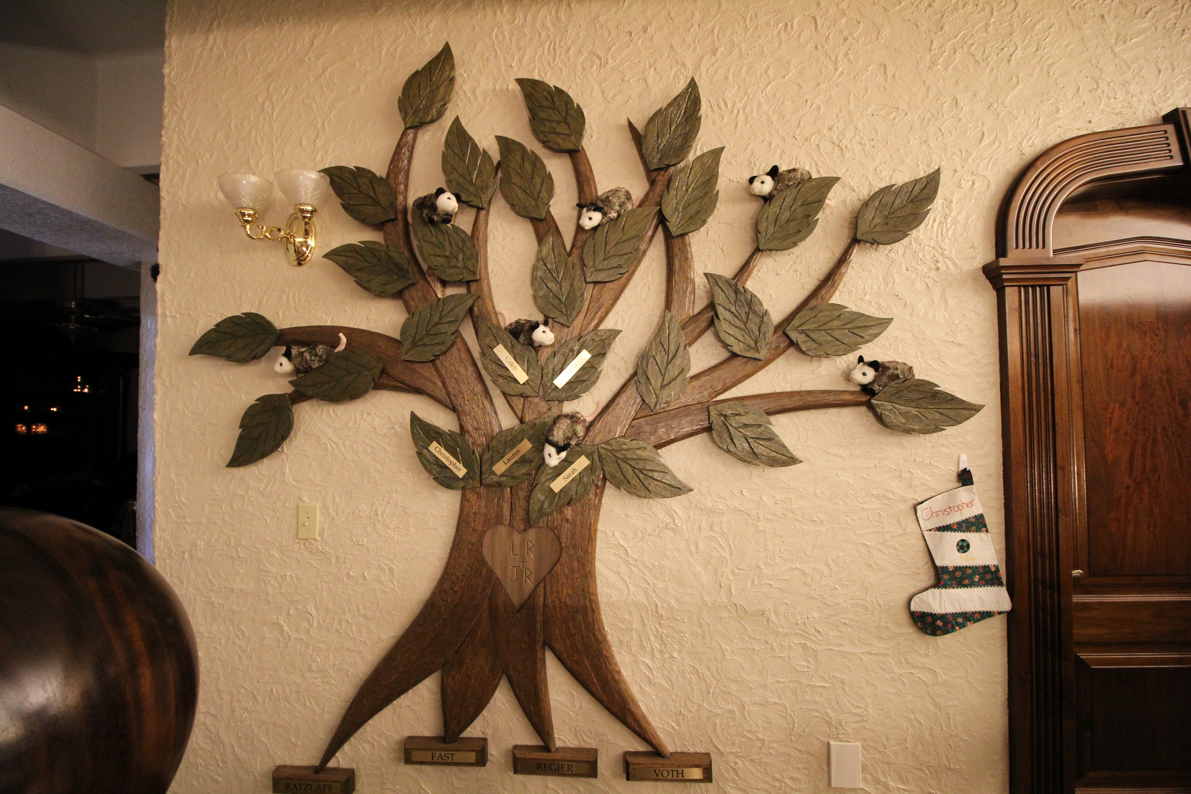

Much care is required when translating words and phrases from one language to another.

After considerable study, I have made the determination that the proverb on the left can be loosely translated:

***“If you cannot read Japanese, tilt your head to the right”***

You’re welcome!

**Ancient Japanese Proverb Translated**