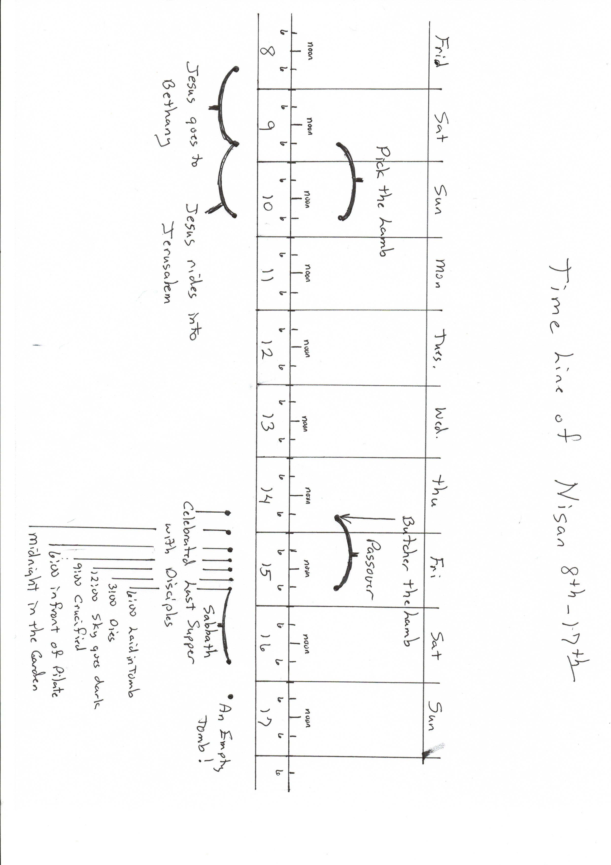

**A Donkey and A Lamb**

By Mr. Lyle

As I stand here on this hill

And overlook the city

I gaze across the valley ‘til

I must look down in pity.

Three crosses stand against the sky.

Crowds gather to watch the show--

Three men condemned to hang and die

Upon that forsaken plateau.

I recall the day I met

The middle man up there.

I will never, ever, ever forget

His kindness and his care.

A Sunday morn five days ago

A day unlike any other

Why I was chosen I do not know

I was standing near my mother.

Two men came by and simply said,

“The Teacher needs them now.”

Untying us both, we were led

Toward a waiting, cheering crowd.

Just outside the gates he came.

He seemed so mild and meek.

He called me softly by my name

And gently stroked my cheek.

I carried a king that day!

He sat there oh so humble.

Palm branches lined the entire way

I did not dare to stumble.

All were singing praise to God,

Shouting as loud as they could.

Through all that noise I was awed

As we traveled each neighborhood.

I wondered how the Son of God

Could have entered the town that way--

Up on the back of this old clod.

A creature that just eats hay.

And now I see him on that tree!

The man dying in the middle!

He gave his life for you and me.

It’s truly a wondrous riddle!

As donkeys go I’m not much.

But the gift that I was given

Was to hear his voice and feel his touch.

And carry the Lamb from Heaven.

