**May 5, 2019**

**Volume 7, Issue 32**

Sunday School Times

***Stuff For Today***

• Bob the Square

• Sinko De Mayo

• Questions and Answers

Published almost weekly, but more like…..whenever, so get used to it, OK?

# Questions and Answers!

**By Mr. Lyle (mrlyle1@gmail.com**

**Fractured History**

**For May 5th**

In the settlement of the New World, the early settlers considered mayonnaise to be a much sought-after delicacy. But the Spanish Conquistadores did not have the recipe, as it had been kept a closely guarded secret in Europe since the Middle Ages. This resulted in a rather large trade of mayonnaise across the Atlantic Ocean to the New World from Spain and Portugal.

As the delicious spread became even more popular and demand began to increase, the mayonnaise trade became quite lucrative. Soon there were countless grand sailing vessels venturing onto and conquering the Atlantic as they worked to supply the ever-burgeoning demand for fresh mayonnaise.

One Spring, however, the weather did not cooperate, and an entire fleet of ships bearing the precious cargo was caught in a horrific storm just outside of the harbor. All of the ships were lost, as well as every jar of their cargo, but all of the crew members miraculously made it to shore relatively unharmed.

Horrified onlookers from the town braved the wind and the rain and watched sadly as the last of the mighty vessels slipped under the waves. The entire mayonnaise shipment had been lost. And there would not be any new shipments of mayonnaise for many months.

The local mayor, recognizing the grief of his townspeople regarding the lost mayonnaise, decided to immortalize the day on the calendar in remembrance of the tragedy. The people there still honor that lost shipment on a holiday they call “Sinko de Mayo.”

**The Proper Way to Pray**

By Mr. Lyle (mrlyle1@gmail.com)

The proper way for a man to pray,

Says Deacon Lemuel Keys,

And the only proper attitude

Is down upon his knees.

No, I should say the way to pray,

Says Reverend Doctor Wise

Is standing straight with outstretched arms

And rapt and upturned eyes.

Oh, no, no, no, said Elmer Slow.

Such posture is too proud.

A man should pray with eyes fast closed

And head contritely bowed.

It seems to me his hands should be

Austerely clasped in front.

Both hands pointing toward the ground,

Said Reverend Doctor Blunt.

Last year I fell in Hitchkins’ well,

Head first, said Cyrus Brown.

And both my heels were stickin’ up,

And my head was pointing down.

And I made a prayer right then and there,

The best prayer I ever said.

The prayin’est prayer I ever prayed

Was standin’ on my head.

**Archeologists X-ray Skull of the Disciple Thomas**

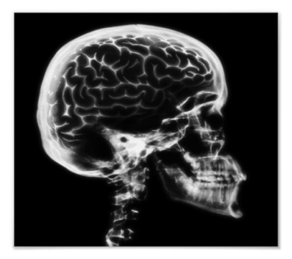



My extreme inventiveness has led to the announcement of this discovery. For centuries, readers of the Bible have wondered at the doubt displayed in the actions of Thomas the disciple. As the x-ray clearly shows there is an abnormality in his brain tissue. Now, we have no doubt regarding his medical condition—he was just like the rest of us!

**Q and A Today!**

**You got questions, and I got answers.**

(at least I hope so, or this is destined to be a VERY boring Sunday School class time.)