**Dear Mom**

**May 12, 2019**

**Volume 7, Issue 33**

Sunday School Times

***Stuff For Today***

• Happy Mother’s Day From Bob the Square

• A Mother’s Day Story and A Mother’s Day Poem

• Questions and Answers

Published almost weekly, but more like…..whenever, so get used to it, OK?

# “Be Careful!”

**A Precious Mom’s Day Poem**

Mom, I know you do the dishes

And I know you cook the food.

I know you scrub the floors

Even when you’re in a bad mood.

And every night you walk the dog

While I’m watching all my shows.

On Thursdays you take out the trash

And you clean and wash the windows.

You always do my laundry,

And always make my bed.

You let me sleep late every day

And play video games instead.

Mom, I know you’re sad I’ll go someday

And leave you all alone.

But right now I’m only 38

And I really like it here at home!

**By Mr. Lyle (mrlyle1@gmail.com**

***Ephesians 5:15-17***

***15 Be very careful, then, how you live—not as unwise but as wise, 16 making the most of every opportunity, because the days are evil. 17 Therefore do not be foolish, but understand what the Lord’s will is.***

Mothers seem to have an obligation to worry or fret over their children. It’s part of their job. At least it certainly seemed that way to me when I was young. My mother’s advice for me each day usually finished with the same familiar two words that I so often casually ignored—“Be careful!”

I could have saved myself much hurt, confusion, heartache, and trouble if I would have listened better. I was too busy being my own person, in control of my own destiny. And of course, as with most young people, I saw myself as indestructible.

I have learned much—the hard way!

Paul, in his advice to the Ephesian church, warned them to “Be careful”. He understood that the world was, and still is, a very dangerous place to be. We are not talking necessarily about physical danger, but rather, issues of spiritual significance.

We all, very conscientiously, strap our seat belts on every time we get in a car to drive somewhere, very mindful of the possible dangers that we face. In contrast, we will often face life’s big issues with little or no thought to God’s perfect will for our lives. We take a carefree attitude and many times “just wing it”, hoping for the best.

Scripture points toward the idea that we should be prepared for the challenges in life. Verse 16 above states that God’s desire for our lives is that we seize each opportunity with every fiber of our being. And using our talents to the best of our ability, make a difference wherever God has placed us.

It is too easy to forget that the world is watching us go through life. No matter who you are, or what position in life you have, or your age, everyone has someone who is watching and looking upon them as a role model.

The question then becomes, will you be a good or bad model?

Verse 17 goes on to clarify a very important detail. All that we do should be in alignment with God’s perfect will. That may be one of the toughest concepts for us as human beings. We tend to be selfish and hardheaded and reluctant to bend to God’s desires.

To understand what the Lord’s will is for our lives requires a couple of things from us. First, knowledge of God’s word is paramount. It is amazing to me how many people go through life, rarely reading the Bible. We will not know His will without knowing Him.

Secondly, we need to develop a close walk with Him, avoiding sin,

praying, and spending time building a relationship with God.

God and my mom were both right. Be careful!

**A Very Touching Mother’s Day Story**

By Mr. Lyle (mrlyle1@gmail.com)

Three sons left home, went out on their own and prospered. Getting back together, they discussed the gifts they were able to give their elderly mother.

The first said, "I built a big house for our mother.”

The second said," I sent her a Mercedes with a driver."

The third smiled and said, "I've got you both beat. You know how Mom enjoys the Bible, and you know she can't see very well. I sent her a parrot that can recite the entire Bible. It took 20 monks in a monastery 12 years to teach him. I had to pledge to contribute $100,000.00 a year for 10 years, but it was worth it. Mom just has to name the chapter and verse, and the parrot will recite it."

Soon thereafter, Mom sent out her letters of thanks.

"Marlon," she wrote the first son, "the house you built is so huge. I live in only one room, but I have to clean the whole house."

"Marvin," she wrote to another, "I am too old to travel. I stay home all the time, so I never use the Mercedes. And the driver is so rude!"

"Dearest Melvin," she wrote to her third son, "You were the only son to have the good sense to know what your mother likes. That chicken was delicious!"

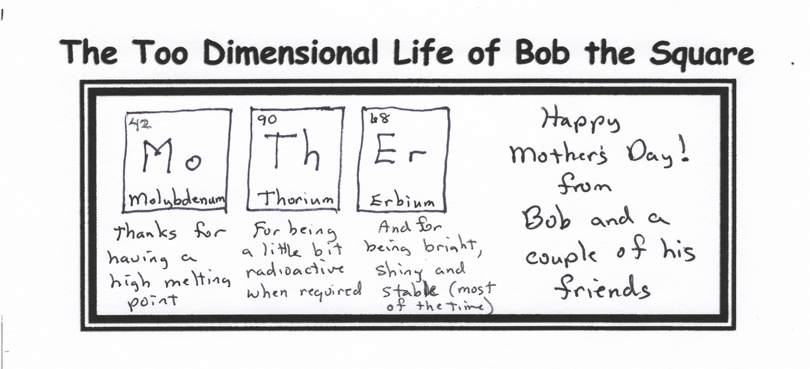

**Remember This:**

**Good Moms always let you lick the beaters.**

**Great Moms turn them off first.**

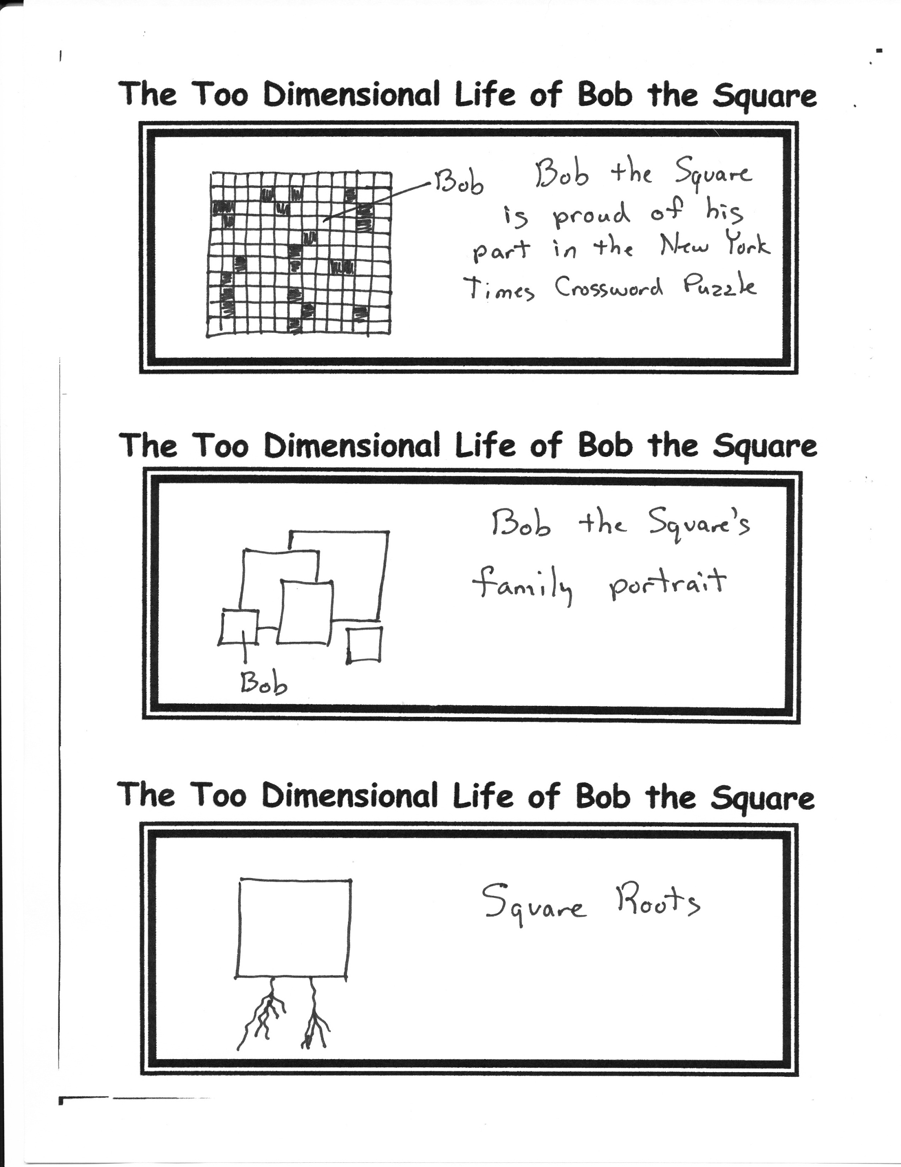

Bob’s Mom

***If you forgot to get your mom a Mother’s Day card, feel free to sign your name here and give this edition to your mom in lieu of a card!***

(Sign Here)