**July 21, 2019**

**Volume 7, Issue 41**

Sunday School Times

***Stuff For Today***

• Bob the square

• Cafeteria Food

• Kabul the Camel

Published almost weekly, but more like…..whenever, so get used to it, OK?

# The Five Wishes OF Kabul The Camel

**By Mr. Lyle (mrlyle1@gmail.com**

***Jeremiah 29:11***

***For I know the plans I have for you, declares the Lord, plans to prosper you and not harm you, plans to give you hope and a future.***

**The Five Wishes of Käbul the Cämel**

Once upon a time, on the hot sands of the Sahara, there lived a camel. His name was Käbul, but no one referred to him by that name. Instead, they called him “Ol’ bag o’ bones”. You see, Käbul was not what most would consider cute or pretty. He wasn’t noble, stately, or handsome. He was just plain homely.

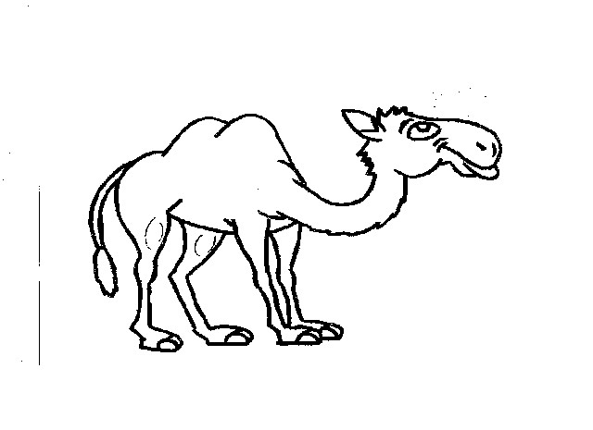

Now, one would not expect a camel to be beautiful because that is just not the way camels are created, but to Käbul, that simply was not good enough. Every day he watched the other animals around him, wishing he could be like them. But at the end of each day, when he looked in the mirror, he was still the same “ol’ bag o’ bones” camel.

One particular morning, Käbul awoke with an uneasy feeling. Oh, the day was normal enough, and yet something about that day would be different from any other he had ever experienced. As Käbul plodded through the desert sands, his mind wandered here and there. As he walked along, a glint of light caught his eye. There, sticking out of the sand dune, was *something.* What in the world could this be? Bending his scruffy neck downward, his lips grasped it’s handle, and with a gentle tug, out came an oil lamp. It was tarnished and dented, but still in reasonable condition. It’s rounded, flowing form was covered in dust, so he gave it a lick with his tongue. What happened next left Käbul wide-eyed and frightened. Smoke began pouring out of the spout of the lamp. As the desert breeze caught the drifting smoke away, there appeared a short, fat, man with a magnificent turban on his head. In a booming voice he said, “You have released me from my fate. For that I am very grateful. I will reward you with five wishes, but be sure to use them wisely!” With a nod of his head, he was gone.

To Käbul, this was too incredible to be believed, and yet he wondered, was it really true? Common sense told him that fairy tales are for library books, not real life! Yet, his heart wanted to believe. Deep in thought, he shuffled along, dreaming and hoping.

Just past a grove of palm trees, Käbul met a most magnificent animal—an elephant. Käbul watched this beast intently. What power! How impressive! Oh, to have a trunk like an elephant, he thought. My, what he could accomplish with a trunk like that! And those huge ears—how handy they must be on a hot day. Gently fanning the air, ears like that could keep someone like him *very* comfortable on a hot day. And so he wished. He wished for an elephant’s trunk and ears. “I wish I was a *camelephant*”. (That was wish number one.)

The most incredible thing then happened. His nose began to grow, and his ears as well! In no time at all, Käbul had a most wonderful trunk and ears to match. He was so excited and happy. This new trunk was absolutely magnificent! How handy this will be, and useful too. Käbul was the happiest *camelephant* there ever was. And as the day grew hotter, he began slowly flapping those large ears. The resulting breeze cooled him nicely. It was simply heavenly.

Käbul paraded himself across the sand proudly, a handsome *camelephant*, if there ever was one. As he continued his walk, an antelope bounded across his path. What a free spirit, he thought! To be able to run and jump so effortlessly would be such fun. And those horns! Those horns would command respect, if only he had some. Käbul wished he had feet like an antelope, and horns like an antelope. “I wish I was a *camelephantelope*” (That was wish number two.)

(Continued next page)

**Camel Trivia**

By Mr. Lyle (mrlyle1@gmail.com)

The word “camel” is derived from the Arabic word for “beauty”.

Camels can drink as much as 40 gallons of water at one stop.

In 1855, the US Congress allowed the War Department $30,000 to purchase camels. They were used for several years until the soldiers got tired of their bad temperament and smell.

If you ever visit Abu Dhabi, be sure to look around for a store that sells a real camel milkshake, made from real camel milk.

Camels can hit speeds of nearly 40 mph for short periods of time, and can hold 25 mph for lengthy periods of time.

Baby camels are born without humps.

Giraffes and rats are the only animal that can last longer without water than a camel.

Approximately 750,000 wild camels roam the outback of Australia.

The oldest known camel lived to be over 35 years old.